Title | Walter and Anna Zion Homestead
Developed by | Josephine Wade, Social Studies Teacher, Bell Middle School.
Grade Level | 4-8
Essential Questions | What opportunities and problems arise when settlers move into areas with unique landscapes or limited accessibility to resources?  Why do people migrate?  Was westward expansion “Manifest Destiny” or conquest?
Contextual Paragraph | The Walter and Anna Zion Homestead is the only known surviving early 20th century sod farm house in eastern Colorado. The homestead was built with sod and constructed in the 1910s by Walter Zion. He, among many other settlers in the area, migrated to Yuma County due to the enactment of the Enlarged Homestead Act of 1909 which allowed homesteaders to claim up to 320 acres (twice the previous limit) in places that could not be irrigated. Walter Zion settled on a rise north of the Arikaree River.  The sod house had three rooms which he built by cutting sod strips that were three feet long, one foot wide, and four inches thick. The roots of the grass grew together which helped to hold the strips of sod into place. The interior was smoothed with a spade and Walter also covered the interior walls with plaster and whitewash. Within a span of several years, the floor, once bare dirt, was covered with concrete, then wooden planks, and finally linoleum. The roof was made from wooden planks, tarpaper, and a layer of sod with tin covering to prevent leaks.  As the Zion family grew, so did the number of buildings. Within a few years, Walter built a one room sod bunkhouse that served as sleeping quarters for his children. He used the land to raise cattle and chickens, and to grow wheat, corn, and cane. As his family and operation grew, Walter Zion added a sod milk house and a root cellar in the 1910s, and a barn and a chicken coop in the late 1920s.  The durability of the sod house continues today which is highly unusual. Though sod homes were not unusual during the early 20th century, sod homes lasting more than forty years were unheard of. The Zion house is the only remaining sod homestead from that period that remains standing. These sod homes represent a time in which westward expansion was booming and the government was trying to get people to settle on the plains.

Resource Set
Zion Homestead, Bunkhouse  Constructed c. 1916 | Eastern Colorado c. 1905 | Example of a Certificate of a Homestead | National Register Nomination for Zion Homestead July 6, 2005 | Root Cellar c. 1915  Resource 4, Photograph 7 | Brooder House c. 1930 Resource 5 Photographs 8 and 16
A recent picture of the bunkhouse taken in 2004. | This map illustrates the area in which the Zion family settled. | This was filed as proof that someone made the necessary upgrades as written in the Homestead Act c. 1900. | The nomination form (27 pages) contains photos, oral history, documents, architectural information, etc. | The root cellar played an important role in the homesteaders' winter food supply. Anna Zion grew potatoes and a variety of vegetables which she canned and stored there. | A brooder house is the first home for baby poultry. It is a heated enclosure that protects these newborns for about 6 weeks.
This picture from 2004 demonstrates the unusual durability of sod since it is still structurally sound more than a century after its construction. | This map illustrates the lack of water sources available in the eastern plains of CO (shown by the absence of waterways or rivers in the area). | The Homestead Act was the reason for the westward expansion and a person had five years to prove they made the upgrades. | National Register Nominations are one of the best places to find complete information on historic properties and their significance. | The root cellar was located about 20 feet from the northeast corner of the main house and measured 31 feet by 21 feet. See nomination for description of the construction of this structure. | This brooder house was a single story, rectangular 10 x 18-foot structure with a concrete foundation. The interior had plasterboard walls. It had a metal shed roof and was located southeast of the main house.

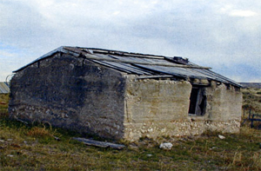 | 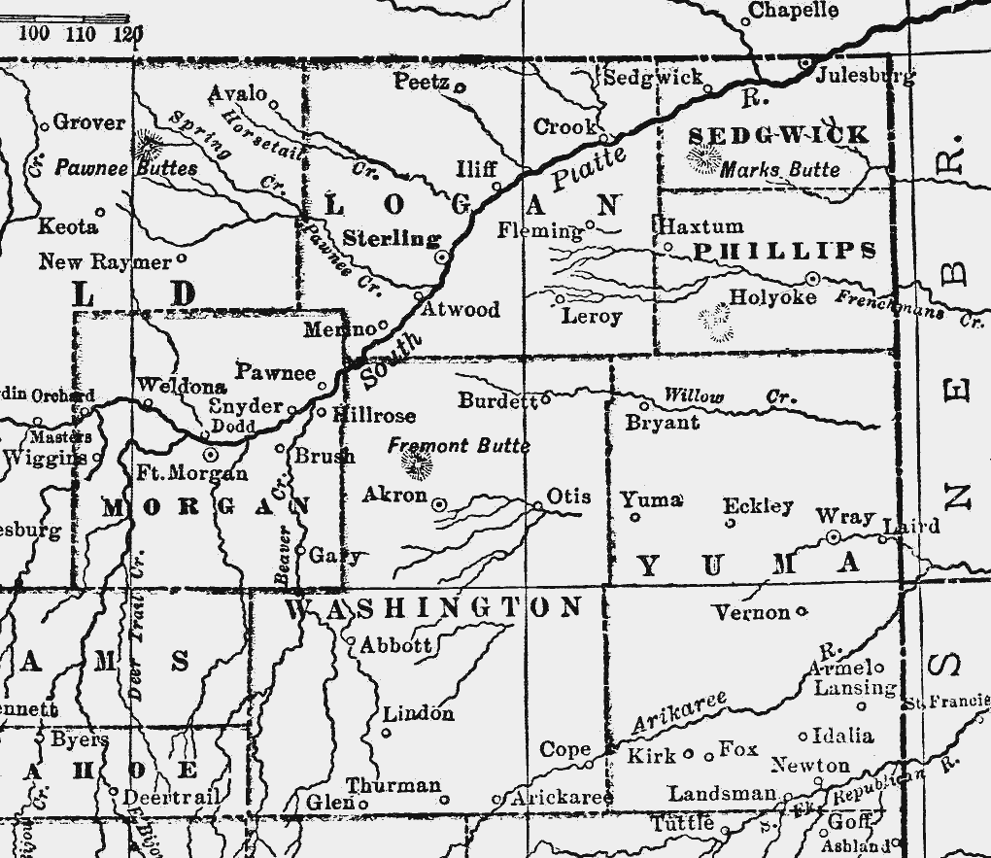 | 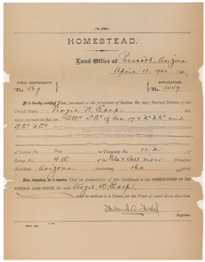 |  | 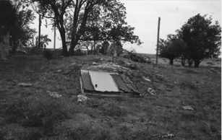 | 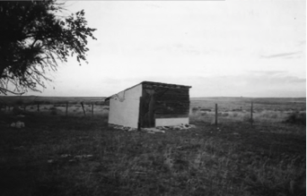
https://npgallery.nps.gov/NRHP/GetAsset/302f9607-f07e-4b64-8753-2eb69e61954a?branding=NRHP | http://www.usgwarchives.net/maps/colorado/countymap/co1905/NeCo05.gif | http://www.archives.com/experts/king-roberta/homestead-records-a-glimpse-into-your-ancestors-past.html | https://npgallery.nps.gov/pdfhost/docs/NRHP/Text/05000652.pdf | https://npgallery.nps.gov/NRHP/GetAsset/302f9607-f07e-4b64-8753-2eb69e61954a?branding=NRHP | https://npgallery.nps.gov/NRHP/GetAsset/302f9607-f07e-4b64-8753-2eb69e61954a?branding=NRHP

Zion Homestead | Zion Homestead | Window Installation Technique for Sod House | Sod Placement Technique for Sod House Walls | Zion Homestead Site Overview | Site overview Photograph 16
Homestead in 1936. Image courtesy of Joe Zion and the Idalia Visions Foundation. | 1912, Image from the 1909 Homesteaders, "God Bless Them." | Sketch depicting window installation. Image from The Sod House. | Sketch of the layer of sod bricks in the wall construction. Image from The Sod House. | Sketch map illustrating the positioning of various buildings that were part of the Zion Homestead. (p. 21) | Photograph of the Zion Homestead that corresponds to the structures labeled in the sketch map.

This homestead building exemplifies the lifestyle of an eastern plains homesteader, rancher, and farmer at the prime settlement phase of Yuma County. | Zion Homestead is an intact example of the ingenious adaptation many plains homesteaders utilized for the construction of their first home. An advantage of sod buildings was the accessibility to the construction materials. On treeless, barren plains, with little water, technology, or building materials for frame or stone buildings, the prairie provided an abundant supply of construction material. | Note the simple but effective construction techniques using available resources. Wooden pegs were driven through holes several places: in the wooden window frame to hold them in place, the planks above the window, and the space between the top of the window and the planks. | The layering of sod strips in an alternating “brick-like” pattern gave strength to the building walls constructed of local materials. | Detailed descriptions of the site and buildings are located in the nomination form. | This last photo in the series brings together the previous images of the individual buildings that make up the 1.27-acre homestead.
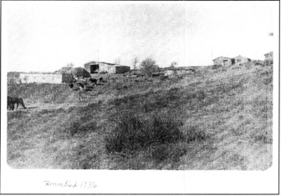 | 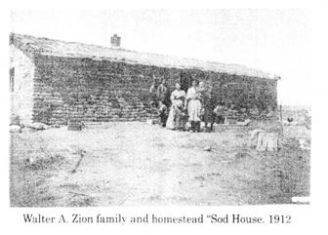 | 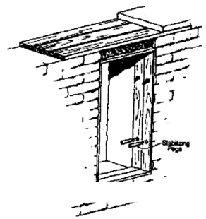 | 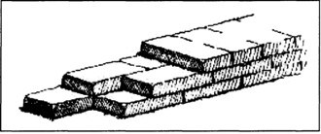 | 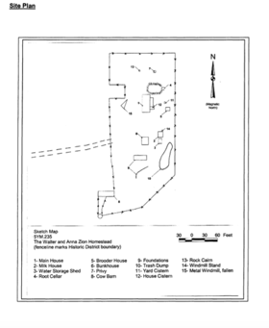 | 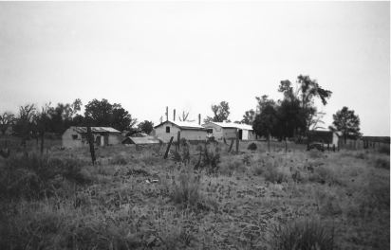
https://npgallery.nps.gov/pdfhost/docs/NRHP/Text/05000652.pdf | https://npgallery.nps.gov/pdfhost/docs/NRHP/Text/05000652.pdf | https://npgallery.nps.gov/pdfhost/docs/NRHP/Text/05000652.pdf | https://npgallery.nps.gov/pdfhost/docs/NRHP/Text/05000652.pdf | https://npgallery.nps.gov/NRHP/GetAsset/a0adb75c-4935-4439-8046-ab795adb2093?branding=NRHP | https://npgallery.nps.gov/NRHP/GetAsset/302f9607-f07e-4b64-8753-2eb69e61954a?branding=NRHP

Foundations Annotations
Curriculum Connections

History

Geography
Curriculum Standards

CO History Standard 1: Formulate appropriate hypotheses about United States history based on a variety of historical sources and perspectives. (Eighth Grade)
a. Use and interpret documents and other relevant primary and secondary sources pertaining to United States history from multiple perspectives.

CO Geography Standard 2.1: Use geographic tools to analyze patterns in human and physical systems. (Eighth Grade)
d. Explain the establishments of human settlements in relationship to physical attributes and important regional connections.

CO Geography Standard 2.2: Conflict and cooperation occur over space and resources. (Eighth Grade)
c. Interpret from a geographic perspective the expansion of the United States by addressing issues of land, security, and sovereignty.

Content and Thinking Objectives

Students will be able to:
- evaluate the various motives and methods of acquiring territory from different perspectives; include both the intended and unintended consequences.
- use maps and other geographic tools to analyze U.S. expansions and patterns of settlement.
- consider how settlers had to adapt to their surrounding geography and environment for building materials and settlements.
- articulate their understanding of the use and value of the various buildings and structures located in this typical homestead.

Inquiry Questions, Activities and Strategies

Inquiry Questions
Was the settlement of America’s western lands “Westward Expansion” or “Territorial Convergence?”

Can historians be completely impartial when writing about history?

How have differing perspectives regarding resources and land use led to cooperative policies or conflict?

Inquiry Activities
Ask students to “solve” the physical geography issues that would have arisen when homesteading, such as floods, droughts, building a home, etc.

Using the resource set for a museum walk, ask students to note the things they observe in the images and the questions that arise from the conversation during the museum walk.

Ask students to speculate on reasons why the Zion Homestead lasted longer than other homesteads and still stands today.

Assessment Strategies

Depending upon how one uses the resources and which standards are chosen, assessment can take many forms. For example:

CO History Standard 1 (a) (Eighth Grade) Use a photo from the resource set and ask students to explain why people were willing to migrate to the plains.

CO Geography Standard 2.1 (d) (Eighth Grade) Ask students to discuss the pros and cons of the Homestead Act while considering the government requirements, the physical geography such as weather, and the resources available to the homesteaders.

CO Geography Standard 2.2 (c) (Eighth Grade) In an essay, ask students to analyze how the geographical and cultural landscape would have impacted America had the government not passed the Homestead Act.

Other Resources
Web Resources

Colorado Encyclopedia: http://coloradoencyclopedia.org/article/walter-and-anna-zion-homestead

Idalia Vision Foundation: http://www.idaliavisions.com/portfolio_page/walter-and-anna-zion-homestead/

Landmark Hunter: http://landmarkhunter.com/145105-walter-and-anna-zion-homestead/

National Park Service: https://npgallery.nps.gov/AssetDetail?assetID=a0adb75c-4935-4439-8046-ab795adb2093

National Register of Historic Places Database: https://www.nps.gov/nr/

Secondary Sources

Shirley Starnes, West Yuma County, Colorado: A History of West Yuma County, 1886-1986 (Yuma, CO: The Committee, 1985).
William Wyckoff, Creating Colorado: The Making of a Western American Landscape, 1860-1940 (New Haven: Yale University Press, 1999).

Preservation Connection

Joseph Zion, Walter and Anna’s son, lived at the homestead and farmed the land until 1975, when he sold the property to neighbors Clayton and Billie Neil Penisch. They donated the land containing the Zion Homestead buildings to the Idalia Vision Foundation in 2001. The Idalia Vision Foundation is a nonprofit established in 1992 to promote historic preservation and community welfare projects in the area.
In 2005, the Zion Homestead was listed in the National Register of Historic Places, because it embodies the distinctive characteristics of a type, period, and method of construction. Idalia Vision Foundation maintains and preserves the homestead. In 2011, the organization repaired the roofs of the sod buildings with the help of two State Historical Fund grants.
How can the enduring sod building provide information about sod construction?

How does the construction of the homestead differ from common building materials? What are the pros and cons of various building materials?

How can the Zion Homestead be used to tell the story of Colorado’s past and the importance of historic preservation?

Why should the Zion Homestead be a part of the story of Colorado?

Working together to tell the story of our state!

Developers


Sponsors


Partners


