Title | Washington Park
Developed by | Anthony Hodes, Education ala Carte
Grade Level | 3 – 4
Essential Questions | How have people interacted with the environment over time in positive or negative ways?  Why are parks like Washington Park an important part of city planning?  How did Reinhard Schuetze contribute to the development of Washington Park?  What was the legacy Reinhard Schuetze left to the Denver Metro area through Washington Park?  How and why does Washington Park play an iconic role in the landscape of Denver?
Contextual Paragraph | Developed in the 1890s and early 1900s, Washington Park is a scenic recreational area occupying about 160 acres southeast of Downtown Denver. Reinhard Schuetze laid out this scenic park in the grand Victorian manner in 1889. It features two beautiful lakes; the largest meadow in the Denver park system; a remnant of the City Ditch (which was essential to the watering and hence the development of the park); a forested hill graded by the Olmsted Brothers and planted by Saco DeBoer; romantic deciduous tree plantings; the largest formal summer flower beds in the Denver park and parkway system; and important architectural embellishments such as the 1913 Boat House on Smith’s Lake. The property is associated with the Denver Park and Parkway System Thematic Resource and the Architecture of Jules Jacques Benois Benedict in the Colorado Multiple Property Submission.  At the turn of the 19th century, noted city planner, Charles Mulford Robinson, and George E. Kessler, a nationally known designer of parks and parkways joined forces to develop the Robinson-Kessler Plan for what became the Denver Park and Parkway System which included Washington Park.  Washington Park was listed in the National Register of Historic Places on September 17, 1986.

Resource Set
Aerial View of Washington Park between 1920 – 1930 | National Register Nomination Form for Denver Park and Parkway System, September 17, 1986 | Reinhold Schuetze, 1860 – 1910 | Saco Rienk De Boer, 1883 – 1974 | Jules Jacques Benois Benedict, 1879 – 1948 | Sketch of Smith Lake and Boathouse/Pavilion
Aerial view shows Smith Lake, the boathouse, bathhouse pier, beach and houses in the Washington Park and Washington Park West neighborhoods. | This “Themed Resource” nomination includes 16 parkways and 15 parks in the Denver system. Included in this nomination is Washington Park. | Born in Germany, Schuetze came to America in 1889 with a comprehensive knowledge of garden design and engineering. | Born in the Netherlands, DeBoer suffered from tuberculosis and came to the US in 1908 looking for a drier climate. He ultimately settled in Denver. | Benedict was described as “…one of the most flamboyant personalities in Denver’s architectural history.” He was a master of the Beaux Arts style. | This sketch was part of the submission for a survey and State Historical Fund planning grant to preserve the boat house and other structures in the park.
Washington Park was planned in the late 19th century on the eastern part of Denver. The name, Washington Park, came to identify the park and surrounding neighborhood. | Washington Park has an individual nomination for inclusion in the National Register of Historic Places however the form itself has not been digitized. | The City of Denver hired him in 1894 to develop the Denver parks system including Washington and Cheesman Parks. He was also commissioned in 1895 to design the Colorado State Capitol grounds and the zoological garden. | After converting a dump on Cherry Creek into Sunken Gardens Park he caught the eye of Mayor Robert Speer. After the death of Reinhard Schuetze (Denver’s first landscape architect) Speer named DeBoer as Schuetze’s successor. | In 1909 he designed and managed the construction of the boathouse in Washington Park. The Boating Pavilion is the only one of his urban park designs that is still extant.  The boathouse was part of the early 20th century City Beautiful Movement. | The Boathouse Pavilion was a combination of Classical, Benedict’s Beaux-Artes/Italianate, Prairie Style and the Arts and Crafts movement.  In the winter, the first level was used as a warming space when ice skating was permitted on the lake.

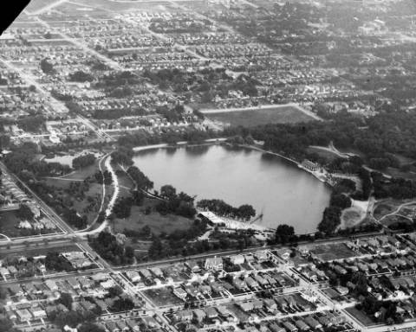 | 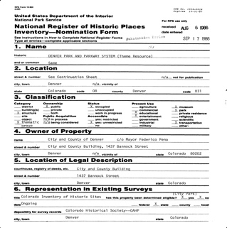 | 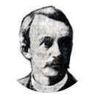 | 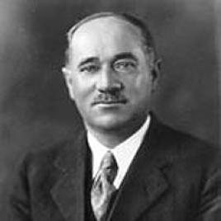 | 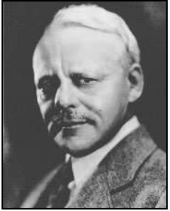 | 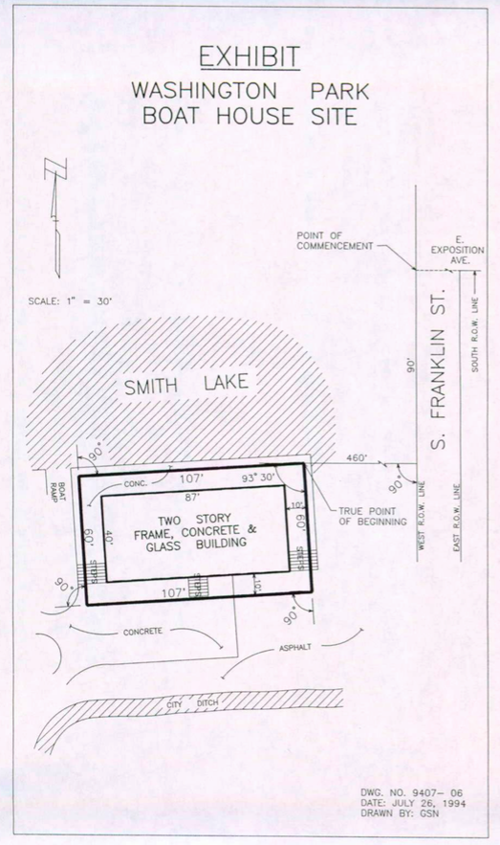
http://digital.denverlibrary.org/cdm/singleitem/collection/p15330coll22/id/55705/rec/5 | http://legacy.historycolorado.org/sites/default/files/files/OAHP/crforms_edumat/pdfs/613.pdf | http://fairmountheritagefoundation.org/wp-content/uploads/Famous-faces-Reinhard-Schuetze.pdf | https://tclf.org/pioneer/sr-deboer | http://legacy.historycolorado.org/archaeologists/architecture-jules-jacques-benois-benedict-colorado | http://gis.co.gov/OAHP_Images/5DV/5333/5DV_5333-d_Site_Form_and_Nomination.pdf

Band Stand c. 1930 – 1950 | Sketch of Mt. Vernon Gardens Plan c. 1925 | Mount Vernon Gardens, Washington Park, 1986 | DeBoer’s Plan for the Lily Pond in Washington Park c. 1917 | Washington Park Fountain c. 1919-1923 | Workmen putting house on new site in Washington Park, June 15, 1930
Photo is a view of a wooden bandstand in the park. A foot bridge is nearby. | S. R. DeBoer’s plan for the Mount Vernon Gardens in the park.  The gardens are a replica of Martha Washington’s garden at Mount Vernon, arranged in complex geometric shapes.  Photo #52 | In view of Mrs. Washington’s garden is an elm tree grafted from the old Washington Elm in Massachusetts, the spot where then-General Washington assumed command of the Continental Army in 1775. | Today, the one-acre Lily Pond is available for fishing.  Photo #53 | A side view of the Wynken, Blynken and Nod marble fountain statue in the park.  Originally built as a fountain on the west side of the park, it was relocated as a statue to its current location in 1981 outside the Eugene Field House on the east side. | Workmen stand near the Eugene Field house in Washington Park. The wood frame house has a hip roof and is on a partial brick foundation.  Originally located at 315 W. Colfax it was purchased and relocated at the behest of Margaret “Molly” Brown.

Over the years, the park hosted many activities that brought the public together to enjoy the outdoors.  The bandstand is still used today to host festivals and other gatherings. | This garden utilizes the site to full advantage, making use of a low retaining wall edging the garden to represent the stone walls of her original greenhouses. | From these gardens one may look away to the distant Rockies to the west, especially notable are the sunsets from this spot.  Photo 47E | The lily pond was built by the Olmsted Brothers, sons of Frederick Law Olmsted. Considered the father of urban park planning, he introduced what would become the City Beautiful Movement in 1893. | Considered an area of significance in the nomination to the National Register, it was sculpted by Mabel Landrum Torrey. | Field was a noted journalist, story-writer and poet who lived in Denver from 1881 – 1883 while he served as the managing editor of the Denver Tribune newspaper.  One of his most noted poems is “Wynken, Blynken and Nod.”
 | 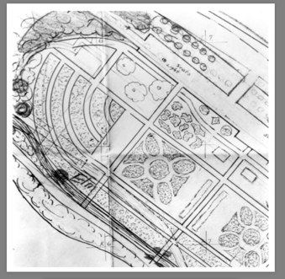 | 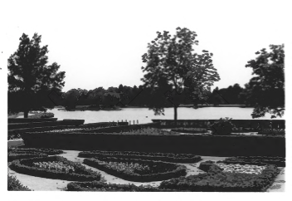 | 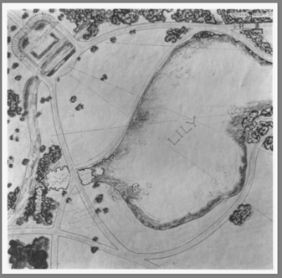 |  | 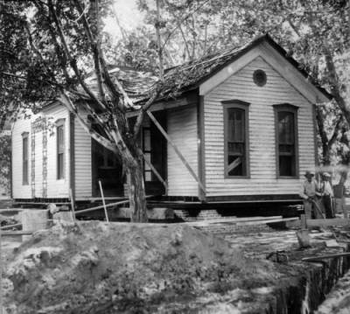
http://digital.denverlibrary.org/cdm/ref/collection/p15330coll22/id/24821 | https://npgallery.nps.gov/NRHP/GetAsset/6a155a1f-2247-49a1-94ed-d648cb8e586c?branding=NRHP | https://npgallery.nps.gov/NRHP/GetAsset/6a155a1f-2247-49a1-94ed-d648cb8e586c?branding=NRHP | https://npgallery.nps.gov/NRHP/GetAsset/6a155a1f-2247-49a1-94ed-d648cb8e586c?branding=NRHP | http://digital.denverlibrary.org/cdm/ref/collection/p15330coll22/id/17443 | http://digital.denverlibrary.org/cdm/ref/collection/p15330coll22/id/39380

City Ditch and Concrete Bridge, 1985 | Washington Park, view looking West, 1984 | Skating at Washington Park c. 1900 – 1920 | Bathing Scene at Washington Park c. 1910 - 1920 | Boat House and Pavilion, 1985 | Bath House between 1930 and 1950
Built in the 1860s this 26 mile hand-dug ditch introduced “greening” to Denver. It is an engineering marvel for the use of gravity alone to carry water northward from the Platte River. This portion of the ditch in Washington Park is located south of the boat house.  Photo 48 | A view of Washington Park looking west with Mount Evans visible in the tree break across Grasmer Lake.  Grasmer Lake is one of two lakes (the other is Smith Lake) and one pond (Lily Pond) fed by water from the City Ditch as it runs through Washington Park.  Photo 47A | Children, women and men skate on the ice of Smith Lake. A crowd of people stand near the boat pavilion. Houses can be seen in the distance.  During the winter time the swimming lake became an ice rink used for skating. The boat pavilion offered a place for shelter and warming | Men, women, and children in bathing suits sit on the pier at Smith Lake.  Swimmers are in the water. Rowboats and the boathouse pavilion can be seen in the distance. | The boathouse is located on the southern shore of Smith Lake.  Denver architect Jules Jacques Benois Benedict designed the boathouse which opened in 1913. It contains an eclectic mix of Italianate, Prairie, and Arts and Crafts styles.  Photo 50 | View of the bathhouse at Washington Park. The building has a retractable awning and U. S. flags fly from poles on the roof.  It is one of three historical structures in the park. The other two are the Boat House and the Eugene Field House.
Nominated to the National Register October 8, 1976, “Smith’s Irrigation Canal” is Denver’s first water canal.  It enabled Washington Park to flourish both in terms of beauty and for recreational purposes. | Grasmere Lake was added to the park in 1906 and named after a village and lake associated with the poet Williams Wordsworth in the English Lake District.  A network of curving roads encircled the two lakes with a tree-lined perimeter separating the park from the surrounding neighborhoods. | This is one example of how the diversity of recreational options meant that the park was used year-round. | Smith Lake and Grasmer Lake were both fed by the Smith Ditch (aka City Ditch) which was completed in 1867.  Swimming was allowed in Smith Lake until the 1950s when maintenance costs became too costly. | Washington Park is representative of Denver’s long-term commitment to fostering its citizens’ health and recreational opportunities. Today CO continues to be known for its physically active populace and Washington Park continues to be one of its most popular centers. | Built in 1911, it was designed by Frederick Ameter and James B. Hyder. That same year Smith Lake opened for swimming.  The men’s dressing room was in the west wing. In 1912 the women’s dressing room opened in the newly built east wing.

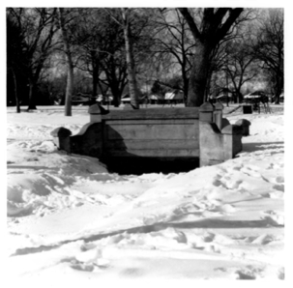 | 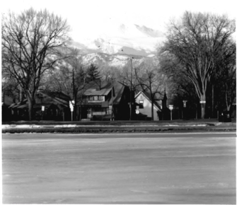 |  |  | 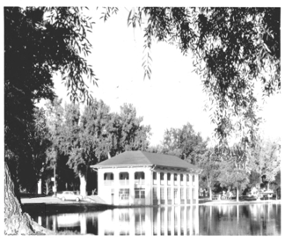 | 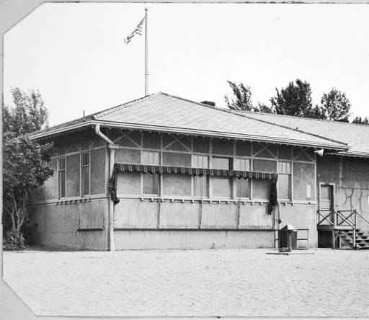
https://npgallery.nps.gov/NRHP/GetAsset/6a155a1f-2247-49a1-94ed-d648cb8e586c?branding=NRHP | https://npgallery.nps.gov/NRHP/GetAsset/6a155a1f-2247-49a1-94ed-d648cb8e586c?branding=NRHP | http://digital.denverlibrary.org/cdm/ref/collection/p15330coll22/id/55728 | http://digital.denverlibrary.org/cdm/ref/collection/p15330coll22/id/55722 | https://npgallery.nps.gov/NRHP/GetAsset/6a155a1f-2247-49a1-94ed-d648cb8e586c?branding=NRHP | http://digital.denverlibrary.org/cdm/ref/collection/p15330coll22/id/24809

Foundations Annotations
Curriculum Connections

History
Geography
Literacy

Curriculum Standards
CO State History Standard 2: People in the past influence the development and interaction of different communities or regions. (Third Grade)
- Describe the history, interaction, and contribution of the various peoples and cultures that have lived in or migrated to a community or region.

CO State Geography Standard 1: Use various types of geographic tools to develop spatial thinking. (Third Grade)
- Read and interpret information from geographic tools and formulate geographic questions.
c. Locate the community on a map and describe its natural and human features.

CO State Geography Standard 2: The concept of regions is developed through an understanding of similarities and differences in places. (Third Grade)
- Observe and describe the physical characteristics and human features of a region.
- Identify the factors that make a region unique including cultural diversity, industry and agriculture, and land forms.

CO State History Standard 1: Organize and sequence events to understand the concepts of chronology and cause and effect in the history of Colorado. (Fourth Grade)
- Construct a timeline of events showing the relationship of events in Colorado history with events in United States and world history.
- Analyze primary source historical accounts related to Colorado history to understand cause-and-effect relationships.
- Explain the cause-and-effect relationships in the interactions among people and cultures that have lived in or migrated to Colorado.

CO State History Standard 2: The historical eras, individuals, groups, ideas and themes in Colorado history and their relationships to key events in the United States. (Fourth Grade)
Describe interactions among people and cultures that have lived in Colorado.

CO State Geography Standard 1: Use several types of geographic tools to answer questions about the geography of Colorado. (Fourth Grade)
d. Illustrate, using geographic tools, how places in Colorado have changed and developed over time due to human activity.
CO State Geography Standard 2: Connections within and across human and physical systems are developed. (Fourth Grade)
a. Describe how the physical environment provides opportunities for and places constraints on human activities.
b. Explain how physical environments influenced and limited migration into the state.
Analyze how people use geographic factors in creating settlements and have adapted to and modified the local physical environment.

Curriculum Standards (continued)
CCSS.ELA-LITERACY.RH.6-8.1: Cite specific textual evidence to support analysis of primary and secondary sources.

CCSS.ELA-LITERACY.RH.6-8.2: Determine the central ideas or information of a primary or secondary source; provide an accurate summary of the source distinct from prior knowledge or opinions.

Content and Thinking Objectives

Students will be able to:
- use primary and secondary sources to learn about the past.
- examine places, regions and the connections among them.
- use maps and photos to understand how we interpret the past and how humans use space in their natural and built environment.
- identify social and economic decisions that caused people to migrate to different regions.
- analyze key historical periods and patterns of change over time within and across nations and cultures.
Inquiry Questions, Activities and Strategies

Inquiry Activities
Discuss the role that Reinhard Schuetze, the Olmsted Brothers, Saco Rienk DeBoer, and Jules Jacques Benois Benedict played in the development and history of Washington Park. Who are some other people who impacted how Washington Park looks today?
- Use these National Register of Historic Places Forms and other resources for more information.
  - http://legacy.historycolorado.org/sites/default/files/files/OAHP/crforms_edumat/pdfs/647.pdf
  - http://legacy.historycolorado.org/sites/default/files/files/OAHP/Guides/Architects_deboer.pdf
  - http://legacy.historycolorado.org/sites/default/files/files/OAHP/crforms_edumat/pdfs /613.pdf <%22>

Using the primary sources included here as well as other information that you find in books, newspaper articles and online, investigate why Washington Park played such an important role in Denver, beginning in the late 1800s through the current day.

Inquiry Questions, Activities and Strategies (continued)

Examine photographs in this resource set from the past 100+ years of Washington Park. Construct a timeline using these photographs and others and discuss the changes over time. How did the landscape around the property influence its design and construction? What other factors influenced the design and construction? Include present day use of the property in your discussion. The Denver Public Library has more photographs of Washington Park that can be used for your timeline.

Additional activity and strategy information from the Colorado Department of Education:
https://www.cde.state.co.us/standardsandinstruction/highimpactinstructionalstrategies/ss
Assessment Strategies

Depending upon how one uses the resources and which standards are chosen, assessment can take many forms. For example:

CO State Geography Standard 2 (a) (Fourth Grade) Describe the opportunities Washington Park offers human activities. Use maps and images to describe how Denver and Washington Park have changed and developed due to human activity.

CO State History Standard 1: (b and c) and CO State History Standard 2: (a) (Fourth Grade) Ask students to compare and contrast the architecture of the buildings at Washington Park and the other parks in Denver. What can you learn about the history of Denver and the migration to the area from this architecture? How has the environment influenced the architecture?

Other Resources
Web Resources

National Register of Historic Places Homepage: http://www.nps.gov/nr

Resources from History Colorado:
- https://www.historycolorado.org/denver-park-and-parkway-system-thematic-resource

Resources from Colorado Encyclopedia:
- https://coloradoencyclopedia.org/article/washington-park
- https://coloradoencyclopedia.org/article/saco-rienk-deboer

Web Resources (continued)

Pam Marquez, “Local History: perennial Washington Park” Denver Metro Media, July 30, 2015: http://www.denvermetromedia.com/Profile/lifestyle/history-perennial-wash-park-surprising-historical-usage/

Resources from the Denver Public Library: http://digital.denverlibrary.org/

Secondary Sources

Resources from History Colorado – Denver Park and Parkway System http://legacy.historycolorado.org/sites/default/files/files/OAHP/crforms_edumat/pdfs/613.pdf

Don Etter, “Denver Park and Parkway System,” National Register of Historic Places Inventory Nomination Form (March 1986).

Sarah O. McCarthy, Denver’s Washington Park, Images of America (Charleston, SC: Arcadia, 2014).

Thomas J. Noel, Denver Landmarks and Historic Districts: A Pictorial Guide (Niwot: University Press of Colorado, 1996).

Preservation Connection

Washington Park, bounded by East Virginia, South Franklin, East Louisiana and South Downing Streets was added to the National Register on September 17, 1986 (https://npgallery.nps.gov/NRHP/AssetDetail?assetID=5ae7cb88-2d97-4cb7-bb69-c14b0cd2e663). It is significant in its own right for community planning, landscape architecture, the architectural style of buildings in the park and the architects who designed them. It is also a part of another register nomination the Denver Park and Parkway System Thematic Resource (http://legacy.historycolorado.org/sites/default/files/files/OAHP/crforms_edumat/pdfs/613.pdf) that highlights not only Washington Park, but Cheesman Park (https://npgallery.nps.gov/NRHP/AssetDetail?assetID=a2fb8728-1628-4c74-9289-8d9c4e9db952), City Park (https://npgallery.nps.gov/NRHP/AssetDetail?assetID=5cfb1fc7-8d9a-41b3-bc60-025273144685) and Civic Center Park.

Within Washington Park are a variety of significant structures. The Eugene Field House, built in 1875 reflects the late Victorian style found in much of the construction in early Denver (https://npgallery.nps.gov/NRHP/AssetDetail?assetID=1d3ce5a8-a6e1-413d-b7d3-6b4bedfc5f88). It was moved to the park from its original location at 315 West Colfax in 1930. It is an early example of the importance of preservation as Denver socialite Margaret “Molly” Brown was instrumental in arranging for the move thus saving the house from destruction. Field, managing editor of the Denver Tribune, lived in Denver between 1881 and 1883. A journalist, story writer and poet he is famous for his children’s poem “Wynken, Blynken and Nod.” A marble fountain statue by Mabel Landrum Torrey in Washington Park commemorates the poem.

The boating pavilion (boathouse) designed in 1913 by Jules Jacque Benois Benedict is one of the architecturally significant buildings in the park. It is an eclectic mix of Italianate and Prairie Arts and Crafts style.

Built in the 1860s, Smith’s Irrigation Ditch (also known as the City Ditch) is a 26-mile-long hand-dug irrigation ditch that introduced “greening” to Denver. It was an engineering marvel as it used gravity alone to carry water from the South Platte River northward. One section, located in Washington Park, was listed in the National Register October 10, 1976 (https://npgallery.nps.gov/NRHP/AssetDetail?assetID=05d5408d-1e0a-4ef1-8c64-0f8957d90aeb).

Why is it important to study and preserve a collection of parks and buildings in a city rather than just one individual park on a particular site?

How does this contribute more fully to our understanding of the city as a whole and its history?

Working together to tell the story of our state!

Developers


Sponsors


Partners


