Title | Rim Rock Drive
Developed by | Josephine Wade, Social Studies Teacher, Bell Middle School
Grade Level | 4-8
Essential Question | How do human activity and the environment affect each other?  How have different people impacted the state of Colorado and beyond?  What happens when people interact with the environment?  How does the physical geography influence migration?  How does Colorado’s environment play a part in migration?
Contextual Paragraph | Rim Rock Drive is a 23 mile scenic road through Colorado National Monument. The road increased tourism of Colorado National Monument by allowing cars to be driven through the area. In 1911, due to the work of John Otto, President William Howard Taft established Colorado National Monument. After the designation, John Otto directed the construction of Serpents Trail which was the first road through the Monument. The road was considered dangerous however, as 52 switchbacks were included in the 7.5 mile long road.  Rim Rock Drive became a reality due to the Civilian Conservation Corps (CCC) program of the New Deal. CCC workers carved and graded Rim Rock Drive with construction beginning in 1933. Several federal and local services funded this venture which ended up costing more than $500,000, but resulted in a 23 mile long road. The paving of Rim Rock Drive began after WWII and was completed by 1951. In 1950, Serpents Trail was officially closed to vehicles and became a hiking trail.  In the 1980s, due to proposed fees for use of the road by the National Park Service, a lawsuit was filed involving the National Park Service, Mesa County, and a local property owner, John Wilkenson, who thought that local property owners should be able to use the road without paying fees. In 1986, favor was granted to the plaintiff as the court declared the road a public right of way.  In 1994, Rim Rock Drive was listed in the National Register of Historic Places and now receives more than 400,000 visitors per year.

Resource Set
Rim Rock Drive at the Colorado National Monument | Rim Rock Drive at the Colorado National Monument | Jeeps at Rim Rock Drive | Rim Rock Tunnel | Rim Rock Construction | Masonry Work along Rim Rock Drive
View of one of the tunnels through Rim Rock Road. | Picture of two men heaving a boulder onto a wheeled cart. | View of Rim Rock with two Jeeps on the road. | View of a tunnel during construction with tracks to help with the movement of building supplies. | Three men building the road using a container to clear and haul the rocks. | Picture of men building a retaining wall at Rim Rock c. 1933.
Provides an authentic glimpse of the road after its conception emphasizing the extreme terrain builders had to work with and shape to build the road. | The construction of Rim Rock Drive was the major source of construction employment for Grand Junction residents during the 1930s. | Provides a glimpse of the deep grades that builders had to consider and maneuver when constructing the road. | The tracks give another perspective for how resources were supplied to places like Rim Rock when access and technology were limited. | The picture provides a glimpse about how resources were transported prior to the availability of construction equipment. | The Civilian Conservation Corps included the construction of rocks walls to help drain and prevent erosion.

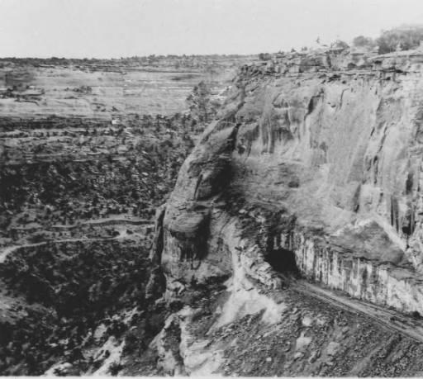 | 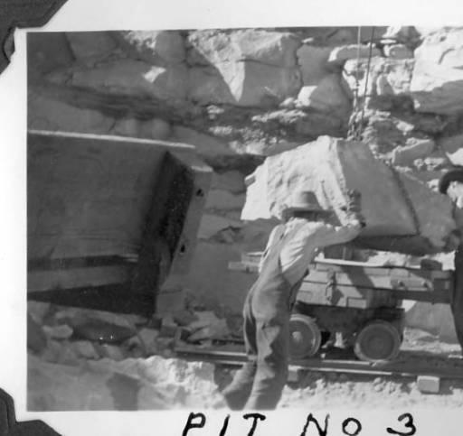 | 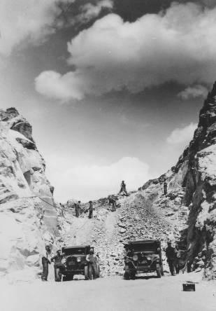 | 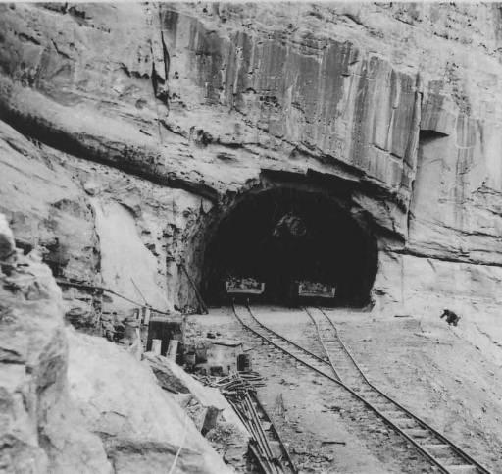 | 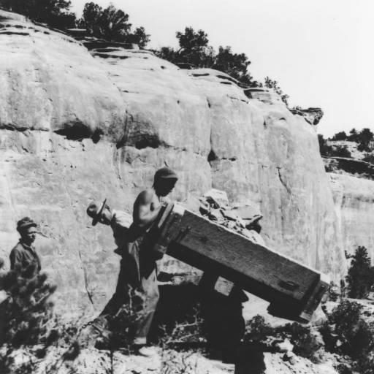 | 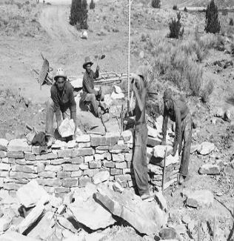
http://digital.denverlibrary.org/cdm/ref/collection/p16079coll32/id/382155 | http://digital.denverlibrary.org/cdm/ref/collection/p16079coll32/id/382156 | http://digital.denverlibrary.org/cdm/ref/collection/p16079coll32/id/362671 | http://digital.denverlibrary.org/cdm/ref/collection/p16079coll32/id/362672 | http://digital.denverlibrary.org/cdm/ref/collection/p16079coll32/id/362677 | https://coloradoencyclopedia.org/image/masonry-work-along-rim-rock-drive

Building Rim Rock Drive | Rock Work on Rim Rock Drive | Rim Rock Drive | Rim Rock Drive, Fruita, Mesa County, CO | National Register of Historic Places Nomination Form | Scenery at Colorado National Monument,
Bird’s eye view of a stretch of the road with buildings where the construction workers lived during their time there. | Men working on the road using different tools to pick away at the rock. | A bird’s eye view of part of Rim Rock Drive c. 1951. | Picture of the paved road of Rim Rock Drive. | Nominated April 21, 1994. The Rim Rock Drive represented the major source of construction employment in the Grand Junction area during the Depression and had a substantial impact on the economy of the area. | Panoramic picture of the scenery at Colorado National Monument.
The members of the CCC program of the New Deal were brought in to build the road. Example of the numbers of people who may have lived in the buildings during their employment. | Another picture that demonstrates how different tools were used to build roads such as pick axes, sledge hammers, etc. | The picture provides a look at the scenery which is part of the reason for its preservation efforts and designation in the National Register of Historic Places. | View of the road that shows the rock cut and one of the guard walls that were constructed. The engineering and design required for its time contribute to the road’s significance in the National Register. | Rim Rock Drive Historic District is significant in the improvement of automobile access to and development of Colorado National Monument. | View of the Colorado National Monument illustrating the reason why the Monument is in the National Register. Rim Rock Drive increased tourism through automobile access to the site in significant numbers.
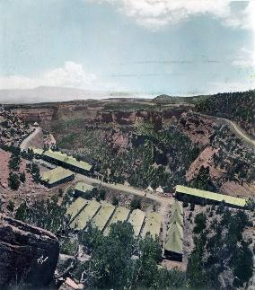 | 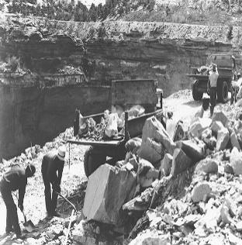 | 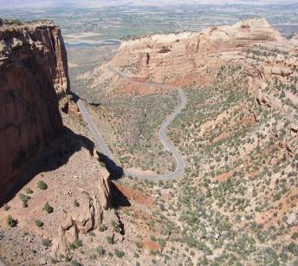 | 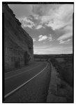 |  | 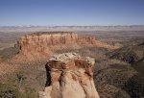
https://coloradoencyclopedia.org/image/building-rim-rock-drive | https://coloradoencyclopedia.org/image/rock-work-rim-rock-drive | https://coloradoencyclopedia.org/image/rim-rock-drive | https://www.loc.gov/resource/hhh.co0176.photos/?sp=4 | https://npgallery.nps.gov/NRHP/AssetDetail?assetID=149139ab-bbf9-45b2-b954-507ff7b6c830 | https://www.loc.gov/resource/highsm.33006/

Foundations Annotations
Curriculum Connections

History
Geography
Curriculum Standards

CO State History Standard 2: The historical eras, individuals, groups, ideas and themes in Colorado history and their relationships to key events in the United States. (Fourth Grade)
d. Describe the impact of various technological developments.

CO State Geography Standard 2: Connections within and across human and physical systems are developed. (Fourth Grade)
c. Analyze how people use geographic factors in creating settlements and have adapted to and modified the local physical environment.
d. Describe how places in Colorado are connected by movement of goods and services and technology.

Content and Thinking Objectives

Students will be able to:
- analyze and gather evidence from primary and secondary sources.
- identify cause and effect relationships (when describing the history, interactions, and contributions of the diverse people/cultures in Colorado’s history).
- define technology and explain the impact of various technological developments in Colorado’s past.
- describe how the physical environment of Colorado’s regions provided opportunities for and placed constraints on people/groups over time.

Inquiry Questions, Activities and Strategies

Inquiry Questions
In what ways have geographic, economic, cultural, and technological changes influenced Colorado today?

How did people alter their environment to facilitate communication and transportation?

How does the physical environment affect human activity and vice versa? How does tourism impact the built environment?

What were the design and construction challenges the builders of Rim Rock Drive faced? How does that compare to road construction today?

Inquiry Activities
Ask students to analyze how technological advances affected the way that Colorado’s landscape has been used from the 1930s to present using a “Thinking Map.”

Using the resource set to create a museum walk, ask students to note things they observe in the images and questions that arise from the conversation during the activity.

Ask students to research the ways people used technology to facilitate the construction of the road and analyze the different obstacles that may have occurred during that period versus the available technology today.
Assessment Strategies

Depending upon how one uses the resources and which standards are chosen, assessment can take many forms. For example:

CO History Standard 2 (d) (Fourth Grade) Students can choose one of the above pictures to analyze and describe how technological advances have changed Colorado’s physical landscape.

CO Geography Standard 2 (d) (Fourth Grade) Create a project (Google slides, Prezi, Podcast, poster, tri-fold, board game, etc.) that explains how the builders used the available resources to build into the mountain.
Other Resources
Web Resources

Colorado Encyclopedia: www.coloradoencyclopedia.org

Library of Congress: www.loc.gov

Denver Public Library: www.denverlibrary.org

National Park Service “Scenic Rim Rock Drive”: https://www.nps.gov/colm/planyourvisit/scenic-rim-rock-drive.htm
National Register: https://npgallery.nps.gov/NRHP/GetAsset/149139ab-bbf9-45b2-b954-507ff7b6c830?branding=NRHP
Secondary Sources

Alan J. Kania, John Otto of Colorado National Monument (Boulder, CO: Roberts Rinehart, 1984).

Lisa Schoch-Roberts, A Classic Western Quarrel: A History of the Road Controversy at Colorado National Monument, Cultural Resources Selections 10 (Denver: US Department of the Interior, National Park Service, Intermountain Region, 1997).

Preservation Connection

Preservationists consider Rim Rock Drive significant for several reasons. The site itself has a high degree of integrity of setting, design, location materials, and workmanship. It is representative of the second stage of auto access to and development of the Colorado National Monument and allows visitors to enter the monument from either the east of the west. The early 20th century Serpent’s Trail, built during the first stage of auto access, was replaced by Rim Rock Drive.
The building of the road provided a major source of employment for those living in and around Grand Junction. It is the classic example of the kinds of work done during the Depression by government supported public works projects such as the Public Works Administration (PWA), the Works Progress Administration (WPA) and the Civilian Conservation Corps (CCC) all of which took part in the development of Rim Rock Drive.
Rim Rock Drive is the first modern road designed to enhance recreational use of the Colorado National Monument. Visitors driving through the monument can observe first-hand the distinctive engineering techniques that were used in this example of cliff face road building – much of which was accomplished without the modern road-building machines used today.
Rim Rock Drive was added to the National Register of Historic Places April 21, 1994.

Why is Rim Rock Drive listed in the National Register of Historic Places?
How can the road continue to tell the story of Colorado’s past well into the future?
What were the design and construction challenges the builders of Rim Rock Drive faced? How does that compare to road construction today?

How does the design and construction of the road impact how visitors to National Monument experience the site? Why is that important?

Working together to tell the story of our state!
Developers


Sponsors

Partners


