Title | Raton Pass
Developed by | Laura Mace, Teacher, Creighton Middle School
Grade Level | 7 – 12
Essential Questions | What was travel like in early Colorado?  How have changes in transportation affected the built environment in Colorado?  How did changing networks of transportation affect the lives of Colorado settlers?  What unique challenges did Colorado’s mountains present early settlers?  How did Hispanic and Anglo-American settlers interact in the borderlands of southern Colorado? How did these interactions change over time?  What can mountain passes teach us about human geography?  How can transportation corridors link societies culturally and economically?  How is life in a frontier region different from life in an established region?  How did mountain ranges influence patterns of travel and settlement in Colorado?  How do details help develop the main idea in a piece of writing?  How do details in a piece of writing develop distinctions between and connections among individuals, ideas and events?

Contextual Paragraph | A passageway between states, mountains, and cultures, Raton Pass rises 7,798 feet above sea level. In the 1800s, Anglo-American settlement populated the valleys north of the pass, in what would become Colorado, while south of the pass, Hispanic culture had been dominant for hundreds of years. Under Spanish rule, the area was closed to trade, but when Mexico gained its independence in 1821, the surge in trade led to the forging of the Santa Fe Trail.  In this mountainous region, passes serve as short but challenging routes between outposts of civilization. Raton Pass formed a risky leg of the Santa Fe Trail, travelling through the snowcapped Sangre de Cristo Mountains. Most travelers avoided it, using the Cimarron Cut to travel the flatter, drier lands to the east.  In 1822, William Becknell left Bent’s Fort and headed south through the Raton Pass. The trail followed a rocky bed of Raton Creek on the north ascent and Old Willow Creek on the southern descent. Wide enough for one wagon at a time with axels splintered and sawed by the rocks which covered the trail, Becknell, nevertheless opened Raton Pass for wagon traffic that year.  Soon after a new route, the Cimarron Cutoff, across the Cimarron Desert south of the Raton Pass Mountain Trail pass opened. The lack of water, arid environment and increased Indian harassment were considered less hazardous than Raton Pass and the Mountain Branch. For the next 20 years or so the Mountain Branch was virtually abandoned.  During the Mexican-American War, Stephen Watts Kearny led his army across Raton Pass to conquer Santa Fe. The lands of New Mexico and Colorado were annexed by the United States with the Treaty of Guadalupe Hidalgo in 1846. The need to move the Colorado Volunteers quickly to help defend Glorietta Pass against the Confederate Army in 1862 meant using Raton Pass once again.  In 1865 Richens L. “Uncle Dick” Wootton approached the territorial legislatures for the Colorado and New Mexico Territories for a charter to build a road from Trinidad to the Canadian River in New Mexico. He proposed a toll road through Raton Pass. In 1866, he began preparing the road for heavy wagon and stagecoach travel. The cost to use this 27-mile stretch of road was $1.50. Barlow Sanderson Company established a stage station at Wootton’s ranch five miles below the summit on the northern slope.  The Atchison, Topeka, and Santa Fe Railroad challenged Wootton’s toll road in 1878 when they decided to tunnel under the summit of the pass to cut down on what was already a steep climb. In the meantime, they built a temporary track over the pass to allow trains to begin traveling the route ending most wagon and stage coach travel over Raton Pass. The railroad tunnel under the pass opened in September 1879.  A second tunnel under Raton Pass was completed in 1908. Then the new Belen Cutoff in central New Mexico was completed and Raton Pass was used only for passengers and local freight. Long haul freight used the Belen Cutoff. The original 1879 tunnel was closed in 1953, but the 1908 tunnels is still in service for the Amtrak passenger train that uses Raton Pass on its route between Chicago and Los Angeles.
Contextual Paragraph (continued) | The rise of automobile highways affected the use of Raton Pass. In 1926 the highway over Raton Pass was designated as US 85. In 1942, it was realigned to the old Wootton route along the Santa Fe Trail. The route was then incorporated into Interstate 25 in the early 1960s. The interstate runs slightly east of Raton Pass and the railroad tunnels under the pass. The summit is the best place to see the surviving remnants of earlier routes.  From foot and wagon travel to the railroad to the interstate highway system, Raton Pass and the Raton Pass Scenic Highway exemplifies the all-important story of transportation in the West. The pass was listed as a National Historic Landmark in 1961 and was included in the National Register of Historic Places in 1966.

Resource Set
The Personal history of Mary Burleson, pioneer | Wagon Trains on the Santa Fe Trail | View of New Mexico from Raton Pass, 1940 | Col. Stephen W. Kearny, Army of the West | Timeline Maps of the Santa Fe Trail, National Parks Service GIS | “Arrival of the Caravan at Santa Fe,” c. 1844
A four-image PDF with the option to view as text for easy reading. It is Mrs. Burleson’s account of taking a wagon train over Raton Pass to settle in northern New Mexico in the early 1800’s. | Black and white photograph of a wagon train on the Santa Fe trail, taken around 1845. | Black and white photograph of the view southbound on Raton Pass upon entering New Mexico, taken around 1940. | Oil on canvas portrait of Stephen W. Kearny, commander of the Army of the West during the Mexican American War. | Set of four National Parks Service maps showing the Santa Fe Trail from 1821 to 1845, the height of its use. | Reproduction of a lithograph showing a train of covered wagons and celebrating travelers arriving at Santa Fe.

A detailed account of travel in a prairie schooner in a government-sponsored wagon train, with explanations of the dangers faced by pioneers. Also includes details of life on the frontier, showing the self-sufficiency of the settlers and the opportunities offered by the gold rush. Includes a reference to a toll wagon road. | Iconic covered wagons crowd in together along a path in the foothills. This photograph illustrates the safety in numbers for pioneers, and the rough landscape wagons travelled over in the west. It underscores the relief railroads brought to frontier travel. | The first glimpse of New Mexico shows a mountainous landscape like that of Colorado’s. Anglo and Hispanic settlements contended with many of the same challenges presented by the rugged, arid environment. Each culture dealt with these issues in different ways as populations expanded. | Illustrates the military significance of the pass and others like it in the New Mexico-Colorado borderlands. In August 1846, the Army of the West invaded New Mexico over Raton Pass, because it had more water available for the travelling army than the Cimarron Cutoff, in the arid summer. The route was so rough that, even with leveling crews, the army lost several wagons on the pass. Upon arrival, Kearney claimed New Mexico for the United States, which would be made official with the Treaty of Guadalupe-Hidalgo two years later. | Raton Pass is clearly favored in the first map, but subsequent maps show use of the Cimarron Cutoff, which was less arduous terrain. The Cutoff route was more vulnerable to attacks from Ute and Apache bands, and had less available water. That it was still chosen over Raton Pass highlights the intensity of Raton Pass’ terrain. | The difficulties of the Santa Fe Trail behind them, men in cowboy hats fire their guns as the caravan arrives at the end of the trail. Raton Pass was part of a difficult journey, but the opportunities to settle, mine and trade in the southern Colorado and northern New Mexico region lured many such caravans on the long journey.

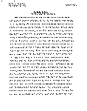 | 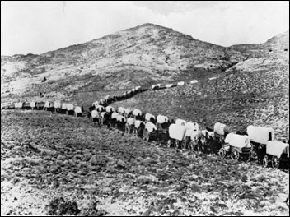 | 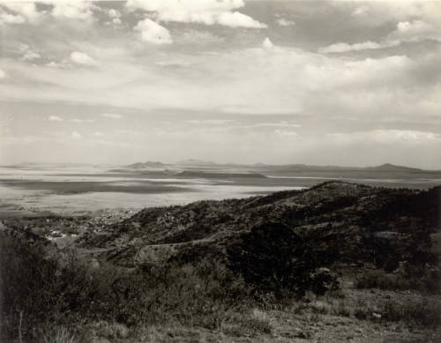 | 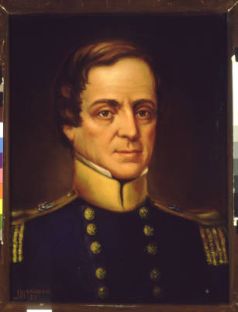 | 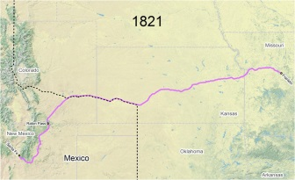 | 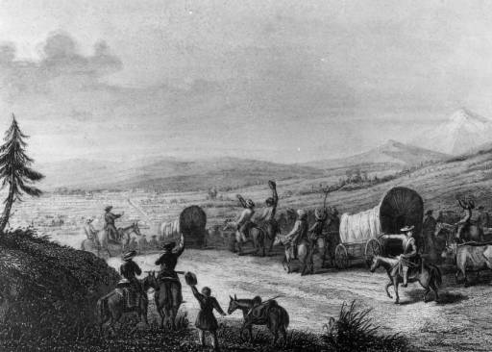
https://www.loc.gov/item/wpalh001186/ | https://www.nps.gov/nr/twhp/wwwlps/lessons/117glorietaraton/117glorietaraton.htm | http://digital.denverlibrary.org/cdm/singleitem/collection/p15330coll22/id/77366/rec/2 | http://digital.denverlibrary.org/cdm/singleitem/collection/p15330coll21/id/3540/rec/17 | https://www.nps.gov/safe/learn/historyculture/map-timeline.htm | http://digital.denverlibrary.org/cdm/singleitem/collection/p15330coll22/id/13281/rec/2

View of Colorado from Raton Pass, 1943 | Main Street Trinidad, CO, c. 1870 | Railroad Tunnel under Raton Pass | Map of Trinidad, Colorado, 1882 | National Register Nomination Form for Raton Pass, October 15, 1966 | East of Willow Creek, looking north along the early pack route
Color photograph of the view into Colorado northbound on Raton Pass, taken in 1943. | Black and white photograph of the dirt road serving as the “main street” for the rugged settlement of Trinidad in the 1870’s. Trinidad was the settlement at the northern end of the pass. | An Amtrak passenger train emerges from the tunnel under Raton Pass. Rail travel revolutionized the west, especially along Colorado’s mountain routes. | A panoramic map of Trinidad, Colorado shortly after statehood, with the grid layout of streets and structures typical of a US style settlement. | The nomination form contains a complete description of the route through Raton Pass, boundaries of the nominated area, history of the region and four photos. | Photo 3 in the series of photos included in the nomination form. The photo contains the vantage to observe the original pack trail over Raton Pass.

As New Mexico integrated into the United States, achieving statehood in 1912, travel across Raton Pass became more regular. From a risky wagon-road to a railroad gateway, the pass connected the eastern parts of both states. | The town of Trinidad is the first city north of Raton Pass, and was included in Colorado upon statehood. Like the name of the town, which means “trinity” in Spanish, the adobe buildings in this photograph indicate the town’s Hispanic origins. It is strikingly rugged, and like transportation on the pass, developed with the times and increasing development in the area. | The Atchison, Topeka, & Santa Fe Railroad won the race to build the first railroad over Raton Pass in 1878. Because of the harsh winter weather at over 7,000 feet, they built a tunnel a year later. Rail travel made rugged terrain like Raton Pass much safer and more efficient, tightening cultural and economic ties between Colorado and New Mexico. | In contrast to the dusty main street shown in the photograph of main street from a previous decade, this map shows how developed and Americanized the town of Trinidad became in the late 1800s. Raton Pass played its role in growing Trinidad, and the town increased demand for safe, reliable transportation over the pass. | The significance of the selection of Raton Pass to be included in the National Register contains several categories commerce, the military, transportation and exploration/settlement.  The periods of significance encompass 1821 to 1899. | The four photos contained in the nomination illustrate the rugged terrain of Raton Pass. They provide an understanding of the many of the difficulties in using Raton Pass in the past.
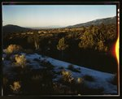 | 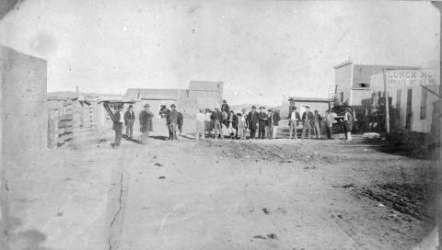 | 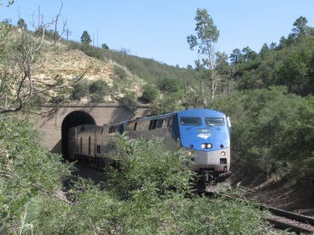 | 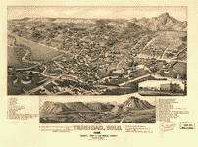 | 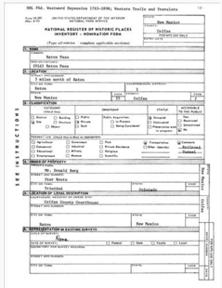 | 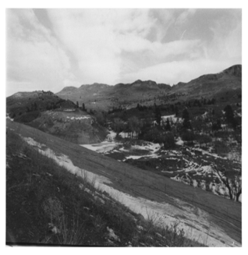
https://www.loc.gov/item/fsa1992001382/PP/ | http://coloradoencyclopedia.org/image/main-street-trinidad-1870s | http://coloradoencyclopedia.org/image/railroad-tunnel-under-raton-pass | https://www.loc.gov/item/75693144/ | https://npgallery.nps.gov/NRHP/AssetDetail?assetID=8eda3297-45d9-4930-b424-4eedc4214e0f | https://npgallery.nps.gov/NRHP/GetAsset/8fb61cb4-6375-4b23-a33a-245e57103681/?branding=NRHP

Foundations Annotations
Curriculum Connections
History
Geography
Language Arts
Curriculum Standards
CO State History Standard 1: Formulate appropriate hypotheses about United States history based on a variety of historical sources and perspectives. (Eighth Grade)
- Use and interpret documents and other relevant primary and secondary sources pertaining to United States history from multiple perspectives.
- Analyze evidence from multiple sources including those with conflicting accounts about specific events in United States history.

CO State Geography Standard 1: Use geographic tools to analyze patterns in human and physical systems. (Eighth Grade)
- Describe the nature and spatial distribution of cultural patterns.
- Recognize the patterns and networks of economic interdependence.
- Explain the establishment of human settlements in relationship to physical attributes and important regional connections.

CO State Reading, Writing and Communications Standard 2: Quality comprehension and interpretation of informational and persuasive texts demand monitoring and self-assessment. (Eighth Grade)
- Use key ideas and details to cite the textual evidence that most strongly supports an analysis of how a text makes connections among and distinctions between individuals, ideas, or events.

Content and Thinking Objectives
Students will be able to:
- evaluate how innovation in transportation changed Colorado.
- explain the impact of mountain passes on commerce and settlement in Colorado.
- analyze how details help establish the main idea of a piece of primary source text.
- analyze how a text makes connections among and distinctions between individuals, ideas, or events.

Inquiry Questions, Activities and Strategies
Inquiry Questions
How can physical barriers lead to cultural barriers?

How have mountain passes affected Colorado’s settlement and development of the built environment?

How can details form or support the main idea of a text?

Inquiry Activities
Close read Mary Burleson’s account of traveling over Raton Pass in a caravan under military guard. Then show students the photograph of the wagon train along the Santa Fe Trail, the modern Raton Pass railroad tunnel, and the NGIS maps. What eras do these photographs represent in Colorado history? Depending on grade level, ask students to put the images in order or narrate the chronology formed by the diary, images and maps.

After viewing the sources, ask students to predict whether Raton Pass would become more or less important as Colorado achieved statehood and grew economically.

Close read Mary Burleson’s account of traveling in a wagon caravan over Raton Pass. Highlight or underline the most descriptive passages. As a class, discuss the piece and summarize the main idea.

Assessment Strategies
Depending upon how one uses the resources and which standards are chosen, assessment can take many forms. For example?

CO State History Standard 1 (a, b) (Eighth Grade) After close reading Mary Burleson’s account and chronologically ordering the primary source images, ask students to look carefully at the primary source photographs. If you were a reporter from England, what details would you include in your notebook for writing your news story? How would you describe the environment, the people and the hardships for your readers?

Ask students to write their own diary entries of a) wagon, b) train, and c) highway travel over Raton Pass. Include: cultural transitions, physical dangers.

After the close reading of Mary Burleson’s diary and the class discussion of its main idea, share the passages you underlined. Why do you think Burleson chose to use a wealth of detail in this section?

What do you think were the greatest difficulties for Mary Burleson on her journey?

Write a journal entry about a difficult journey in your life. What details did you choose to include? How do these details help your reader understand what was challenging for you?

CO State Geography Standard 1 (b, c, d) (Eighth Grade) Using the primary sources, give students blank topographic maps. Ask them to draw maps predicting where U.S. settlement would take place in Territorial Colorado based on the locations of passes, rivers, and existing Native American and Hispanic settlements.

Other Resources
Web Resources
National Register of Historic Places Homepage: https://www.nps.gov/nr

Raton Pass Scenic Highway Nomination for NPS Register: http://www.nmhistoricpreservation.org/assets/files/NM_Colfax-County_Raton-Pass-Scenic-Highway.pdf

Colorado Encyclopedia: http://coloradoencyclopedia.org/article/raton-pass-0

The National Parks Service: https://www.nps.gov/nr/travel/american_latino_heritage/Raton_Pass.html

Library of Congress: https://www.loc.gov/search/?in=&q=raton+pass&new=true&st=

Raton Pass Nomination form for National Register of Historic Places: https://npgallery.nps.gov/NRHP/GetAsset/8eda3297-45d9-4930-b424-4eedc4214e0f?branding=NRHP

Colorado Encyclopedia – Santa Fe Trail: https://coloradoencyclopedia.org/article/santa-fé-trail-0

National Park Service – Santa Fe Trail: https://www.nps.gov/safe/index.htm
Secondary Sources
Jared V. Harper and John R. Signor, Santa Fe’s Raton Pass, 2nd ed. (Midwest City, OK: Santa Fe Railway Historical and Modeling Society, 2010).
Anne F. Hyde, Empires, Nations and Families: A History of the North American West, 1800–1860 (Lincoln: University of Nebraska Press, 2012).
Stephen G. Hyslop, Bound for Santa Fe: The Road to New Mexico and the American Conquest, 1806–1848 (Norman: University of Oklahoma Press, 2002).

Secondary Sources (continued)
Janet Lecompte, “The Mountain Branch: Raton Pass and Sangre de Cristo Pass,” in The Santa Fe Trail: New Perspectives, special issue of Essays and Monographs in Colorado History, no. 6 (1987).
George H. Drury, Santa Fe in the Mountains: Three Passes of the West: Raton, Cajon, and Tehachapi (Waukesha, WI: Kalmbach, 1995).
Preservation Connection
Raton Pass has a long and significant history as a thoroughfare for early traders and travelers on the Santa Fe Trail. The exploration and settlement of southern Colorado and Northern New Mexico, transportation and commerce and use for military purposes distinguish this rugged byway and contribute to its importance. While many accounts of various events and activities related to the pass endure through the written record, time and technology have erased much of the physical evidence. The best preserved remains of the Raton Pass part of the Santa Fe Trail exist on the “saddle” or summit of the pass.
Today, while travelling the Raton Pass Scenic Highway that links Trinidad, CO to towns and cities in northern New Mexico, one can imagine the same journey 150 years in the past.
Preservation Inquiry Questions
Based on the National Register criteria, why is the Raton Scenic Highway significant?
What can historic resources like Raton Pass and the Raton Scenic Highway teach us about the past? Why is important to preserve them?
What do students gain from learning about historic transportation corridors?
How do modern transportation routes reflect the economic and political patterns of the past?
How can historic preservation teach us about the everyday lives of people in the past?

Working together to tell the story of our state!

Developers


Sponsors


Partners
