Title | Lindenmeier Folsom Site
Developed by | Sally Purath, Instructor, Osher Lifelong Learning Institute
Grade Level | 4 – 12
Essential Questions | What does the Lindenmeier Folsom Site tell us about the lives of Paleo-Indians 11,000 years ago?  Why is this Colorado Paleo-Indian site famous nationwide?
Contextual Paragraph | The Lindenmeier Folsom Site, listed in the National Register of Historic Places on May 16, 1984, is one of the most famous prehistoric sites in the United States, having been the first Paleo-Indian campsite to be excavated. Most of what is known about Folsom peoples is based on this rich archaeological site. It reveals much about their tool production, domestic living practices, and social organization. It shows evidence that other nomadic people (the Plano Culture) occupied the region for 13,000 years after the Folsom Culture.  The Lindenmeier Folsom Site had both a campsite and a kill site. Either a single camp made up of multiple groups of twenty to forty people occupied the site or numerous groups could have returned there seasonally.  The campsite had clusters of stone and bone debris that were work areas where they made Folsom style points and other tools, cooked food, cleaned, made animal hides into leather, and made clothes. The remains included the bones of extinct bison, stone tools, and an assemblage of beads including drilled marine shells that must have been carried 800 miles from their place of origin.  The kill site had the remains of nine bison, a camel bone, and meat processing tools with no signs of habitation. The area was regarded as desirable because of access to water and resources that attracted game animals and the men who hunted them.  The site was well preserved because it was buried under twelve to fifteen feet of sediment and silt. Located in an arroyo (gully formed by a brook or a stream), it was revealed by water washing it until the edges appeared. Local residents Judge C.C. Coffin and his son A.L Coffin discovered the site in 1924 on the ranch of William Lindenmeier located just north of Fort Collins. Dr. Frank H.H. Roberts, Jr. of the Smithsonian Institute excavated it from 1935-1940. Artifacts from the site are held by the Smithsonian Institution, the Denver Museum of Nature and Science, the Fort Collins Museum of Discovery, and in private collections. The site is currently owned by the city of Fort Collins and was incorporated into the Soapstone Prairie Natural Area. It is open for public visitation from March 1 to November 30 each year.

Resource Set
Arroyo Surrounding the Lindenmeier Site, north of Ft. Collins, CO | Folsom points from Area I-Lindenmeier Site, Northern CO | Three views of a cast of a Folsom Point from the Lindenmeier Site | First Excavation in the Arroyo at the Lindenmeier Site, Northern CO (1934) | Excavation Showing Dark Midden Layer, Lindenmeier Site, Northern CO | National Register of Historic Places Multiple Property Documentation Form, June 15, 1990
The environment surrounding the Lindenmeier site. It is at the intersection of three major physiographic zones; Rocky Mountain front range, Colorado Piedmont and the High Plains. | These drawings illustrate 10 of the 59 complete fluted Folsom points found on the Lindenmeier site. They also illustrate some of the style variations that were caused from breaking and resharpening.  The different styles of bases may be a reflection of several different people making them. | This picture shows three views of a cast of a Folsom point that was discovered on the Lindenmeier site. The cast was made sometime in the 1960s or ‘70s. This is an excellent example of the "classic" Folsom point that has wide and full flute flake removals and fine pressure flaking along the edges. This point (cast) measures 1 13/16 inches (4.6 cm) long. | This picture shows the first 1934 excavation where Frank Roberts opened up an area in the arroyo (dry gully) where he discovered a deeply buried concentration of bones and stone artifacts that proved to be a Folsom occupation level. The excavation was referred to as the “Big Pit.” | The most important discovery at Lindenmeier was a Folsom habitation component in the form of a distinctively dark colored midden (an old dump for domestic waste). This was found at varying depths over a wide area. In fact, in some areas it was eroded to the surface.  These are the find spots that enabled collectors to discover the site. | This nomination is for Prehistoric Paleo-Indian Cultures of the Colorado Plains.  It contains detailed information on the Clovis, Folsom and Plano Cultures delineating the chronological relationship among the three cultures.
The photo of the arroyo illustrates how the site was buried and preserved for thousands of years before water eventually eroded and revealed it. | These ten Folsom points were recovered from a location on the site known as area I. Area I is situated on the western portion of the site. | NOTE: The term “flake” refers to a piece of hard stone chipped off and used as a tool. For information on pressure flaking see https://www.youtube.com/watch?vVbiw8lwmKk | The excavation then moved to an area above the arroyo designated as area I. Area I is situated on the western portion of the site. | It was generally encapsulated under several feet of ancient alluvial (water deposited) sand, clay and gravel. | The Folsom Culture is discussed in great detail in Section F, pages 14 – 19.

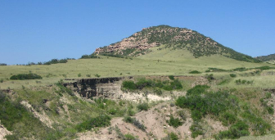 | 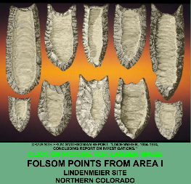 | 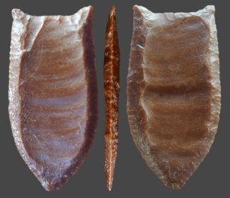 | 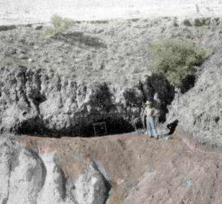 | 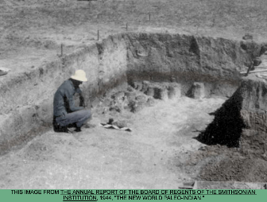 | 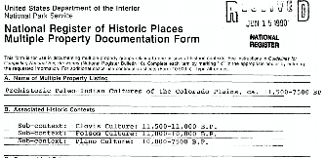
https://en.wikipedia.org/wiki/Lindenmeier_Site | http://lithiccastinglab.com/gallery-pages/2012marchlindenmeiersitepage1.htm | http://lithiccastinglab.com/gallery-pages/2012marchlindenmeiersitepage1.htm | http://lithiccastinglab.com/gallery-pages/2012marchlindenmeiersitepage1.htm | http://lithiccastinglab.com/gallery-pages/2012marchlindenmeiersitepage1.htm | http://www.historycolorado.org/sites/default/files/files/OAHP/crforms_edumat/pdfs/615.pdf

Folsom Tools from the Lindenmeier Site, Northern CO | Folsom Tools from the Lindenmeier Site, Northern CO | National Register of Historic Places Nomination Form for the Lindenmeier Site  May 16, 1984
Tools are discussed in great detail in Section F, Page 15. | Tools are discussed in great detail in Section F, Page 15. | The form includes detailed information that provided the basis for the 1990 Prehistoric Paleo-Indian Nomination.

Figures a and b are bifaces. Figures c – e are distal edge tools. Figure f is a double edge tool. | Figures g – h are notches. Figures i– k are tips. | The Lindenmeier Site is considered to be one of the earliest known manifestations of Folsom Culture.
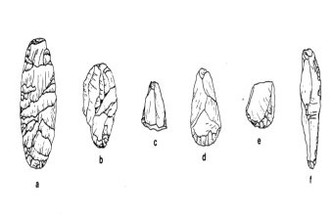 | 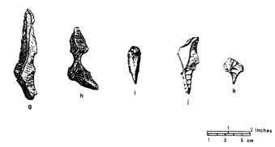 | 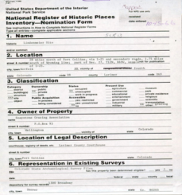
http://www.historycolorado.org/sites/default/files/files/OAHP/crforms_edumat/pdfs/615.pdf | http://www.historycolorado.org/sites/default/files/files/OAHP/crforms_edumat/pdfs/615.pdf | Nomination form is not yet digitized. Much of the information can be found in the Prehistoric Paleo-Indian nomination.

Foundations Annotations
Curriculum Connections

History

Geography

Curriculum Standards

CO State Geography Standard 2: Explain and interpret geographic variables that influence the interaction of people, places, and environments. (High School)

CO State Geography Standard 3: The interconnected nature of the world, its people and places. (High School)

CO State Geography Standard 1: Use geographic tools to analyze patterns in human and physical systems. (Eighth Grade)

CO State Geography Standard 2: Conflict and cooperation occur over space and resources. (Eighth Grade)

CO History Standard 2: The historical eras, individuals, groups, ideas, and themes in Colorado history and their relationships to key events in the United States. (Fourth Grade)

CO State Geography Standard 2: Connections within and across human and physical systems are developed. (Fourth Grade)

Content and Thinking Objectives

Students will be able to:
- explain why the Lindenmeier Folsom Site is so important to the understanding of Paleo-Indian peoples 11,000 years ago locally, nationally, and internationally.
- compare and contrast Folsom points with projectiles from other time periods.
- analyze how discarded tools and bones can reveal knowledge of how people lived thousands of years ago.
- explain how archeology sites can both be preserved and revealed by geographic and environmental factors.

Objectives are based on the Colorado Department of Education Content Connections located at:
https://www.cde.state.co.us/contentareas/contentconnections/5gr_changetransform

The Colorado Department of Education Prepared Graduate Competencies at:
https://www.cde.state.co.us/cosocialstudies/cas-ss-corrections

Inquiry Questions, Activities and Strategies

Inquiry Questions
What is the significance of this site to archaeologists?

How does the Folsom period contribute to the larger understanding of people in other time periods?

What was the process of preservation of this historic site?

What are the similarities and differences between the different types of projectile points found in Colorado?

Inquiry Activities
Ask students to research Paleo-Indian Folsom culture and complete a Venn diagram comparing their way of life to other Paleo-Indians (Clovis and Plano) living in Colorado.

Compare Folsom projectile points with ones made by other Paleo-Indians who lived Colorado.

Ask students to identify the institutions that might be informed if they discovered an ancient archaeology site to ensure it would be properly excavated and preserved.

Activity/Strategy:https://www.cde.state.co.us/cosocialstudies/instructionalstrategies

Assessment Strategies

Depending upon how one uses the resources and which standards are chosen, assessment can take many forms. For example:

CO Geography Standard 2: (High School) Explain the geographic variables that influenced the discovery of the Lindenmeier Site.

CO Geography Standard 3: (High School) Research the artifacts found at the Lindenmeier Site and explain how such items as camel bones and marine shells could have gotten to pre-historic Colorado.

CO Geography Standard 2: (High School) Examine the projectile points pictured in the resource set and theorize how the making of these points affected the daily life of the Folsom people over time. Share your findings in a presentation for your group or class.

Assessment Strategies (continued)

CO Geography Standard 3: (High School) Consider the factors that caused groups of Paleo-Indians to both live in small nomadic groups and also to come together seasonally. Create a digital presentation to share your thinking.

Grade CO Geography Standard 1: (Eighth Grade) Using maps and pictures of the area around the Lindenmeier Folsom Site, analyze why nomadic peoples would choose to return to the site regularly for thousands of years. Create a chart showing their reasons for returning.

Grade CO Geography Standard 1: (Eighth Grade) Make an argument to convince friends who discovered a large cache of projectile points why it is important to report this finding to an institution that will preserve them rather than keep the points for themselves.

Grade CO Geography Standard 2: (Eighth Grade) Make a chart that illustrates how cooperation among various tribal groups could help and also cause harm to Paleo-Indian Folsom people.

CO Geography Standard 2: (Fourth Grade) Write a story from a Colorado Paleo-Indian man’s and/or woman’s point of view about what life was like living in the area at the Lindenmeier Folsom site about 11,000 years ago.

Other Resources
Web Resources

National Register of Historic Places Nomination form for Prehistoric Paleo-Indian Cultures of the Colorado Plains from the Office of Archaeology and Historic Preservation at History Colorado: http://www.historycolorado.org/sites/default/files/files/OAHP/crforms_edumat/pdfs/615.pdf

“Lindenmeirer Folsom Site-Photos and Artifacts” The Lindenmeier Site, February 29, 2012: http://lithiccastinglab.com/gallery-pages/2012marchlindenmeiersitepage1.htm

“Lindenmeier: A Folsom Man Site” Fort Collins Images, April 2, 2017: https://fortcollinsimages.wordpress.com/2017/04/02/lindenmeier-a-folsom-man-site/

“Lindenmeier Site Sheds Light on Ancient Folsom:” Coloradoan, July 20, 2016: http://www.coloradoan.com/story/life/2016/07/11/fleming-lindenmeier-site-sheds-light-ancient-folsom/86926412/

Secondary Sources

Jason M. LaBelle, "Lindenmeier Folsom Site,"Colorado Encyclopedia, last modified December 28, 2017, http://coloradoencyclopedia.org/article/lindenmeier-folsom-site

Brenda Martin, Ph.D., Kate Bowell, Treloar Tredennick Bower, and Terry Burtonk The Excavation of Lindenmeier: A Folsom Site Uncovered 1934-1940 (Fort Collins, CO, 2009). This booklet can be also found online as a PDF at http://fcmod.org/wp-content/uploads/2013/lindenmeier.pdf

Preservation Connection

The Lindenmeier Folsom Site, listed in the National Register of Historic Places on May 16, 1984, is one of the most famous prehistoric sites in the United States, having been the first Paleo-Indian campsite to be excavated. Most of what is known about Folsom peoples is based on this rich archaeological site. It reveals much about their tool production, domestic living practices, and social organization. It shows evidence that other nomadic people (the Plano Culture) occupied the region for 13,000 years after the Folsom Culture.

The site was well preserved because it was buried under twelve to fifteen feet of sediment and silt. Located in an arroyo (gully formed by a brook or a stream), it was revealed by water washing it until the edges appeared. Local residents Judge C.C. Coffin and his son A.L Coffin discovered the site in 1924 on the ranch of William Lindenmeier located just north of Fort Collins. Dr. Frank H.H. Roberts, Jr. of the Smithsonian Institute excavated it from 1935-1940. Artifacts from the site are held by the Smithsonian Institution, the Denver Museum of Nature and Science, the Fort Collins Museum of Discovery, and in private collections. The site is currently owned by the city of Fort Collins and was incorporated into the Soapstone Prairie Natural Area. It is open for public visitation from March 1 to November 30 each year.

Preservation Inquiry Questions:

Why is this site worth preserving?

What is the difference between an archaeologist and a paleontologist?

Is an archaeologist a preservationist? Why or why not?

Preservation Inquiry Questions (continued)

How does preserving this site tell an important story about the history of Colorado?

Who has taken on the role as preservationist of this site?

Working together to tell the story of our state!

Developers


Sponsors


Partners
