Title | Georgetown-Silver Plume Historic District
Developed by | Cathy Fuller, Middle School Teacher, Guardian Angels School, Denver CO
Grade Level | 4
Essential Question | Who were the early settlers of Georgetown and Silver Plume?  How did social class determine the development of each of these towns? And how did this influence the architecture and design of each?  How has this region been able to prosper over time?
Contextual Paragraph | According to the Colorado Encyclopedia, the Georgetown-Silver Plume Historic District is one of the best-preserved historic mining districts in Colorado. Located in the upper Clear Creek Valley, Georgetown thrived as a commercial and professional center, while Silver Plume developed as a diverse town of working-class miners.  The diversities in these two towns provides an excellent opportunity to understand the differences in the cultures tied to the practice in mining throughout Colorado. Silver Plume, home to the men who worked in the mines, is a hodgepodge of different ethnicities. The different sections in the Silver Plume cemetery (organized by religion and ethnicity) offer a greater understanding of who lived and worked in the region.  Similarly, the architecture of homes and other structures in Georgetown speak to the class of those who lived in the town. Significant architectural-style structures found in the Historic District and described in the National Register of Historic Places include Hamill House, Maxwell House, Luedde House, Spencer House, Bowman-White House, Public School, Hotel de Paris, Clear Creek County Court House, the Old Jail and Grace Episcopal Church.  After World War II, this area evolved into a tourist attraction and continues to be a popular destination for Front Range residents. Georgetown, Silver Plume and the Alpine Valley were added to the National Register of Historic Places November 13, 1966.

Resource Set
Georgetown, CO | Georgetown, CO | National Register Nomination for Hamill House Georgetown, CO | Hamill House Georgetown, CO | Hamill House, Georgetown, CO | Hamill House Building Survey
View of downtown Georgetown from 5th Street. The Alpine Hose Firehouse is at the end of the street. c. 1939 | Georgetown Valley facing south toward Guenella Pass. | Placed in the National Register on May 31, 1972, the Hamill house is significant for its Gothic Revival Architecture and Social History. | Hamill House, Argentine and Third Streets, Georgetown, Clear Creek County, CO. | 1951 note on the back of the photo credits Mrs. Edith Wick with the restoration in 1946. The house is now operated as a museum. | Historic American Buildings Survey,  1933 of the Hamill House. Contains documentation, photos, drawings, etc.
Because of efforts by preservationists, the street appears much the same today. The mountains surrounding the city contribute to the historic landscape of the town. | Georgetown is shown nestled in Clear Creek Canyon. The photo illustrates the layout of the town. It was taken by renowned photographer William Henry Jackson c1901. | The nomination form contains 3 high resolution photos of the Hamill House and its grounds. Photos include the solarium, stone stable and carriage house. The form also contains detailed descriptions of the architecture and history of the house and the Georgetown area. | Measured drawing of the Hamill House and grounds. Historic American Building Survey, 1933. | Exterior view of the Hamill House. Acquired by mine owner William A. Hamill in 1874. Additions to the house and grounds were made between 1874 and 1881. Hamill House is listed individually in the National Register for its architectural and historic significance. | The main house is associated with William A. Hamill, who made his fortune through investments in the silver mines in and around Georgetown.

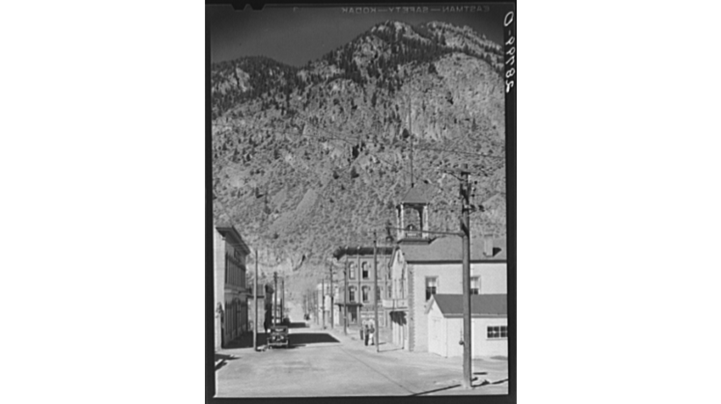 | 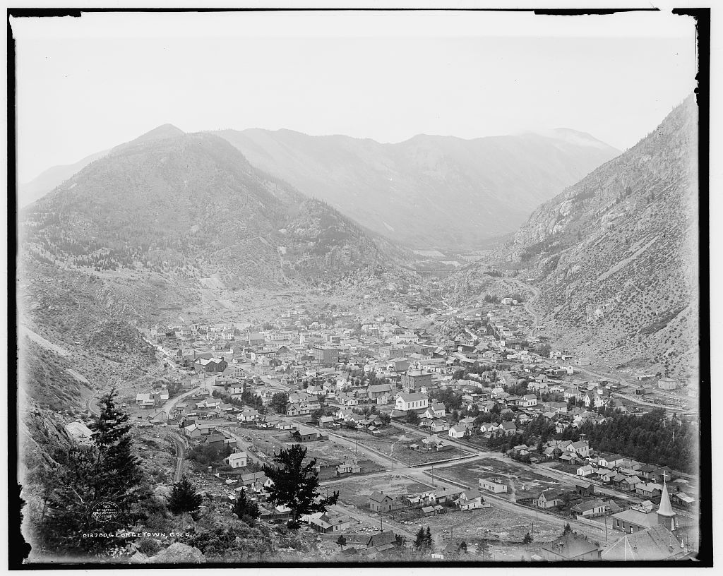 |  | 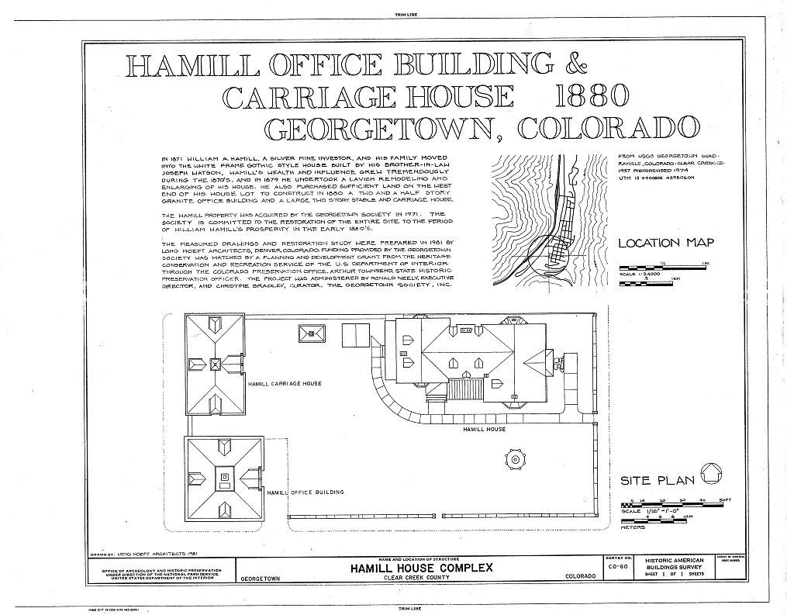 | 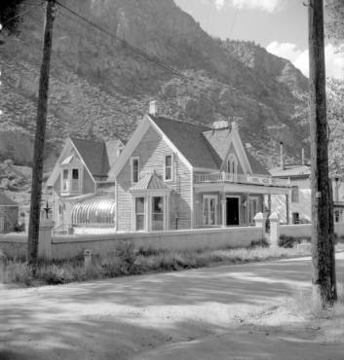
https://www.loc.gov/item/fsa2000010191/PP/ | https://www.loc.gov/item/det1994000624/PP/ | https://npgallery.nps.gov/NRHP/AssetDetail?assetID=da0290b5-11e8-4d2f-bb8b-4229264ed2b4 | https://www.loc.gov/item/co0101/ | http://digital.denverlibrary.org/cdm/ref/collection/p15330coll22/id/2252 | https://www.loc.gov/item/co0102/

Georgetown, east of Rose Street | Silver Plume, CO | Silver Plume School, Main Street, Silver Plume, CO | Silver Plume Methodist Church | Georgetown Alpine Hose Company #2 | Nomination for the Alpine Hose Company #2 in Georgetown, CO
Stereograph view of Georgetown, CO, looking southeast, between 1874 and 1880. | Stereograph view of Silver Plume, CO looking northwest between 1870 and 1879. | Historic American Buildings Survey, 1933. Contains several architectural drawings of the school.  Designed by William Quayle, and built in 1894, it served as a school until 1959. | This Methodist church was built in the 1880s. It is located at Main and Hancock in Silver Plume and is still in use today. | The Alpine Hose Company #2 is two structures with the bell tower being added in 1880 to the Hose House which was built in 1878. | The nomination was added in the National Register on January 25, 1973. It contains both the history of the Hose Company and a description of its architectural elements.

The photo illustrates the layout of the town located in a broad valley that enabled a pattern of streets similar to other small towns in Colorado at this time.  Two story structures, a church with a spire in the background and distinctive residential and business districts speak to the economic level of the town | The central business district is in the foreground, and Republican Mountain and mines are in the background. The haul road is visible cutting across the entire image.  The topography of Silver Plume resulted in structures built in clusters in the narrow valley and along the hills that surround the town. | It reopened as the Silver Plume Historical Museum in 1970.  Quayle's extensive use of glass, symmetry, and strong rounded arches are indicative of the Romanesque style of architecture popular in the late 1880s. The building was meant to be viewed from the front as evidenced by the lack of ornamentation on the side and rear facades. | This Methodist church was built in the 1880s and was originally equidistant between Brownsville and Silver Plume. When the former town declined as the latter boomed, the church was moved a half mile closer to Silver Plume in 1891. | The 1875 two-story false front wood frame building housed the Alpine Hose Company No. 2, one of several volunteer fire companies organized during the late 1800s to protect the community. The distinctive 65-foot wood frame bell tower located at the rear of the building is a highly visible feature within the historic downtown area. | The Alpine Hose Company #2 is significant for its architecture and engineering. What makes it different from other hose companies in the area was the bell tower which was much larger, higher and far more prominent than those of the others
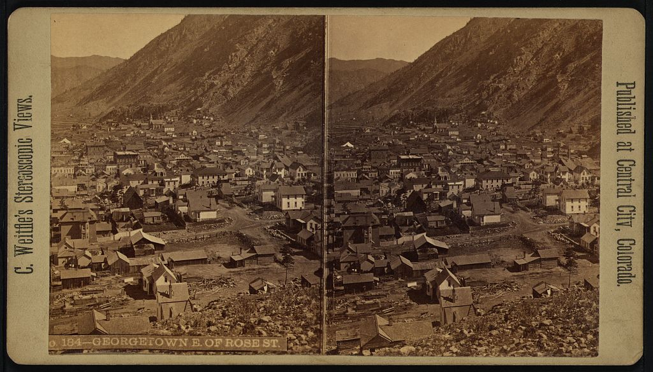 | 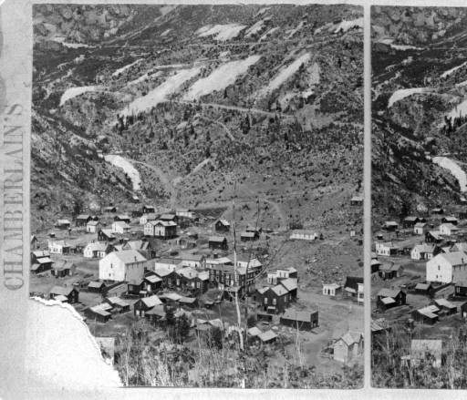 | 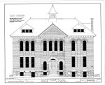 | 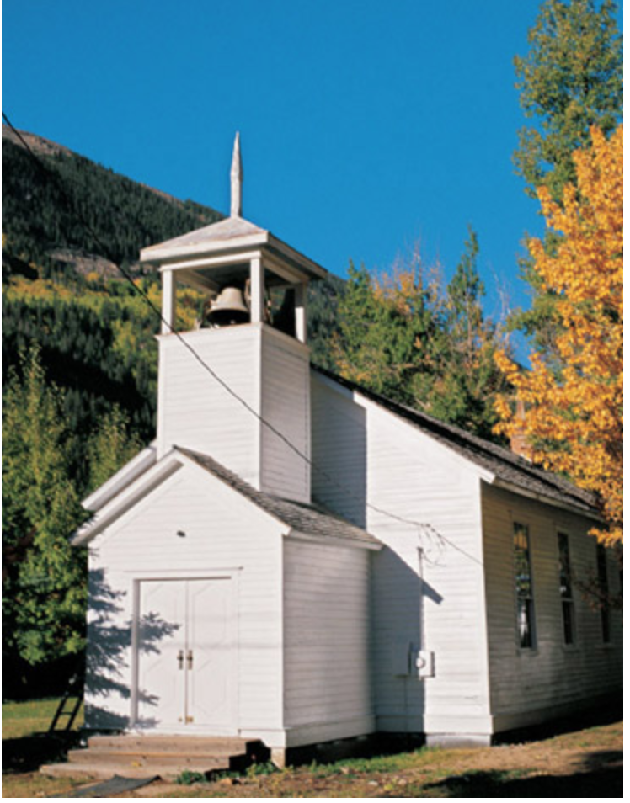 | 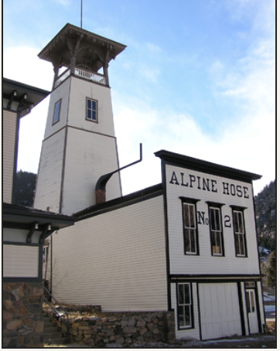 | 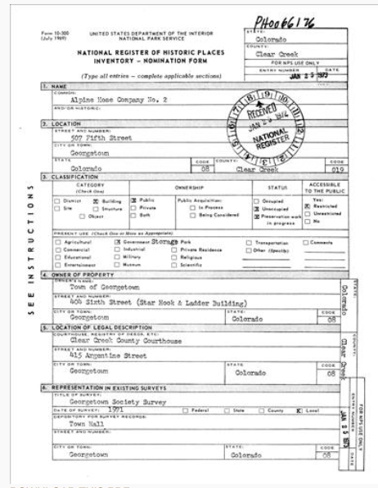
https://www.loc.gov/item/2006680958/ | http://digital.denverlibrary.org/cdm/ref/collection/p15330coll22/id/3719 | https://www.loc.gov/resource/hhh.co0002.sheet?st=gallery | https://erenow.com/common/hiddenhistoryoldwesthauntsofushistory/hiddenhistoryoldwesthauntsofushistory.files/image021.jpg | http://legacy.historycolorado.org/sites/default/files/images/OAHP/GE/5CC12.jpg | https://npgallery.nps.gov/NRHP/AssetDetail?assetID=b38a3a04-5167-47de-91ef-8f9701233431
National Register Nomination for the Georgetown-Silver Plume Historic District, November 13, 1966 | Silver Plume Depot photo from National Register Nomination Form, May 6, 1971 | Interior of the Everett Mine Tunnel, Georgetown-Silver Plume Historic District nominated October 7, 1991 | Exterior view of the Maxwell House, Georgetown, CO c. 1974 | Map of Colorado Territory Embracing the Central Gold Region | Clear Creek County Court House, Georgetown, CO
Nomination form contains 40 photos of the Georgetown-Silver Plume area, the Alpine Valley, Georgetown Loop and I-70. | The depot constructed in 1884 as the terminal point of the CO Central Railroad route from Denver to the Clear Creek mining region. It has since been restored and is part of the Silver Plume train station complex. | The Everett and Lebanon Mine Tunnels National Register nomination form contains, 2 topographical maps and a diagram indicating the drifts, shafts and crosscuts of the two mines. | Construction began in 1870; the house was acquired by B.F. Potter in 1891, who added the tower and decorative elements to the facade. Mr. and Mrs. Frank Maxwell purchased the house in 1891. | Map showing the counties of Colorado and which are considered to have mining stakes. | Photo taken by John Vachon in May 1942 is one of a series of photos taken in Georgetown.
The historic district nomination form contains not only geographic descriptions of the region but a comparison and history of two very different towns in the Alpine Valley. Information about architecture, economics and social class are included | The Silver Plume Depot is a reminder of the excitement and activity that characterized the Clear Creek Mining District in the 19th century.  Constructed of wood, the freight door is visible at the far end of the structure. A bay-type widow is located between the freight door and the entrance. | The Clear Creek Mining District began due to gold strikes. By about 1865 silver became the predominant ore. The mines led in silver-lead production from 1872 to 1894, a year after the collapse of the silver market.  By 1901 both mines were considered “idle” properties by mining directories. | The eclectic style includes a French mansard roof on the left of the facade, Italianate windows, Greek Revival pediments, and Queen Anne patterned shingles. A wood and metal fence is in front of the house, with a hedge, trees. Leavenworth Mountain is visible behind the house. | Relief shown by hachures (Parallel lines used in the hill-shading on maps, their closeness indicates the steepness of the gradient.) c. 1862. | This site also contains Sanborn Fire Insurance maps of the Georgetown area in 1886. These maps illustrate the building materials used in the town. They are wonderfully detailed and contain a wealth of information about Georgetown’s built environment.

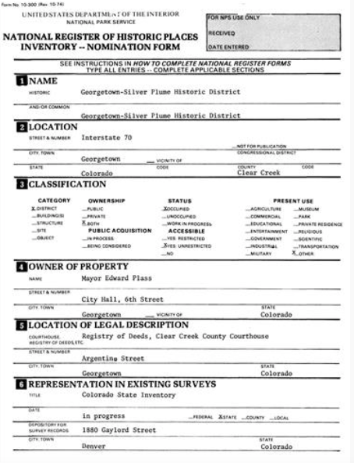 | 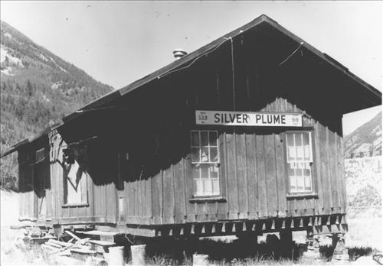 | 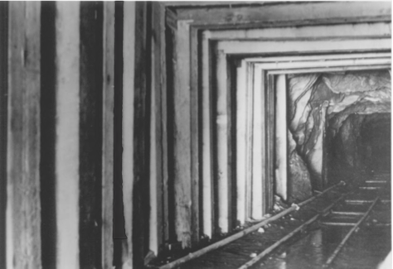 | 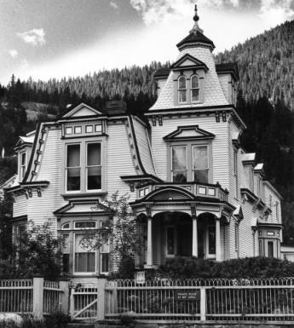 | 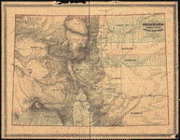
https://npgallery.nps.gov/NRHP/AssetDetail?assetID=6002ace7-d14c-4a56-8fff-ada3d1986f0a | https://npgallery.nps.gov/NRHP/AssetDetail?assetID=d39067ba-1d9e-4706-abf5-915d24a76651 | https://npgallery.nps.gov/NRHP/AssetDetail?assetID=9dc775b9-a263-451d-82da-6312172a52b1 | http://digital.denverlibrary.org/cdm/ref/collection/p15330coll22/id/2235 | https://www.loc.gov/item/2003630493/ | https://www.loc.gov/item/fsa2000046420/PP/

Foundations Annotations
Curriculum Connections

History
Geography

Curriculum Standards

CO State History Standard 1: Organize and sequence events to understand the concepts of chronology and cause and effect in the history of Colorado. (Fourth Grade)
b. Analyze primary source historical accounts related to Colorado history to understand cause-and-effect relationships.
d. Identify and describe how major political and cultural groups have affected the development of the region.

CO State History Standard 2: The historical eras, individuals, groups, ideas and themes in Colorado history and their relationships to key events in the United States. (Fourth Grade)
- Analyze various eras in Colorado history and the relationship between these eras and eras in United States history, and the changes over time.
- Describe interactions among people and cultures that have lived in Colorado.
d. Describe the impact of various technological developments.

CO State Geography Standard 1: Use several types of geographic tools to answer questions about the geography of Colorado. (Fourth Grade)
a. Answer questions about Colorado regions using maps and other geographic tools.
b. Use geographic grids to locate places on maps and images to answer questions.
d. Illustrate, using geographic tools, how places in Colorado have changed and developed over time due to human activity.

CO State Geography Standard 2: Connections within and across human and physical systems are developed. (Fourth Grade)
a. Describe how the physical environment provides opportunities for and places constraints on human activities.
c. Analyze how people use geographic factors in creating settlements and have adapted to and modified the local physical environment .
d. Describe how places in Colorado are connected by movement of goods and services and technology.

Content and Thinking Objectives

Students will be able to:
- describe the people who settled in the Georgetown and Silver Plume Historic District and explain why different people settled in different parts of the region.
- compare the landscape of the area today compared to the time it was settled using the resources from the primary source set.
- explain why the geographic features that made the Georgetown and Silver Plume Valley a place where miners and pioneers settled and how this geography influenced how and what they built.
- describe the changes in the economies from mining to tourism and the importance of preservation in this area to maintain these towns.
Inquiry Questions, Activities and Strategies

Inquiry Activities
Ask students to compare the development of Georgetown and Silver Plume, who settled where and why. How did their buildings compare? Why? What was different?

Using Google Earth and Google Maps, ask students to find existing preserved buildings and describe how they have changed over time, or how they have not changed. What materials were used to successfully preserve buildings? What do these preserved buildings tell us about the towns and people who lived there?

Ask students to overlay historic pictures onto a current map of Georgetown and Silver Plume and make comparisons.

Using the primary sources in the resource set, ask students to write a descriptive paragraph or essay describing the scenery, buildings, and activity of this area at the time it was founded.

Assessment Strategies

Depending upon how one uses the resources and which standards are chosen, assessment can take many forms. For example:

CO History Standard 2 (b) (Fourth Grade) Ask students to describe the interactions between Georgetown citizens and those of Silver Plume.

CO Geography Standard 2 (a, c, d) (Fourth Grade)

How were Georgetown and Silver Plume developed in relation to the mountains surrounding them? How did the geography around the towns impact growth over the years?

Other Resources
Web Resources

National Register of Historic Places: www.nps.gov/nr
National Register – Alpine Hose Company #2: https://npgallery.nps.gov/NRHP/AssetDetail?assetID=b38a3a04-5167-47de-91ef-8f9701233431
National Register – Georgetown-Silver Plume Historic District: https://npgallery.nps.gov/NRHP/AssetDetail?assetID=6002ace7-d14c-4a56-8fff-ada3d1986f0a
National Register – Hamill House: https://npgallery.nps.gov/NRHP/AssetDetail?assetID=da0290b5-11e8-4d2f-bb8b-4229264ed2b4
National Register – Lebanon and Everett Mine Tunnels: https://npgallery.nps.gov/NRHP/AssetDetail?assetID=9dc775b9-a263-451d-82da-6312172a52b1
National Register – Silver Plume Depot: https://npgallery.nps.gov/NRHP/AssetDetail?assetID=d39067ba-1d9e-4706-abf5-915d24a76651
Historic Georgetown: https://www.georgetown-colorado.org/
Town of Georgetown: http://www.town.georgetown.co.us/
Historic Georgetown, Inc. (Preservation): https://www.historicgeorgetown.org/
History Colorado: http://www.historycolorado.org/museums/georgetown-loop-historic-mining-railroad-park%C2%AE
History Colorado Office of Archaeology and Historic Preservation (OAHP): http://www.historycolorado.org/archaeologists/clear-creek-county
Library of Congress: www.loc.gov

Secondary Sources

David Digerness, The Mineral Belt (Volume III) Georgetown; Mining; Colorado Central Railroad; An Illustrated History (Denver: Sundance Books, 1982).

Liston Edgington Leyendecker, Duane Smith, and Christine A. Bradley. The Rise of the Silver Queen: Georgetown, Colorado, 1859-1896 (Boulder: University of Colorado Press, 2005).

Liston E. Leyendecker, The Griffith Family and the Founding of Georgetown (Boulder: University Press of Colorado, 2001).

Preservation Connection

The Georgetown-Silver Plume Historic Mining District possesses remarkable integrity and the historic structures in the two towns are reminiscent of a bygone era. Georgetown, in particular, is unique among Colorado's mining towns. Because the wealth of the mining district was centered here, Georgetown took on a wealthy aura and the buildings show this wealth. Silver Plume, on the other hand, was the work center. Here the majority of mines were located. Homes in Silver Plume are far less impressive than those of the Georgetown. Though the ore was removed from Silver Plume, so was the wealth. This working relationship between the two towns has been cause for much resentment—both past and present.

According to History Colorado, since 1970 Georgetown has been known as Colorado’s “Preservation Queen” because it has maintained many of its historic downtown structures. It has been able to match nearly $3 million in State Historic Funds through a private preservation group known as Historic Georgetown, Inc., created in 1970. It has worked with local government to enact one of the first and toughest sets of preservation ordinances in the state of Colorado. The Georgetown-Sliver Plume historic district has received numerous grants from the State Historic Fund including preservation funds for the Hotel de Paris, the Silver Plume School House/George Rowe Museum, and the Georgetown Loop Railroad.

The Georgetown-Silver Plume Historic District was listed in the National Register of Historical Places November 13, 1966.

What could students learn by visiting the Georgetown-Silver Plume Historic District?

Why might tourists visit Georgetown? What things might a tourist want to do on a visit? How do preservation efforts benefit from tourism?

How might preservation efforts suffer from tourism?

Working together to tell the story of our state?

Developers


Sponsors


Partners


