Title | Cliff Palace, Mesa Verde National Park
Developed by | Laura Douglas, Education ala Carte
Grade Level | 3 – 4
Essential Questions | How can primary sources help us learn about the past and how the people lived at Cliff Palace in what is now Mesa Verde National Park?  What natural resources were used by the Ancestral Puebloan people that lived at Cliff Palace?  How did the natural environment effect the way in which Ancestral Puebloan built their shelters?  Why did the Ancestral Puebloan people migrate from Cliff Palace?
Contextual Paragraph | Mesa Verde National Park is located in Montezuma County, Colorado in the southwestern corner of the state. As of its nomination to the National Register of Historic Places in 1978 it had more than 800 archaeological sites recorded or in the process of inventory. Today there are nearly 5,000 documented sites including about 600 cliff dwellings. Mesa Verde, which means, “green table” was inhabited by Ancestral Puebloans, a branch of the San Juan Anasazi Indians, from about 580 CE to 1300 CE. Today it is the most extensive and well-developed example of prehistoric cliff dwellings. For in depth information about Mesa Verde National Park visit the Colorado Encyclopedia at: https://coloradoencyclopedia.org/article/mesa-verde-national-park.  Archaeologists have identified distinct periods during Mesa Verde’s habitation based on artifacts and ruins discovered there. The Cliff Palace was constructed during the Pueblo III period. According to dendrochronology (tree-ring dating), Cliff Palace construction and refurbishment happened from 1190 CE – 1260 CE, although most was done during a 20-year span. A comprehensive account of the history of the Cliff Palace is available at: https://coloradoencyclopedia.org/article/cliff-palace. (This article is leveled for 4th, 8th, and 10th grade readers.)  Mesa Verde Cliff Palace has over 150 individual rooms, towers as high as 4-stories and more than 20 underground ceremonial chambers known as kivas. At its peak, it was the home of 100 Ancestral Puebloans. Because of its size, it is thought that Cliff Palace was a social, administrative site with high ceremonial usage.  These cliff dwellings were constructed of sandstone, wooden beams and mortar. Many of the walls were decorated with pink, brown, red, yellow and white earthen plasters. Unfortunately, the wall decorations have been the first thing to erode.

Contextual Paragraph (continued)
The people who lived at Cliff Palace were farmers who worked fields on the mesa tops. They used dry-land farming techniques to grow corn, squash and beans. Ancestral Puebloans got water from the nearby seep springs and the Mancos River, which is located several miles away from Cliff Palace. Archeologists have documented farming terraces and dams built in natural drainages and water diversion systems. The people who once lived in this area efficiently captured and stored the small amount of available water needed to meet their needs.

Resource Set
Cliff Palace, 1899 | Fewkes Canyon Seep Spring | Example of chinking at Cliff Palace | Overview of Cliff Palace from across the canyon | Map of Mesa Verde National Park | Chapin Mesa, map, Mesa Verde NP
On December 18th, 1888, two cowboys, Richard Wetherill and Charlie Mason, were riding across the mesa top looking for stray cattle. These ranchers from the Mancos Valley may have been the first white men to see what they called "Cliff Palace." Over the next 18 years, these same men, as well as various exploring and tourist parties made expeditions into Mesa Verde. | Residents of Cliff Palace carried water to the dwelling from several nearby springs. Although there is a small seep located near the entrance of Cliff Palace, it is unknown if it supplied enough water for all of the people who lived here. The closest spring today is in Fewkes Canyon near Sun Temple. | The Ancestral Pueblo people shaped each sandstone block using harder stones collected from nearby river beds. The mortar between the blocks is a mixture of local soil, water and ash. Fitted in the mortar are tiny pieces of stone called "chinking." Chinking stones filled the gaps within the mortar and added structural stability to the walls. | Cliff Palace is the largest cliff dwelling in North America. Constructed from sandstone bricks and a mortar of clay, ash, and water, these buildings have been standing for more than 800 years as a testament to the architectural skills of Ancestral Pueblo people. | Map of Mesa Verde National Park | Map of Chapin Mesa by the National Park Service, US Department of the Interior

No laws protected the sites at the time, and earlier visitors often removed artifacts or defaced the sites. Protection for the dwellings came with the establishment of Mesa Verde National Park in 1906. | Fewkes Canyon is named after Jesse Walter Fewkes. In 1909, Jesse Walter Fewkes of the Smithsonian Institution excavated and stabilized Cliff Palace. | Similar construction techniques were used at other nearby Ancestral Puebloan sites, such as Hovenweep and Lowry Pueblo. | The massive alcove that houses Cliff Palace is 89 feet deep and 59 feet high. | This map shows cliff dwellings and mesa top dwellings and identifies which are visible from the road and which are open to the public. Also included are distances to each, as well as facilities available at Mesa Verde. | This map shows the different cliff dwellings around Chapin Mesa and the distances between each, as well as clearly marked places to view the ruins.
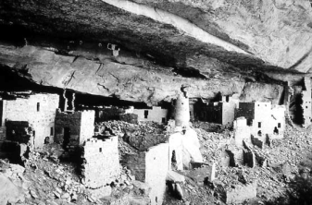 | 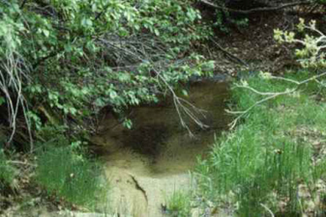 | 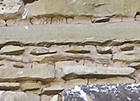 | 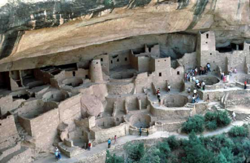 | 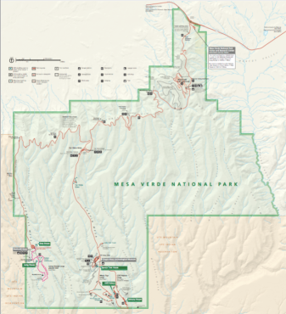 | 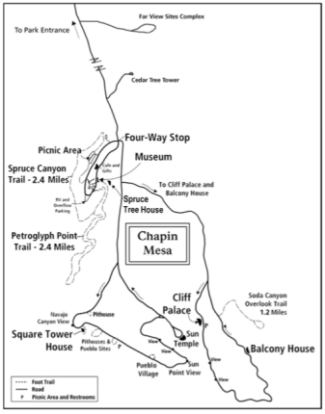
https://www.nps.gov/meve/learn/historyculture/cd_cliff_palace_discovery.htm Image 1 | https://www.nps.gov/meve/learn/historyculture/cp_cliff_palace_fewkes.htm | https://www.nps.gov/meve/learn/historyculture/images/cp_chinking.jpg | https://www.nps.gov/meve/learn/education/images/ag_cliffpalace.jpg | https://www.nps.gov/carto/app/#!/maps/alphacode/MEVE | https://www.nps.gov/meve/planyourvisit/upload/map_chapin.pdf

Cliff Palace floor plan | Mural 30, Cliff Palace, Mesa Verde National Park | Cliff dwelling courtyard with kiva entrances | View of wall painting in Cliff Palace Tower | Sandal woven from yucca plant | Shell necklace
Report to the Superintendent of the Mesa Verde National Park and J. Walter Fewkes, in charge of excavation and repairs of ruins to the Secretary of the Interior 1909. | Mural 30, on the third floor of a rectangular tower at Cliff Palace, is painted in red against a white wall. The mural includes geometric shapes that are thought to portray the landscape. This mural is similar to murals inside other cliff dwellings, including Spruce Tree House and Balcony House. | While kivas were used for different purposes, their roofs served as a central courtyard. Doors bordering the courtyard were small because people were shorter then than they are today, and because the smaller entryways kept rooms warmer at night, especially during winter months. | Ancestral Puebloans used layers of colorful plaster to decorate their walls. Designs were often painted on with a yucca brush or fingers using paint made from a combination of colored pigments mixed with water. | Sandals woven from yucca fiber were typical footwear of the Mesa Verde people. Yucca fibers were boiled or soaked and then pounded to expose the inner fibers. These fibers were also used to produce rope, snares, mats, baskets, belts, and much more. | The Ancestral Puebloans were artists and traders – trading with a network of tribes to bring shells such as these from the Gulf of California to wear as ornamental jewelry.
Connected rooms fanned out around these plazas, creating a housing unit. One room, typically facing onto the plaza, contained a hearth. Family members most likely gathered here. Other rooms located off the hearth were most likely storage rooms, with just a small opening. Cliff Palace features some unusual structures, like a circular tower, and archaeologists are not certain as to the exact use of the tower. | Scholars have suggested that the red band at the bottom symbolizes the earth while the lighter portion of the wall symbolizes the sky. The top of the red band, forms a horizon line that separates the two. There are also triangular peaks, perhaps mountains on the horizon line. The rectangular element in the sky might relate to clouds, rain, or the sun and moon. The dotted lines might represent cracks in the earth. | To enter the kiva, one must climb a ladder down into the earth. Some scholars theorize that this served as a reminder of where Ancestral Puebloans believed they came from. It also provided the possibility for people to be cleansed by ritual smoke as they entered the kiva. | This painting was found inside a room at Cliff Palace, and includes triangles possibly representing mountains, and geometrical designs common to Ancestral Puebloan art. | The large green fruit of the yucca plants were used as food and the yucca roots were used as soap or shampoo. | Due to extensive trading as well as local production, many different types of jewelry have been found at Mesa Verde sites. Other trade items found in the cliff dwellings include Macaw feathers from Central America, turquoise from New Mexico, and copper bells from Mexico.
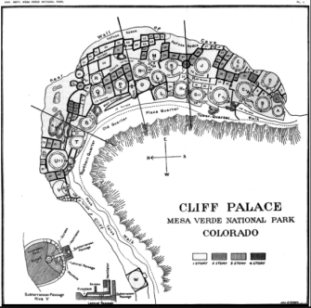 | 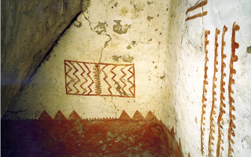 | 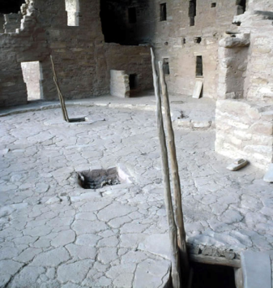 | 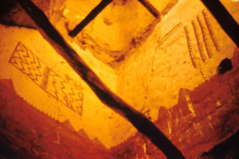 | 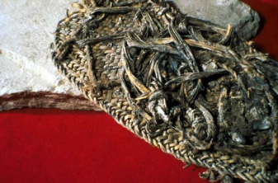 | 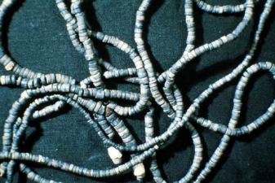
https://www.nps.gov/parkhistory/online_books/reports/meve/1909a.jpg | https://www.nps.gov/meve/learn/education/classrooms/lp_the-dirt-on-ancestral-puebloan-plaster.htm | https://www.nps.gov/meve/learn/education/images/ag_courtyardkiva.jpg | https://www.nps.gov/meve/learn/education/images/ag_wallpainting.jpg | https://www.nps.gov/meve/learn/education/artifactgallery_sandal.htm | https://www.nps.gov/meve/learn/education/images/ag_necklace.jpg

Cliff Palace, Mesa Verde, CO | Cliff Palace, Mesa Verde | Cliff Palace from the south | Kiva diagram | "Dismantled towers, and turrets broken," Cliff Palace in the Mesa Verde, CO | Rocky Mountain PBS Colorado Experience “Living West: Water”
Cliff Palace, Mesa Verde, CO, 1911. | Cliff Palace, Mesa Verde, 1898. | Reports to the Superintendent of the Mesa Verde National Park and J. Walter Fewkes, in charge of excavation and repairs of ruins to the Secretary of the Interior, 1909. | Kivas were gathering places and sometimes also places to weave. Pilasters supported a beam-and-mud roof. Entry was by a ladder through a hole in the roof. The small hole in the floor is a sipapu, or symbolic entry to the underworld. | "Dismantled towers, and turrets broken," Cliff Palace in the Mesa Verde, CO,1898. | After settling in southwest Colorado for over 700 years, the Ancient Puebloans of Mesa Verde and Goodman Point suddenly left their cliff dwellings and spring side kivas, leaving behind a variety of archaeological treasures. Published 31 October 2014.

Cliff Palace is the largest cliff dwelling in North America. Constructed from sandstone bricks and a mortar of clay, ash, and water, | The buildings at Cliff Palace have been standing for more than 800 years. This is a testament to the architectural skills of the Ancestral Puebloans. | The buildings ranged from 1 to 4 stories, and some went to the top of the stone ceiling. | The roofs of the kivas were used as courtyards where many daily routines occurred such as women grinding corn or preparing food, and men making tools or weaving cloth. | Prior to the time when Cliff Palace was built, people in the Mesa Verde area used an adobe technique using brick made of clay, sand and straw or sticks. Cliff Palace and the other cliff dwellings of the 13th century were a stone and mortar construction with more decorative elements in the construction and on the objects found inside them. | This 28-minute video provides a detailed description and images from the Four Corners region and a discussion about the Ancestral Puebloan people, agriculture and water. Historians and archaeologists discuss the reasons for this sudden movement.
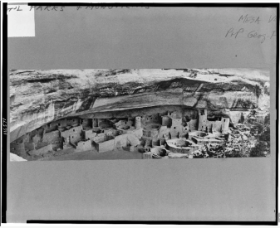 | 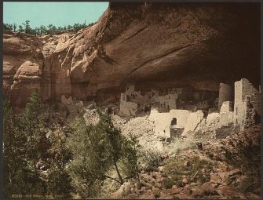 | 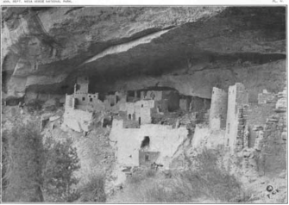 | 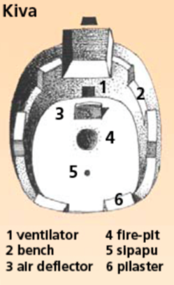 | 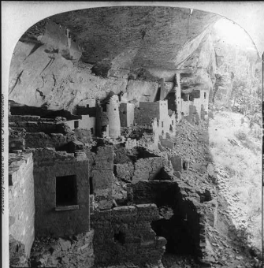 | 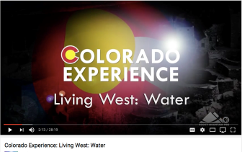
https://www.loc.gov/resource/cph.3c16571/ | https://www.loc.gov/item/2008678195/ | https://www.nps.gov/parkhistory/online_books/reports/meve/1909d.jpg | https://www.nps.gov/meve/learn/education/upload/ancestral_puebloans.pdf | https://www.loc.gov/item/2004679783/ | https://www.youtube.com/watch?v=HYBAkSyiYas

Foundations Annotations

Curriculum Connections

History

Geography

Economics

Curriculum Standards

CO State History Standard 2: People in the past influence the development and interaction of different communities or regions. (Third Grade)
- Describe the history, interaction, and contribution of the various peoples and cultures that have lived in or migrated to a community or region.

CO State Geography Standard 1: Use various types of geographic tools to develop spatial thinking. (Third Grade)
- Read and interpret information from geographic tools and formulate geographic questions.
c. Locate the community on a map and describe its natural and human features.

CO State Geography Standard 2: The concept of regions is developed through an understanding of similarities and differences in places. (Third Grade)
- Observe and describe the physical characteristics and human features of a region.
- Identify the factors that make a region unique including cultural diversity, industry and agriculture, and land forms.
- Give examples of places that are similar and different from a local region.

CO State History Standard 1: Organize and sequence events to understand the concepts of chronology and cause and effect in the history of Colorado. (Fourth Grade)
- Explain the cause-and-effect relationships in the interactions among people and cultures that have lived in or migrated to Colorado.

CO State History Standard 2: The historical eras, individuals, groups, ideas and themes in Colorado history and their relationships to key events in the United States. (Fourth Grade)
Describe interactions among people and cultures that have lived in Colorado.

Curriculum Standards (continued)

CO State Geography Standard 2: Connections within and across human and physical systems are developed. (Fourth Grade)
a. Describe how the physical environment provides opportunities for and places constraints on human activities.
b. Explain how physical environments influenced and limited migration into the state.
Analyze how people use geographic factors in creating settlements and have adapted to and modified the local physical environment.

CO State Economics Standard 1: People respond to positive and negative incentives. (Fourth Grade)
Give examples of the kinds of goods and services produced in Colorado in different historical periods and their connection to economic incentives.
c. Explain how the productive resources of Colorado have influenced the types of goods produced and services provided.
Content and Thinking Objectives

Students will be able to:
- use primary sources to learn about the past.
- describe archaeological sites in terms of landscape, geographical features, construction materials and possible uses.
- name some of the natural resources in the Mesa Verde region and discuss how natural resources might have been used by Ancestral Puebloan people.
- consider social and economic reasons that led to the migration of the Ancestral Puebloans.
Inquiry Questions, Activities and Strategies

Inquiry Activities
Examine the Cliff Palace Floor Plan. Identify and label as many features as you can on the drawing. How does this drawing help you to understand life at Cliff Palace in the 12th and 13th century? Why were the kivas closer to the outside of the cliff dwelling? Why were the taller, 4-story structures closer to the back wall?

Different theories explain why the Ancestral Puebloans chose to build homes, storage areas, and kivas in these rugged cliff walls. Some researchers believe that it was to defend against invading tribes, others believe it brought protection from the weather – to stay cool in the summer, and warm and protected in the winter. What research can you find to support or dispute these theories?

Assessment Strategies

Depending upon how one uses the resources and which standards are chosen, assessment can take many forms. For example:

CO State Geography Standard 1 (a, c) (Third Grade) Look at the map of Chapin Mesa and the Map of Mesa Verde National Park. Find Cliff Palace, Spruce Tree House, Balcony House and Square Tower House on these maps. How far apart is each of them? How often do you think the inhabitants of the various cliff dwellings saw each other? Why would they see each other? What do you notice about the location of each of these cliff dwellings? How far is each cliff dwelling from a source of water? How might this have affected the location of the cliff dwellings? What other resources are nearby?

CO State History Standard 2 (b) (Fourth Grade) Describe the scenery and landscape of Mesa Verde and Cliff Palace. How do the photos of Cliff Palace help you understand why Mesa Verde National Park and Cliff Palace has one half a million tourists each year?

Other Resources
Web Resources

National Register of Historic Places Homepage: https://www.nps.gov/nr/

National Register of Historic Places Nomination: http://gis.co.gov/OAHP_Images/5MT/4341/5MT_4341-c_Nomination.pdf

The Colorado Encyclopedia – Mesa Verde National Park: https://coloradoencyclopedia.org/article/mesa-verde-national-park

The Colorado Encyclopedia – Cliff Palace: https://coloradoencyclopedia.org/article/cliff-palace

Resources from the National Park Service
- Mesa Verde – Preserving the “Works of Man”: https://www.nps.gov/meve/index.htm
- Mesa Verde – Cliff Palace: https://www.nps.gov/meve/learn/historyculture/cd_cliff_palace.htm
- Mesa Verde – History and Culture: https://www.nps.gov/meve/learn/historyculture/index.htm

Mesa Verde National Park (UNESCO/NHK): https://www.youtube.com/watch?v=P5K4JNthGlo

Secondary Sources

Lesson Plan – “The Dirt on Ancestral Puebloan Plaster and Paint”
https://www.nps.gov/meve/learn/education/classrooms/lp_the-dirt-on-ancestral-puebloan-plaster.htm

David Grant Noble, The Mesa Verde World: Explorations in Ancestral Pueblo Archaeology (Santa Fe, NM: School of American Research Press, 2006).

Crow Canyon 3-D Sites Gallery: http://www.crowcanyon.org/index.php/galleries/3-d-sites-gallery

Jesse Walter Fewkes, “Antiquities of the Mesa Verde National Park Cliff Palace”: https://www.nps.gov/parkhistory/online_books/bae51/sec7.htm

Mesa Verde Cliff Dwellings: https://www.khanacademy.org/humanities/ap-art-history/indigenous-americas/a/mesa-verde-cliff-dwellings

Mesa Verde Ancestral Puebloans and Their World: https://www.nps.gov/meve/learn/education/upload/ancestral_puebloans.pdf

Activity 3: Background – Ancestral Puebloan Chronology at Mesa Verde: https://www.nps.gov/meve/learn/education/classrooms/upload/ep_activity3_chronology.pdf

Reports to the Superintendent of the Mesa Verde National Park, 1909: https://www.nps.gov/parkhistory/online_books/reports/meve/1909a.htm

Mesa Verde Multimedia Presentations – Cliff Dwelling Tours: https://www.nps.gov/meve/learn/photosmultimedia/multimedia.htm

Preservation Connection

The Cliff Palace is significant for several reasons. It is the largest cliff dwelling in the United States and is recognized as a unique and spectacular pre-historic ruin. This site has provided archaeologists and historians with a plethora of information about life in the American southwest in the 13th century. The Cliff Palace illustrates the pinnacle of Ancestral Puebloan architecture and construction. These people excelled not only in building and construction but in the manufacture of pottery which is among the best uncovered in North America. The Cliff Palace in particular and Mesa Verde in general is a landmark of cultural preservation. The National Park represents one of the earliest attempts to preserve a large tract of archaeological ruins and the collection of artifacts through legislation.

Preservation Connection (continued)

The Cliff Palace was first discovered in 1888 by Richard Wetherill and Charlies Mason. In 1891 Wetherill, his brother and Mason showed Mesa Verde to the visiting Swedish scholar, Gustaf Nordenskiold, who spent the summer excavating the Cliff Palace and other dwellings in the area. Jesse Walter Fewkes re-excavated the site in 1909. The Cliff Palace ruins were stabilized in 1934 by Earl Morris of the Carnegie Institution. Since World War II there have been intermittent efforts to continue stabilization. Increase in visitation impacted the condition of the ruins.

The Cliff Palace contains 20 underground kivas. They exhibit all the feature of classic Mesa Verde kivas found throughout this period. Kivas evolved from the pithouse structures of the Pueblo I period. Each of those at the Cliff Palace had a ventilator, deflector, fire pit and sipapu (small ceremonial hotel in the floor symbolizing the entrance into the spirit world). There were also wall niches, a bench a southern recess and six pilasters (columns) in the kivas.

After Kiva F collapsed, a conservation project closed the Cliff Palace to the public during the spring and fall of 2015. However, daily tours continued in the summer that year.

Preservation Questions

What is the relationship between history and archaeology? How do they pertain to historic preservation?

We know similar construction techniques were used at the Cliff Palace, Lowry Ruin and Hovenweep. What might we be able to learn about Ancient Puebloans by comparing these three sites?

How can we know about or understand a place and its people if there is no written history?

Why is it important to preserve archaeological sites like Cliff Palace? What can be learned from this site?

What has been the human impact on Cliff Palace since first discovery of the site? How can we limit the impact on the site?

Working together to tell the story of our state!

Developers


Sponsors


Partners


