Title | Chimney Rock Archaeological Area
Developed by | Anthony Hodes, Education ala Carte
Grade Level | 3 – 4
Essential Question | How can primary sources help us learn about the past and how the people lived at Chimney Rock?  Why is it important to preserve archaeological sites like Chimney Rock? What can be learned from this site?  What social and economic decisions caused people to migrate to Chimney Rock?

Contextual Paragraph | Twenty-two miles west of Pagosa Springs in the San Juan National Forest, a pair of distinctive rock pinnacles stand guard over one of the most intriguing archaeological sites in the Four Corners region. The lofty landmarks, known today as Chimney Rock and Companion Rock, guided nineteenth-century American prospectors who were searching for silver and gold in the San Juan Mountains.  Located in the southwest corner of Colorado just north of the New Mexico border, the Chimney Rock Archaeological Area is home to hundreds of archaeological sites. One of these sites, the Chimney Rock Pueblo, is known for its dramatic setting high atop Stollsteimer Mesa, which is marked by two rocky pinnacles. Archaeologists do not know for certain why this particular place was chosen for settlement or what its purpose may have been. However, based on the presence of a Chaco-style Great House and other similarities to the great cultural center of Chaco Canyon to the south, the Chimney Rock Pueblo is known as a Chacoan Outlier community. Of all known outliers, it is the northeastern-most, highest, and most isolated from Chaco Canyon.  While there is evidence that people were living in the Chimney Rock Archaeological Area at least as early as AD 600, these early ruins are located primarily in the valleys and lowlands below the mesa. The ruins probably represent small groups that hunted and practiced limited farming. Archaeologists disagree as to whether the indigenous population eventually began to move up to the mesa from the valley below or whether there was an influx of new settlers from Chaco Canyon to the mesa top.  Chimney Rock National Monument covers seven square miles of the San Juan National Forest and preserves more than 150 ancient homes and ceremonial buildings including a Great Kiva, a pit house, a multi-family dwelling, and a Chacoan-stlye Great House Pueblo, mostly dating to the Pueblo II period. Many of the significant sites within the Monument are located on Peterson Mesa, including a Chacoan-style Great House; this area was probably used for viewing/sighting important astronomical observations.  Today Chimney Rock is one of the best recognized archaeo-astronomical resources in North America, with alignments with the northern lunar standstill, summer solstice, equinoxes and Crab Nebula.

Resource Set
Plan of the Chimney Rock Outlier (adapted from Eddy 1977) Figure 4 | Chimney Rock Kiva 5AA.83 | Chimney Rock pueblo wall ruins (1986) 5AA.83 | Kiva - Chimney Rock  c. 1910-1930 | Chimney Rock - cliff top ruins c. 1910-1930 | Chimney Rock National Monument, a 4,726-acre U.S. national monument in San Juan National Forest 2015
This site is a multi-room masonry pueblo at the peak of Chimney Rock Mesa just below the fire tower. This multi-room masonry pueblo has a roughly rectangular plan consisting of two kivas and 36 ground floor rooms. From Colorado Cultural Resource Survey, CHS 96-02-104. Page 8 of report. | No one knows how kivas were used a thousand years ago although many anthropologists assume kivas were used for ceremonial purposes. Some prehistoric kivas may not be ceremonial. Today, traditional Puebloans consider their religious beliefs sacred and private.  While many kivas have a sipapu or entrance to the spirit world, none have been found in the three excavated kivas at Chimney Rock. | Chimney Rock wall ruins.  Over time, erosion reduced the Great House and other structures to ruins. Beginning in 1970, the U.S. Forest Service and Dr. Frank Eddy of the University of Colorado at Boulder began repair and restoration work on the site's major excavated structures. | A man stands near the rim of recently excavated kiva at probably the Chimney Rock Archaeological Area in the San Juan National Forest, Archuleta County, CO. | A man stands on partially excavated Ancestral Puebloan Indian pueblo walls and a kiva at Chimney Rock Pueblo in the Chimney Rock Archaeological Area in Archuleta County, CO. | This area, in Archuleta County between Durango and Pagosa Springs, includes a significant archaeological site.  One of America's newest national monuments, Chimney Rock was declared as such in 2012.  Chimney Rock itself is approximately 315 feet tall. Next to it (on the right in this image) is Companion Rock, is a popular nesting spot for the peregrine falcon.

This 1977 drawing from the Colorado Cultural Survey Report shows the proximity of the different structures and the rise in elevation at Chimney Rock. | Chimney Rock has many of the same architectural (like kivas and great houses) and cultural features as other Chacoan Outliers. | The structures at Chimney Rock were built in the Chacoan-style using sandstone, mud and timbers. The mortar used to bind rocks together was made of clay soil, sand and water. | The round holes in this wall once held wooden vigas. Vigas are wooden beams that supported the roof and created the floors in the rooms of the Great House. | Images of the Great House show masonry and mud walls with openings in the walls for doors and windows. | Chimney Rock represents one of the largest Pueblo II (900-1150 AD) communities in SW Colorado and is considered a Chacoan cultural “outlier.” This site differs from Mesa Verde because it is from a different period of Ancestral Puebloan occupation.
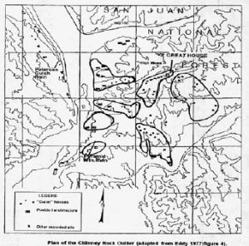 | 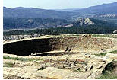 | 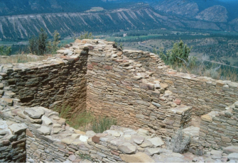 | 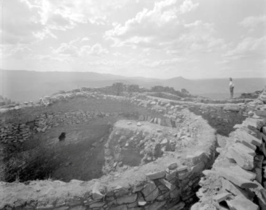 | 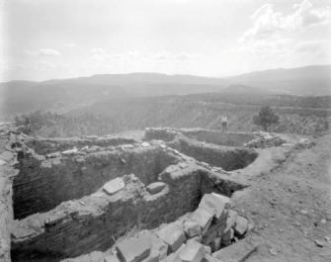 | 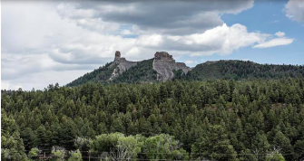
http://gis.co.gov/OAHP_Images/5AA/83/5AA_83-d_Complete_Site_Form.pdf | https://www.historycolorado.org/media/770 | https://www.historycolorado.org/media/788 | http://digital.denverlibrary.org/cdm/singleitem/collection/p15330coll22/id/18316/rec/13 | http://digital.denverlibrary.org/cdm/singleitem/collection/p15330coll22/id/18112/rec/14 | https://www.loc.gov/item/2015632911/

Chimney Rock, Archuleta County, CO C. 1920-1925 | Plan of the Chimney Rock Pueblo, the Great House within the limits of Chimney Rock Mesa community; unexcavated portions are stippled (from Jeancon and Roberts 1924: Plate XII). | Chimney Rock Great House | Effigy jar | Aerial view of Chimney Rock Great House | Chaco Archaeological Protection Site System, Joint Management Plan
Photograph of an automobile on a road below Chimney Rock in Archuleta County, CO circa 1920-1925. | This site is a multi-room masonry pueblo at the peak of Chimney Rock Mesa just below the fire tower. This multi-room masonry pueblo has a roughly rectangular plan consisting of two kivas and 36 ground floor rooms. From Colorado Cultural Resource Survey, CHS 96-02-104. Page 8 of report. The original excavation took place in 1921 and 1922 and stone, pottery and bone were found at the site. | Photo #5AA 83, 2 of 3, 96-02-104.  The vegetation around Chimney Rock includes pinyon, blue spruce, juniper, sage and mountain road, and the wildlife habitat includes deer, elk and peregrine falcon. | Line design starting at neck of a solid thick line bound by two thin lines, one on each side, with space left in between. Mostly consists of triangle scrolls that end in half-terraces interlocking with a hachured line. This jar was described in detail (Colo. Mag., Vol. 1, No. 7, 11/1924, p. 302-303). This object is pictured in the sixth installment (Colo. Mag., Vol. 1, No. 5, 7/1924, Plate 19d, page 217) | Photo #5AA 83, 1 of 3, 96-02-104 from the Colorado Cultural Resource Survey Data Form dated November 24, 1997.  Chimney Rock Archaeological Area is listed in the National Register of Historic Places, August 25, 1970. The Nomination Form is not yet digitized. | Chacoan outliers are defined as Anasazi (Ancestral Pueblo) communities outside of Chaco Canyon dating from the time span AD 500 to 1300 and are distinguished by these characteristics: large-scale planning of multi-storied construction with core veneer masonry large rooms; archeological features including small habitation sites, great kivas and various special use sites; and connected to Chaco Canyon sites by prehistoric roadways.

The dramatic pinnacles of Chimney Rock are visible from all of the Ancestral Puebloan villages identified within the Chimney Rock Archaeological Area. The proximity to the pinnacles and alignments viewed through them is one possible reason for the Chacoan influence at Chimney Rock. | This site map of the Great House Pueblo shows the proximity of the two kivas to the 36 rooms. Archaeologists use maps like this to also analyze construction styles and the years of construction on the site. | The people who inhabited Chimney Rock were farmers who grew corn, beans, and squash below the mesa. They also hunted small animals like turkeys and rabbits, and gathered wild plants and berries. | This bladder-shaped water jar was found in fragments on top of the Chimney Rock mesa. This jar is a masterly piece of workmanship. It is made of fine-grained, dark grey clay with bright white with a slight undertone of bluish black and was originally high polished. The shape looks like a duck but is actually the exact shape of a bladder. | Many researchers have theorized that Chimney Rock functioned as a lunar observatory with the best-known astronomical event being the northern lunar standstill, during which the moonrise can be seen between the pinnacles from the Great House Pueblo every 18.6 years. The major construction phases of the Great House Pueblo at Chimney Rock take place in 1076 AD and 1093 AD, the same time as this lunar standstill. | Chimney Rock was part of the Chaco Canyon economic, political and religious network. Chimney Rock is the northeastern-most, highest, and most isolated outlier community from Chaco Canyon. The network included the redistribution of timber, pottery corn and meat from Chimney Rock in exchange for turquoise, obsidian, feathers, and clay objects.

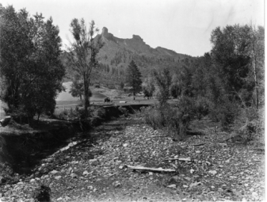 | 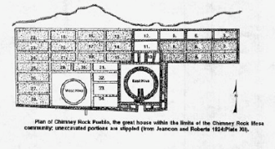 | 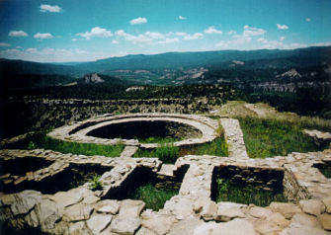 | 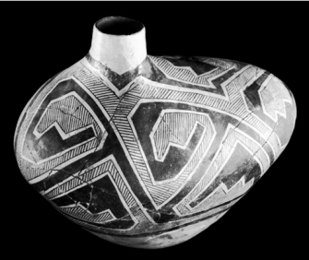 | 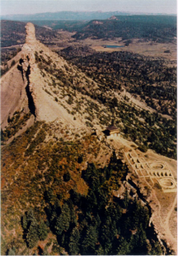 | 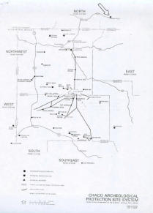
http://5008.sydneyplus.com/HistoryColorado_ArgusNet_Final/Portal/Portal.aspx?component=BasicSearchResults&record=d9699129-ea43-4573-b749-9d06a9770c15&lang=en-US | http://gis.co.gov/OAHP_Images/5AA/83/5AA_83-d_Complete_Site_Form.pdf | http://gis.co.gov/OAHP_Images/5AA/83/5AA_83-d_Complete_Site_Form.pdf | http://5008.sydneyplus.com/HistoryColorado_ArgusNet_Final/Portal/Portal.aspx?component=BasicSearchResults&record=5c7e2e53-051d-4624-a234-e75985a90a8f | http://gis.co.gov/OAHP_Images/5AA/83/5AA_83-d_Complete_Site_Form.pdf | http://gis.co.gov/OAHP_Images/5AA/83/5AA_83-d_Complete_Site_Form.pdf

Foundations Annotations
Curriculum Connections

History

Geography

Economics

Curriculum Standards

CO State Geography Standard 1: Use various types of geographic tools to develop spatial thinking. (Third Grade)
- Read and interpret information from geographic tools and formulate geographic questions.
c. Locate the community on a map and describe its natural and human features.

CO State Geography Standard 2: The concept of regions is developed through an understanding of similarities and differences in places. (Third Grade)
- Observe and describe the physical characteristics and human features of a region.
- Identify the factors that make a region unique including cultural diversity, industry and agriculture, and land forms.
- Give examples of places that are similar and different from a local region.

CO State History Standard 2: People in the past influence the development and interaction of different communities or regions. (Third Grade)
- Describe the history, interaction, and contribution of the various peoples and cultures that have lived in or migrated to a community or region.

CO State Geography Standard 2: Connections within and across human and physical systems are developed. (Fourth Grade)
a. Describe how the physical environment provides opportunities for and places constraints on human activities.
b. Explain how physical environments influenced and limited migration into the state.
Analyze how people use geographic factors in creating settlements and have adapted to and modified the local physical environment.

CO State History Standard 1: Organize and sequence events to understand the concepts of chronology and cause and effect in the history of Colorado. (Fourth Grade)
- Explain the cause-and-effect relationships in the interactions among people and cultures that have lived in or migrated to Colorado.

CO State History Standard 2: The historical eras, individuals, groups, ideas and themes in Colorado history and their relationships to key events in the United States. (Fourth Grade)
Describe interactions among people and cultures that have lived in Colorado.

CO State Economics Standard 1: People respond to positive and negative incentives. (Fourth Grade)
Give examples of the kinds of goods and services produced in Colorado in different historical periods and their connection to economic incentives.
c. Explain how the productive resources of Colorado have influenced the types of goods produced and services provided.

Content and Thinking Objectives

Students will be able to:
- compare and contrast changes in landscape over time.
- use primary sources to learn about the past.
- identify social and economic decisions that caused the Pueblo people who lived at Chimney Rock to migrate to different regions.
- describe archaeological ruins in terms of landscape, geographical features, construction materials and possible uses.
- name some of the natural resources around Chimney Rock and discuss how natural resources might have been used by Ancestral Puebloan people.
- Discuss how natural resources impact a region’s economy, built environment, food diversity, etc.
Inquiry Questions, Activities and Strategies

Inquiry Activities
Examine the different photographs from Chimney Rock Archaeological Area. How do you think the Ancestral Puebloan people constructed their homes? What materials did they use? Were those materials a good choice? What missing features might help you better understand what these structures looked like when they were inhabited? Why do you think these no longer exist?

Compare and contrast the structures at Chimney Rock with those at Chaco Canyon. Why do you think the people who lived in SW Colorado moved from the mesa dwellings of Chimney Rock to the cliff dwellings of Mesa Verde? Discuss the reasons that Chimney Rock was considered a Chaco Canyon outlier.

Examine the map of Great House Pueblo, as well as the aerial view and close up photographs of Great House Pueblo from different time periods. What can you learn by looking at all of these resources that you can’t learn by just examining one? What can you tell about how the site has changed over the last 100 years?

Inquiry Strategies
Use the Library of Congress’ Photo Analysis worksheet to analyze two of the primary sources related to Chimney Rock Archaeological Area. Share the answers with the class. http://www.loc.gov/teachers/usingprimarysources/resources/Analyzing_Photographs_and_Prints.pdf

Assessment Strategies

Depending upon how one uses the resources and which standards are chosen, assessment can take many forms. For example:

CO State Geography Standard 1 (a, c) (Third Grade) and CO State Geography Standard 2 (a, c) (Fourth Grade) Using maps and aerial photographs, explain the relationship between the people of Chimney Rock and other groups who were living in the same region at the same time, and the Chaco culture. Discuss this in terms of natural resources used for food, construction of their homes and tools.

CO State Economics Standard 1 (b, c) (Fourth Grade) Explain the relationship between fundamental human need and natural resource at Chimney Rock.
Other Resources
Web Resources

National Register of Historic Places Homepage: http://www.nps.gov/nr

Colorado Encyclopedia: https://coloradoencyclopedia.org/article/chimney-rock

Chimney Rock National Monument Homepage: http://www.chimneyrockco.org

San Juan National Forest – Chimney Rock National Monument Management Plan: https://www.fs.usda.gov/detail/sanjuan/specialplaces/?cid=stelprdb5390324

History Colorado – Office of Archaeology and Historic Preservation: http://legacy.historycolorado.org/oahp/chimney-rock-site-saved

Chimney Rock National Monument Youth and Education Page: http://www.chimneyrockco.org/junior-archaeologist/

Secondary Sources

Chaco Archeological Protection Site System, Joint Management Plan, “Final Joint Management Plan Chaco Archeological Protection Site System New Mexico/Arizona/Colorado, July 1983.

Chimney Rock Interpretive Association, “Chimney Rock National Monument: A Rare View into an Ancient World,” Colorado Tourism, 2017.

http://gis.co.gov/OAHP_Images/5AA/985/5AA_985-d_Site_Form_and_Nomination.pdf
http://gis.co.gov/OAHP_Images/5AA/83/5AA_83-d_Complete_Site_Form.pdf

Preservation Connection

Chimney Rock Archaeological Area, San Juan National Forest, National Register 8/25/1970, 5AA.985

Chimney Rock is an outlier of the Chacoan culture, and is the most isolated and highest in elevation of the Ancestral Puebloan communities connected to Chaco Canyon, New Mexico. The twin pinnacles are prominent natural landmarks, and its core-and-veneer masonry reflects the same architecture found at Chaco. Some archaeologists believe the site was built solely for religious and astronomical reasons.

The Chimney Rock Archaeological Area, listed in the National Register of Historic Places in 1970, includes the High Mesa ruins near the rocky pinnacles and many other sites located at lower elevations. Some scholars estimate that up to 2,000 Ancestral Puebloan people lived here between A.D. 925 and 1125. According to the religious traditions of modern Taos Pueblo Indians, the spires may have been shrines to the Twin War gods. The Southern Ute Indian Tribe, which owns the land surrounding the Chimney Rock area, holds the pinnacles and ruins sacred as well. Extensive portions of the masonry buildings have been stabilized and reconstructed for today's visitors.
On September 21, 2012, President Obama signed a proclamation establishing Chimney Rock as a National Monument on the San Juan National Forest in southwestern Colorado. The designation was made under the Antiquities Act with bi-partisan support from Colorado officials, Native Americans, local businesses and other stakeholders.
Why is it important to preserve archaeological sites like Chimney Rock Archaeological Area? What can be learned from this site?
What are the positive and negative effects of excavating archaeological sites such as this?
How do people/tourists play a part in the preservation of Archaeological sites? What can be done to limit the negative impact of people/tourists?

Working together to tell the story of our state!
Developers


Sponsors


Partners
