Title/Content Area | Bent’s Old Fort (aka Fort William)
Developed by | CH/TPS
Grade Level | 4–8
Essential Question | Explain the ways in which Bent’s Old Fort served as a cultural crossroads in the 19th century.
Contextual Paragraph | In the late 1820s the Bent brothers, Charles and William, arrived in the area along the Arkansas River north of the Purgatoire River in what would become southeastern Colorado. They partnered with Ceran St. Vrain in building Fort William, or as it came to be known, Bent’s Fort. Located on the Santa Fé Trail, it became an important stop for traders, trappers, American Indian groups and travelers.  Construction of the fort began in the early 1830s. Adobe was the material of choice because it was fire resistant and timber was scarce on the plains. The fort was completed in 1834; a massive structure amid a prairie of blue grama and blue grass. During the summer months several thousand people inhabited the area surrounding the fort. Many had to camp far away from the fort in order to find forage for their animals.  Shortly after Bent, St. Vrain and Company reached the height of influence commercially and politically (around 1846) they became involved in the Mexican American War. The fort was used as a base of operations for the invasion of Mexico and later as a hospital in 1848. The arrival of the military contributed to the demise of the fort as a trading post. The trade with Mexico was ruined, the presence of the military kept Indians away, and soldiers and the supplies for them took up space and disrupted the daily routine.  The old fort was destroyed in 1849. William Bent moved to a new area in the “Big Timbers” section of the Arkansas River and in 1853 began a new trading post known as Bent’s New Fort. It served as a home station and repair shop for Barlow-Sanderson Overland Mail and Express Company and after railroads replaced stage buildings it served as cattle corrals (1881-1884).  By 1915 the fort was falling apart. Only parts of the old walls were still standing. In 1920 the Daughters of the American Revolution acquired the site and for the next 30 years they protected the ruins and marked the site. It became a National Historic Site on June 3, 1960 and the National Park Service took over administration of the site in 1963. After an archaeological study in 1975, the reconstruction of the fort began. It was dedicated June 25, 1976.

Resource Set
Bent’s New Fort,  c. 1859 | Bent’s Old Fort, La Junta, Otero County, CO, c. 2015 | Bent's Old Fort, La Junta, Otero County, CO, c. 2015 | Bent’s Old Fort, La Junta, Otero County, CO | William Bent | Prowers House, Boggsville, CO, c. 2009
Drawing shows Bent's New Fort on a plateau above the Arkansas River in eastern Colorado, near present-day Prowers. | Occasionally referred to as Fort William, the present fort is a 1976 reconstruction of an 1833 fort built by William and Charles Bent, along with Ceran St. Vrain. | View that would have been seen as people approached Bent’s Old Fort from a distance. | Located on the US side of the Arkansas River, this walled adobe building housed personnel and provided shelter, trading, and repair facilities to travelers, trappers, and Indians. | Head and shoulders portrait of William Bent founder of Bent’s Fort on the Santa Fé Trail. Portrait was made sometime in the decade before his death in 1869. | View of the Prowers House on the Boggsville Historic Site in Bent County, CO.
William Bent erected a new establishment on the Arkansas in 1853. This fort was about thirty miles east of Bent's Old Fort, by then in ruins. | The post for trading with trappers and Southern Cheyenne and Arapaho Plains Indians for buffalo robes. | This view emphasizes the starkness of the plains and the welcoming presence of an oasis of civilization in the region. | Historic American Building Survey plans for the frontier-era trading post/fort built by the Bent brothers and Ceran St. Vrain on the Santa Fé Trail. | Donated in the 1930s to Historic Colorado. | Two-story territorial style building that was the home of John W. Prowers, a teamster who worked for William Bent and Ceran St. Vrain.

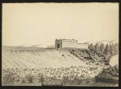 | 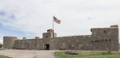 | 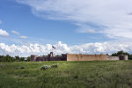 | 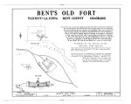 | 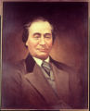 | 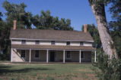
http://loc.gov/pictures/resource/cph.3c28890 | http://www.loc.gov/item/2015632784/ | http://www.loc.gov/item/2015632783/ | http://www.loc.gov/item/co0001/ | http://digital.denverlibrary.org/cdm/singleitem/collection/p15330coll21/id/3577/43d/1 | http://digital.denverlibrary.org/cdm/singleitem/collection/p15330coll14/id/1218/rec/4

Governor Charles Bent, March 1847 | Christopher Carson, c. 1880–1910 | Ceran St. Vrain | Susan Shelby Magoffin | Owl Woman (Mistanta), 1828–1847 | Entrance to Bent's Old Fort
Head and shoulders portrait of Charles Bent who served as governor of the New Mexico Territory taken in the Mexican American War until he lost his life in an 1847 battle. | Christopher "Kit" Carson, half-length seated studio portrait, wearing suit jacket, vest, and tie; photograph of a portrait. | Head and shoulders portrait of Ceran St. Vrain, fur trader from Colorado. He wears a white shirt and collar, with a dark jacket and cravat. | One of the first Anglo women to travel on the Santa Fé Trail. Her diary is one of the major sources about 1840s life in the American Southwest. | First wife of William Bent. | “Gate” or main entrance for those coming to Bent’s Old Fort.
Eldest of the Bent brothers who founded Bent's Fort along the Santa Fé Trail. | Carson was one of the well-known frontiersmen who spent time at Bent’s Old Fort. | St. Vrain was one of the founders of Bent’s Old Fort. | Magoffin, pregnant at the time of her journey, took ill at Bent’s Old Fort and suffered a miscarriage there. | Tried to improve relations between whites and Indians throughout her life. | Gate with watchtower above it speaks to the security measures in place at Bent’s Old Fort.
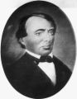 | 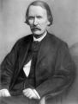 | 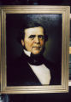 | 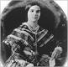 | 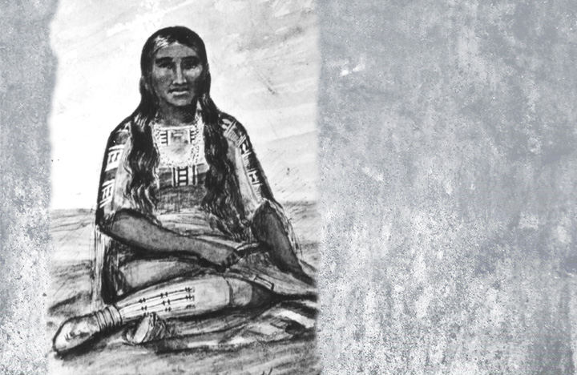 | 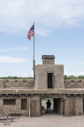
http://digital.denverlibrary.org/cdm/singleitem/collection/p15330coll22/id/10774/rec/3 | http://cdm16079.contentdm.oclc.org/cdm/singleitem/collection/p15330coll22/id/68674/rec/37 | http://digital.denverlibrary.org/cdm/singleitem/collection/p15330coll21/id/3582/rec/6 | http://www.legendsofamerica.com/photos-oldwest/Susan_Shelby_Magoffin.jpg | http://www.cogreatwomen.org/wp-content/uploads/2014/03/own-woman.jpg | http://www.loc.gov/item/2015632517/

Reconstructed Warehouse | Magoffin Room | Reconstructed Laborers Quarters | Reconstructed Billiard Room | Reconstructed Living Quarters | Reconstructed St. Vrain’s Room
These warehouses were used as storage areas for the goods awaiting transport to St. Louis, Missouri. | Susan Magoffin recuperated in the doctor’s quarters after suffering a miscarriage as she traveled the Santa Fé Trail. | Sleeping and eating quarters for laborers, employees, and travelers from the states and Mexican workers who made adobe for the fort. | Billiards helped travelers and employees cope with boredom, idleness, and loneliness. Many games were played to ease the long hours. | Trappers employed by Bent and St. Vrain and living at the fort included Kit Carson, “Old Bill” Williams, “Peg-Leg” Smith, and “Uncle Dick” Wootton. | Highly respected in Santa Fé, St. Vrain’s relationships in New Mexico were invaluable to the Bents. This served as his quarters at the fort.

Four warehouses in all, contained barrels, bags and bundles of trade goods. One served as a “bank vault.” | First known as the quarters of Dr. Hempstead, resident physician. He was reported to have had a well-stocked library. | These rooms reflect the customs and beliefs of Mexicans hired to build the fort. | An 1839 ledger shows a diverse assortment of drinks that were served. Lt. James Albert also used it as an art studio | Three living quarters illustrate the conditions for military, fort employees, and fur trappers. | While away, St. Vrain’s room was used as a guest room. Its most notable occupant was Lt. James Albert.
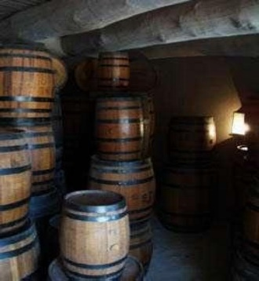 | 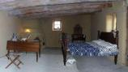 | 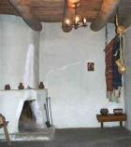 |  | 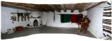 | 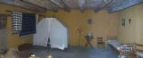
https://www.nps.gov/common/uploads/photogallery/imr/park/beol/59FD1352-155D-451F-67244ED29B37F697/59FD1352-155D-451F-67244ED29B37F697-large.jpg | https://www.nps.gov/common/uploads/photogallery/imr/park/beol/59FE90EF-155D-451F-67FF2A3ABA2D0AAD/59FE90EF-155D-451F-67FF2A3ABA2D0AAD-large.jpg | https://www.nps.gov/common/uploads/photogallery/imr/park/beol/59FDB17A-155D-451F-677274DB4F8B6B8B/59FDB17A-155D-451F-677274DB4F8B6B8B-large.jpg | https://www.nps.gov/common/uploads/photogallery/imr/park/beol/5A0081D1-155D-451F-67DB2EB166BC57C3/5A0081D1-155D-451F-67DB2EB166BC57C3-large.jpg | https://www.nps.gov/common/uploads/photogallery/imr/park/beol/59FF77AB-155D-451F-673E18AC634174D3/59FF77AB-155D-451F-673E18AC634174D3-large.jpg | https://www.nps.gov/common/uploads/photogallery/imr/park/beol/5A019A18-155D-451F-67D60122E66E7E74/5A019A18-155D-451F-67D60122E66E7E74-large.jpg

Nomination form for National Register of Historic Places  May 23, 1985 | Photo array to be included in the National Register of Historic Places Nomination form, 1983
The nomination form contains a wealth of information about Bent’s Old Fort both historically and contemporarily. | Collection of 20 black and white photos of Bent’s Fort from different geographic perspectives.
Areas of significance include commerce, military, exploration/settlement and social history. All are discussed in great detail. | Photos range from surrounding terrain, the fort, the cemetery and race track.
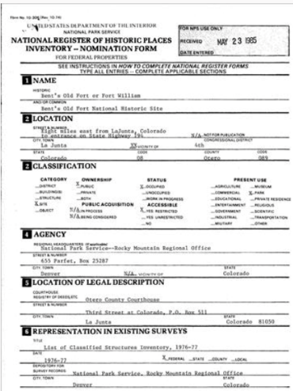 | 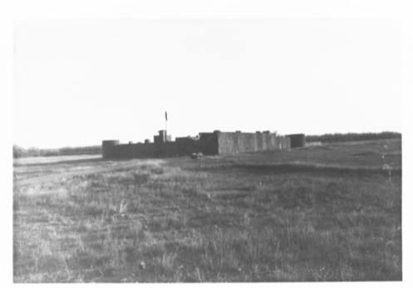
https://npgallery.nps.gov/NRHP/GetAsset/1fc4b244-bd44-41b9-8a73-13dba706df1d | https://npgallery.nps.gov/NRHP/GetAsset/4ecdcd17-9b19-4372-a00e-487cb4de81e2

Foundations Annotations
Curriculum Connections

History
Geography

Curriculum Standards

CO State History Standard 1: Organize and sequence events to understand the concepts of chronology and cause and effect in the history of Colorado. (Fourth Grade)
c. Explain the cause-and-effect relationships in the interactions among people and cultures that have lived in or migrated to Colorado.
CO State History Standard 2: The historical eras, individuals, groups, ideas and themes in Colorado history and their relationships to key events in the United States. (Fourth Grade)
b. Describe interactions among people and cultures that have lived in Colorado.
CO State Geography Standard 2: Connections within and across human and physical systems are developed. (Fourth Grade)
a. Describe how the physical environment provides opportunities for and places constraints on human activities
d. Describe how places in Colorado are connected by movement of goods and services and technology

Curriculum Standards (continued)

CO State History Standard 2: The historical eras, individuals, groups, ideas and themes from the origins of the American Revolution through Reconstruction and their relationships with one another. (Eighth Grade)
d. Evaluate the impact of different factors – of age, ethnicity and class – on groups and individuals in this time period and the impact of these group and individuals on the events of this time period.
CO State Geography Standard 1: Use geographic tools to analyze patterns in human and physical systems. (Eighth Grade)
c. Recognize the patterns and networks of economic interdependence.
CO State Geography Standard 2: Conflict and cooperation occur over space and resources. (Eighth Grade)
a. Analyze how economic, political, cultural, and social processes interact to shape patterns of human population, interdependence, cooperation and conflict.
c. Interpret from a geographic perspective the expansion of the United States by addressing issues of land, security, and sovereignty.

Content and Thinking Objectives

Students will be able to:
- analyze and question primary sources.
- describe life in another historical era, e.g., the 19th century on the Santa Fé Trail.

Inquiry Questions, Activities and Strategies

Inquiry Activities
In small groups, using the Library of Congress’ Photo Analysis Sheet (http://www.loc.gov/teachers/primary-source-analysis-tool/ ), analyze the images related to Bent’s Old Fort and share the questions raised with classmates.
Research the lives of Charles and William Bent, Kit Carson, Ceran St. Vrain, and others associated with Bent’s Old Fort. Assume the identity of the person studied and as that person, present an account of “your” life to classmates.

Assessment Strategies

Depending upon how one uses the resources and which standards are chosen, assessment can take many forms. For example:
CO State Geography Standard 2: (d) (Fourth Grade) Using the images of the inside of Old Bent’s Fort, describe how the fort affected the movement of goods along the Santa Fé Trail.
CO State History Standard 2: (b) (Fourth Grade) Give examples that demonstrate the interactions among those visiting Old Bent’s Fort.
CO State Geography Standard 1: (c) (Eighth Grade) Explain the patterns and networks of economic interdependence that existed at Old Bent’s Fort and along the Santa Fé Trail.
CO State History Standard 2: (d) (Eighth Grade) Evaluate the impact of ethnicity and class as it pertained to Bent’s Fort (Old and New) from 1820-1867.

Other Resources
Web Resources

National Register of Historic Places: https://npgallery.nps.gov/NRHP/AssetDetail?assetID=1fc4b244-bd44-41b9-8a73-13dba706df1d
Colorado Women’s Hall of Fame: http://www.cogreatwomen.org
National Park Service Bent’s Old Fort Information Pamphlet: https://www.nps.gov/beol/index.htm
Legends of America: http://www.legendsofamerica.com/co-bentsfort.html
History Colorado: http://exhibits.historycolorado.org/bentsfort/bents_home.html

Secondary Sources

Cheryl Beckwith, William Bent: Frontiersman (Palmer Lake, CO: Filter Press, 2010).
David Lavender, Bent’s Fort (Lincoln, NE: University of Nebraska Press, 1954).
“Bent’s Fort,” Colorado Experience, Rocky Mountain PBS. http://video.rmpbs.org/video/2365021102/

Preservation Connection

Bent’s Old Fort is significant in several areas: commerce, military, exploration/settlement, and social history. It commemorates the historic role of a fort in pushing the American frontier westward. The reconstructed fort is important as an interpretive feature for helping 21st century visitors better understand life in the 19th century. The graveyard has stones commemorating those who were buried there in the 19th century. All except Edward Dorris, a Civil War casualty are from the Bent period (1825-1849). The remains of George and Robert Bent were temporarily interred there until they were moved to St. Louis for final burial.
In addition to the graveyard, the mid-1970s reconstructed adobe fort and the stone arch at the entrance (built by the Daughters of the American Revolution in 1930) with its granite monument (constructed in 1912 and moved under the arch in 1984) are the “contributing features” that led to inclusion in the National Register of Historic Places. Contributing features are buildings, sites, structures or objects that were present during the period of significance, that relate to the documented significance of the property, possesses historic integrity and/or is capable of yielding important information about the period.

In addition to the typical experience had by visitors, special programs sponsored by the National Park Service throughout the year provide attendees with the opportunity to delve deeper into specific aspects of 19th century life. Frontier Skills Day, Santa Fé Trail Day, Hispanic Heritage Day and Native American Day are among the special programs available. See https://www.nps.gov/beol/planyourvisit/things2do.htm for more information about the programs and sign-up information. Those who have had such an experience tend to become avid historic preservation proponents as they understand the value of such an endeavor.
Preservation Questions
How can Bent’s Old Fort help students more fully understand life in the 19th century southwest?
Why is it important to preserve not only just the fort, but include its surrounding environs as well?

Working together to tell the story of our state!

Developers


Sponsors


Partners


