Title | Elizabeth Byers
Developed by | Elizabeth Duncan and Rae Harris
Grade Level | 3 - 5
Essential Question | In what ways did Elizabeth Byers impact the development of the city of Denver?
Contextual Paragraph | Elizabeth “Libby” Byers (1834–1920) was a Colorado social reformer who arrived in Denver in 1859. She spent the next sixty years establishing and supporting the city’s early charitable organizations, schools, and churches. Her focus on helping the poor led her to found orphanages for both girls and boys and an Old Ladies’ Home. She also started the Ladies’ United Aid Society, which later became the United Way. While her husband, William Byers, used his newspaper, the Rocky Mountain News, to bring people into what became Colorado Territory, Elizabeth Byers established the institutions that enabled people to stay. She helped transform Denver from a mining town to a capital city.

Resource Set
Elizabeth Byers, around age 65 [1890-1910] | Denver, 1858 | Rocky Mountain News Building, 1859 | Denver, 1860 | Denver, 1898 | Denver, 1920
Elizabeth Minerva Byers (Mrs. William N. Byers) sits at the front steps of her 171 South Washington Street home in the Speer neighborhood of Denver, Colorado. | Painting of Denver | William Byers established the Rocky Mountain News. | First known photo of Denver | Photograph of Denver in 1898 | Photograph of Denver, 1920
Picture of Elizabeth at her home with a pet. The family lived in several different homes. | Prior to the discovery of gold, in 1859, the Arapahoe tribe made up most of the population at the confluence of Cherry Creek and the Platte River. | With the discovery of gold, Byers hoped to encourage settlement in the region and used the newspaper to increase people’s interest. | You can see the addition of structures in the brief time after gold was discovered. | Denver grew rapidly from its pioneer beginnings. Elizabeth Byers helped people in need. | By the time Elizabeth Byers died in 1920, Denver had become a thriving city. The institutions she established helped the people of the city,
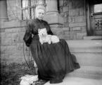 | 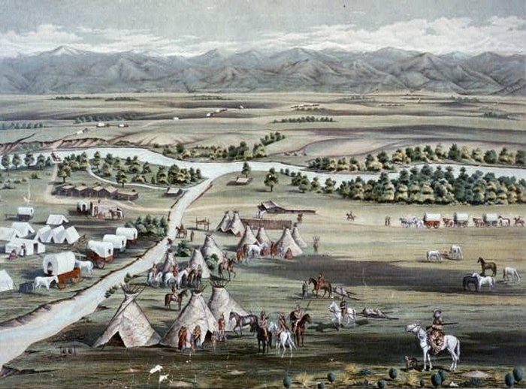 | 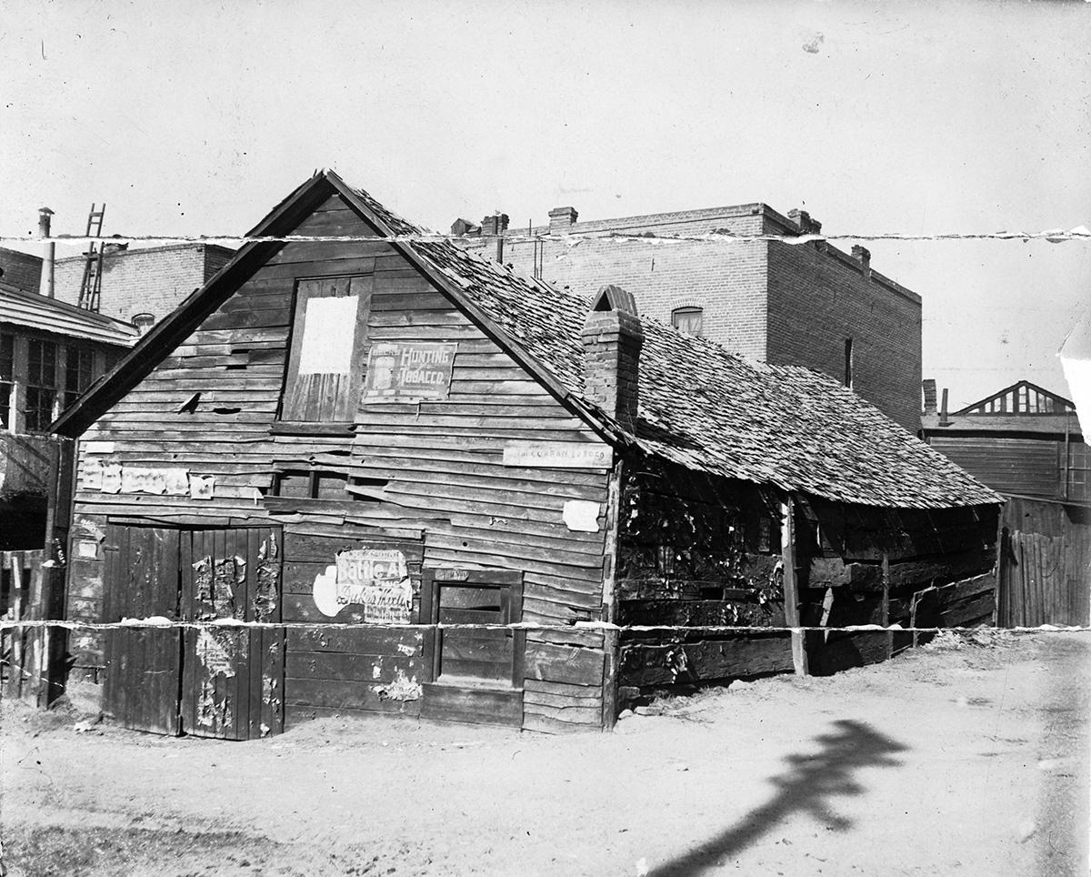 | 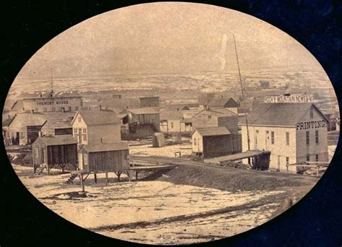 | 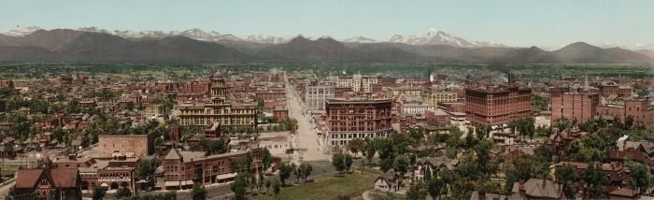
https://digital.denverlibrary.org/digital/collection/p15330coll22/id/68489/rec/15 | https://www.onlyinyourstate.com/colorado/denver/100-years-ago-denver/ | https://coloradoencyclopedia.org/image/early-rocky-mountain-news-office | https://www.pinterest.com/pin/201817627021698046/ | https://www.onlyinyourstate.com/colorado/denver/100-years-ago-denver/ | https://www.facebook.com/TheCrawfordHotel/photos/16th-and-broadway-circa-1920-tbt-denver-history-old-images-of-denver/1799284506831688/

Byers’ Home  1891 | The Denver Old Ladies Home | Denver Orphans Home | Denver Orphans Home | Mrs. William N. Byers and friends, 1897 | Mrs. William N. Byers, 1872 (age 38)
William and Libby built a house at 171 S. Washington St. in Denver that offered them a magnificent mountain view and the opportunity to plant a large garden with an arboretum. | Exterior view of Old Ladies' Home, West 38th Avenue, Denver, constructed by Ladies' Relief Society | Exterior view of the Denver Orphans Home at 1501 Albion St. in Denver | Babies and young children in the Denver Orphans Home | A group portrait with Elizabeth Byers and friends in the interior of a home in Denver, Colorado. | Studio portrait of Elizabeth M. Byers
The Byers moved to “the country,” south of the city. | Elizabeth helped to establish a home for “old ladies.” The home still exists as an independent and assisted living facility. | Constructed in 1902, the Denver Orphans Home (now the Denver Children’s Home) provided a safe environment for needy children. | The Orphans home offered shelter not only to orphans, but also to children whose families could not provide for them. | Elizabeth was part of a group of well-to-do women who hoped to improve (and influence) the lives of working class people. | Elizabeth is dressed in the fashion of the times in this portrait.
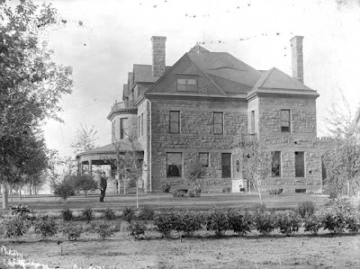 | 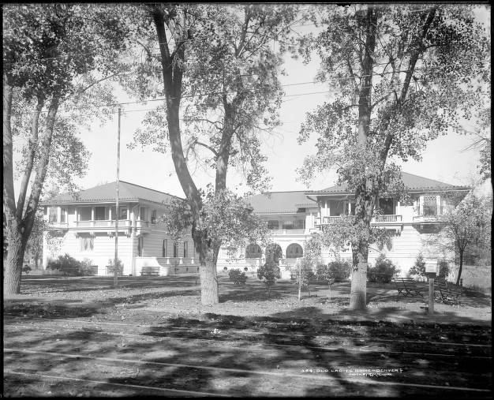 | 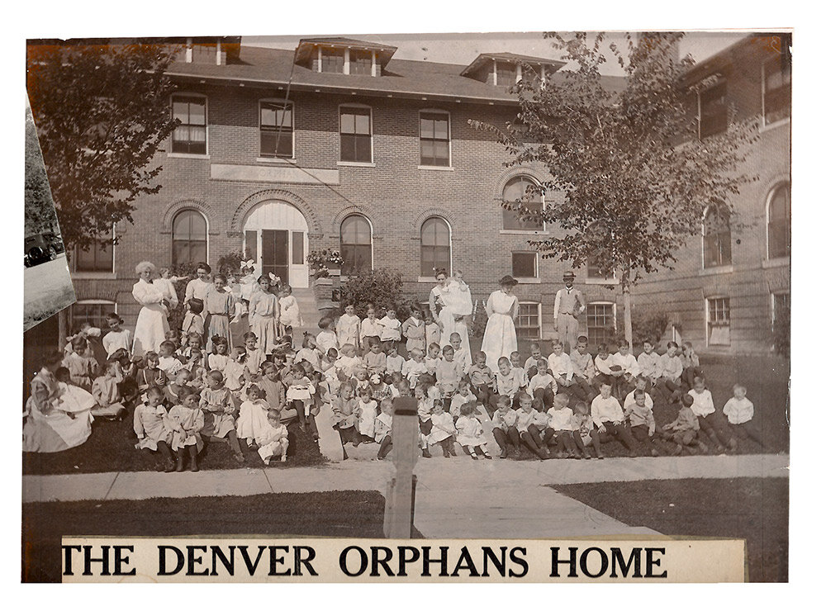 | 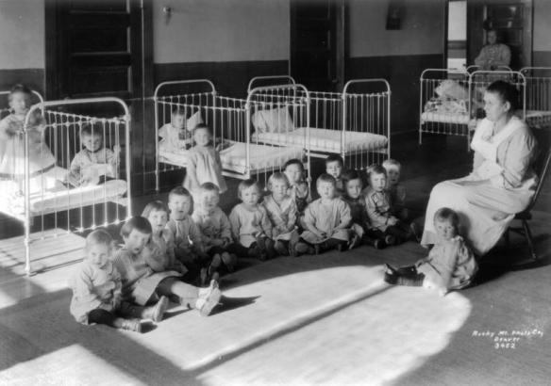 | 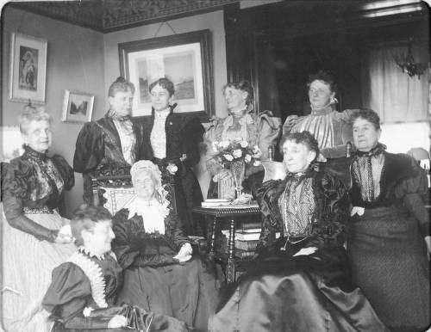 | 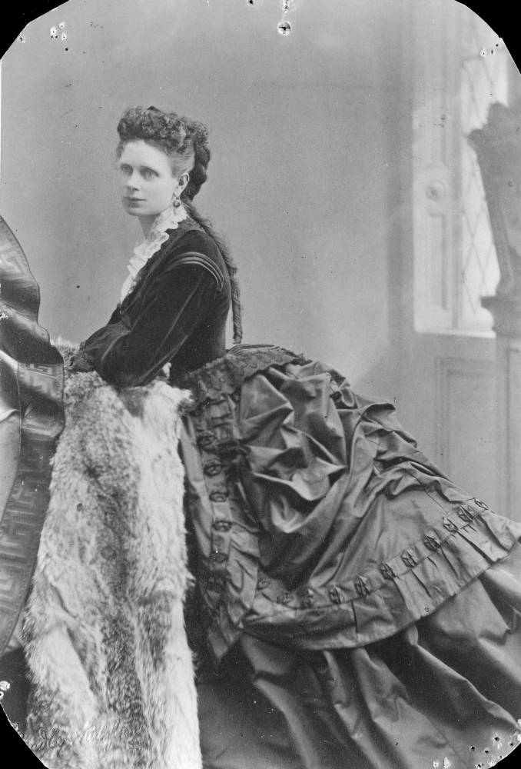
https://denverstumblingleaf.blogspot.com/2010/05/denvers-crumbling-history-west.html | https://digital.denverlibrary.org/digital/collection/p15330coll22/id/77987/ | Denver Children's Home | Babies and Orphans | https://digital.denverlibrary.org/digital/collection/p15330coll22/id/68314/rec/7 | https://digital.denverlibrary.org/digital/collection/p15330coll22/id/68380/rec/42

Mrs. W.N. Byers & her daughter, Mrs. Mary Byers Robinson, 1895 | House of Wm. N. and Elizabeth Byers, Denver, 1862 | Byers’ Home  1880’s
Mrs. William N. Byers (Elizabeth Minerva Byers) sits with her daughter, Mary Byers Robinson, in their cabin in Ferndale, Colorado. | William and Elizabeth Byers pose outside their frame, one story house. The house has board and batten siding, shutters and a brick chimney. | William and Libby moved to a grander house at the corner of 13th and Bannock where they lived for a short time before selling the house to the Evans family.
The Byers family also enjoyed spending time at their mountain cabin. | Coming originally from a modest background, Elizabeth later had the means to help improve the lives of others. | Notice the increased grandeur as the Byers became established in Denver.
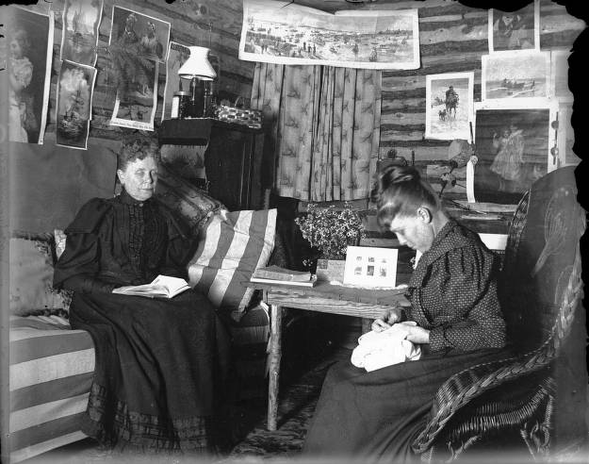 | 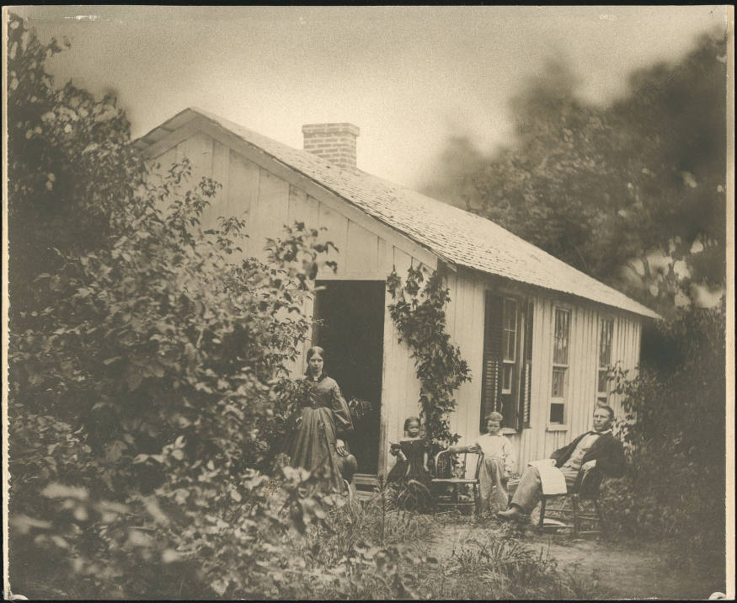 | 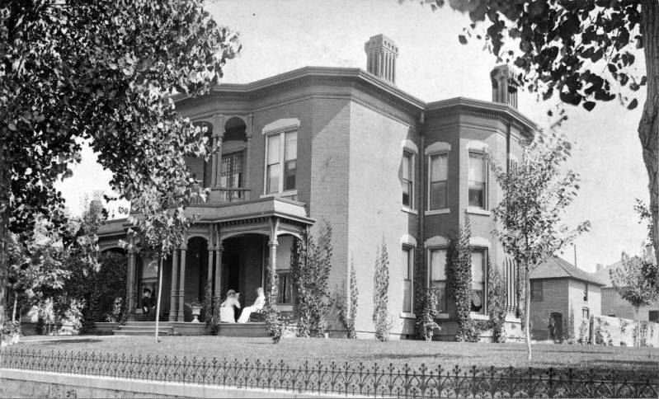
https://digital.denverlibrary.org/digital/collection/p15330coll22/id/66669/rec/12 | https://digital.denverlibrary.org/digital/collection/p15330coll22/id/83282/rec/6 | https://www.coloradovirtuallibrary.org/wp-content/uploads/Byers-Evans.jpg

Foundations Annotations
Curriculum Connections

History

Curriculum Standards

CO State History Grade Level Expectation 1: People in the past influenced the development and interaction of different communities and regions. (Third Grade) Students can:

- Give examples of people, events, and developments that brought important changes to a community or region.
- Recognize how members of a community rely on each other and interact to influence the development of their communities.

CO State Grade Level Expectation 2: The historical eras, individuals, groups, ideas, and themes in Colorado history and their relationship to key events in the United States within the same historical period. (Fourth Grade) Students can:

- Recognize and describe cause-and-effect relationships within Colorado history and draw conclusions about how various events and people affected the development of the state.

CO State Grade Level Expectation 1: Analyze historical sources from multiple points of view to develop an understanding of historical context. (Fifth Grade) Students can:

- Recognize how historical context can affect the perspective of historical sources.
- Make observations and draw conclusions from a variety of sources when studying American history.

Content and Thinking Objectives

The students will be able to:
- list the contributions of Elizabeth Byers to the well-being of needy people in Denver.
- explain the impact of Elizabeth Byers’ leadership as a social reformer in the context of the times.
- examine how Elizabeth was influential in the development of various community projects.
- evaluate how Elizabeth, as one person, brought important changes to Denver, Colorado.

Inquiry Questions, Activities and Strategies

Inquiry Questions:

What contributions did Elizabeth make to improve the lives of people in Denver?

How did Elizabeth change Denver from a rough and tumble outpost to a community that had institutions to support people in need?

How did the people of Colorado benefit from the specific organizations and institutions that Elizabeth created?

How can one person’s passion for a cause impact an entire community?

Inquiry Activities: (You may wish to support students in reading the full article as it provides considerably more detail.)

Using the primary sources provided, invite students to consider what Denver was like when Elizabeth arrived in 1859. Have them contrast that with Denver when Elizabeth died in 1920. Have them reflect on how Denver’s growth was mirrored by the Byers family homes.

After reading the article, ask students to describe the changes Elizabeth Byers made to the Denver community and how they improved life for people.

Encourage students to examine how Elizabeth Byers can be a role model for people today?

Assessment Strategies

Depending upon how one uses the resources and which standards are chosen, assessment can take many forms. For example:

CO State History Grade Level Expectation 2: People in the past influence the development and interactions of different communities or regions. (Third Grade)

b) Give examples of people, events, and developments that brought important changes to a community or region:

Create a brochure that describes the origin and development of one of the organizations or institutions Elizabeth Byers helped to establish that continues to exist today. (Old Ladies Home, Denver Orphans Home, Charity Organization Society, The Woman’s Home Club, etc.)
or

Write an obituary for Elizabeth Byers that describes her contributions to improving life for working-class people. Write it in the form of an article that would have appeared in the Rocky Mountain News.

Other Resources
Web Resources

Find a Grave, Elizabeth Minerva Sumner Byers: https://www.findagrave.com/memorial/40890062/elizabeth-minerva-byers Photos and a news clipping

Biographical Sketch of Elizabeth Byers, 1834-1920. https://documents.alexanderstreet.com/d/1009860077

Virtual Field Trip of the Center for Colorado Women’s History (Byers Evans House): https://www.historycolorado.org/virtual-field-trips

Secondary Sources

Bell, J.v.L. Elizabeth Byers, Denver Pioneer, (Now You Know Bio Book 19), Filter Press, 2020. (for students)

Working together to tell the story of our state!

Developers


Sponsors

Partners


