Title | Emily Griffith
Developed by | Elizabeth Duncan and Rae Harris
Grade Level | 3 - 5
Essential Question | In what ways did Emily Griffith bring “opportunity” to Denver citizens?
Contextual Paragraph | Emily Griffith started the Denver Opportunity School in 1916. The school, which was the first of its kind,provided free education to people regardless of age, race, or gender. Funded by Denver Public Schools, Emily Griffith founded the school with the idea that offering education to “all who wish to learn” would enable them to get better jobs that would enrich society as well as their own lives.

Resource Set
Emily Griffith | Opportunity School Poster | Opportunity School | 9 Pearl Street | Emily Griffith | Opportunity School
Photograph | 1917 Poster advertising the Opportunity School | Original building that housed the Opportunity School at 13th and Welton. | 9 Pearl Street: A home for the boy who needs one. | Photograph | Addition to the Opportunity School building.
This is a photograph of Emily Griffith. | The Opportunity School opened in 1916, offering a variety of free classes to citizens. | The Denver Public Schools offered the abandoned Longfellow School as the original home for the Opportunity School. | In addition to the Opportunity School, Emily Griffith established a home for homeless boys. Now called the Griffith Center, the facility still exists. | This is a photograph of Emily Griffith | This shows the construction of one of several additions added to the original Opportunity School building.
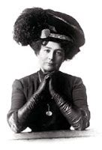 | 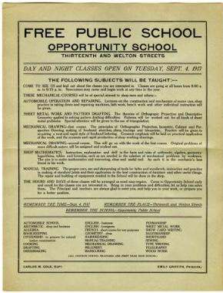 | 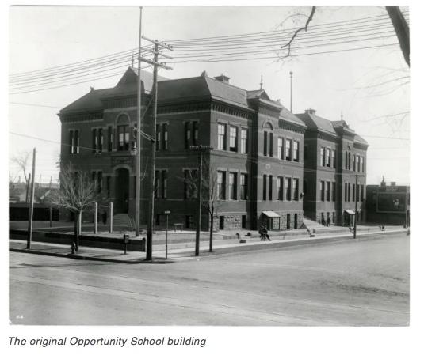 | 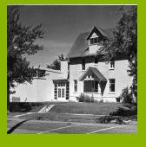 | 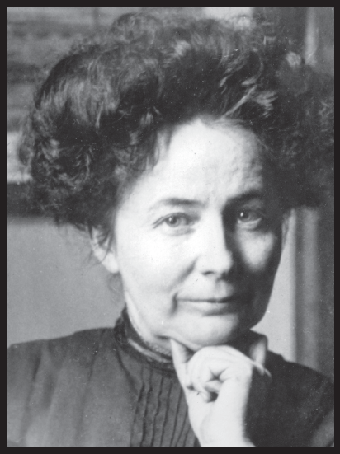 | 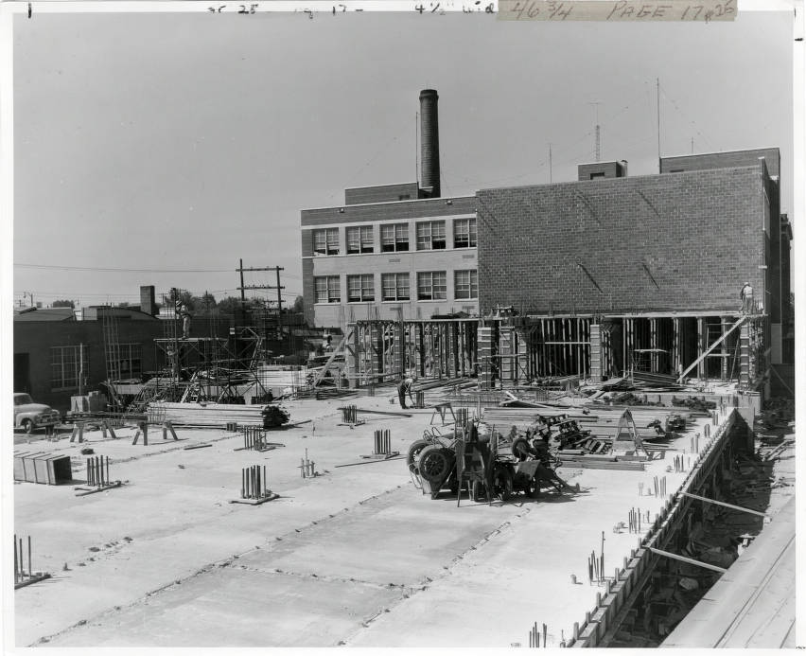
https://history.denverlibrary.org/colorado-biographies/emily-griffith-1868-1947 | https://www.historycolorado.org/denvers-opportunity-school-emily-griffith-poster-1917 | https://history.denverlibrary.org/colorado-biographies/emily-griffith-1868-1947 | https://griffithcenters.org/our-history/ | https://www.coloradovirtuallibrary.org/digital-colorado/colorado-histories/boom-years/emily-griffith-educator/ | https://digital.denverlibrary.org/digital/collection/p15330coll23/id/11905/rec/34

Opportunity School | “One Woman” Newspaper Article | Opportunity School | Opportunity School | Opportunity School | Opportunity School
1920 Millinery (hat-making) class offered at the Opportunity School. | The Moffat County Bell, Volume 7, Number 20, August 25, 1922. | Undated, hair- dressing student in a class offered at the Opportunity School. | 1949 radio repair class offered at the Opportunity School. | Opportunity School at 12th and Welton after addition. | 1949 Opportunity School building.
The Opportunity School offered classes in a variety of areas that allowed immigrants and others to learn skills in areas in which they could find jobs. | This article, published in 1922, talks about the Opportunity School, Emily Griffith, and the difference the school made in the life of the students. | The Opportunity School offered classes in a variety of areas that allowed immigrants and others to train in areas in which they could find jobs. | The Opportunity School offered classes in a variety of areas that allowed immigrants and others to train in areas in which they could find jobs. | The Opportunity School was expanded with an addition. | Addition to the Opportunity School.
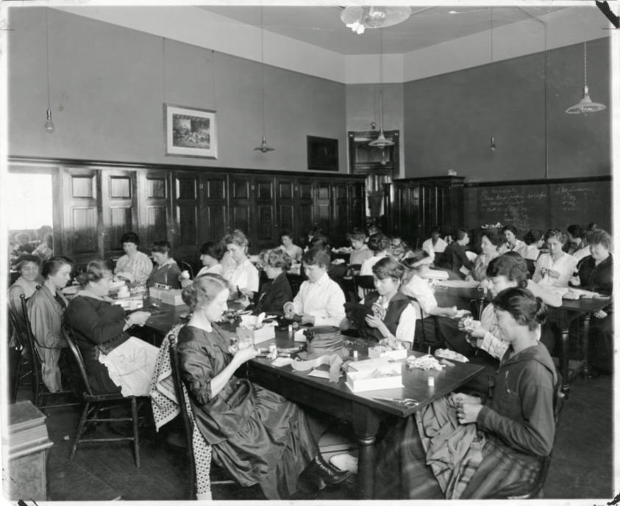 | 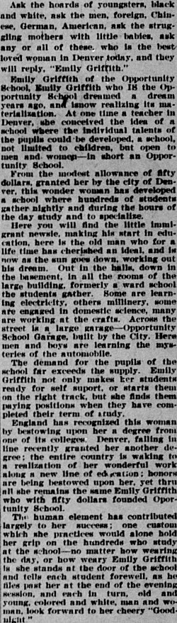 | 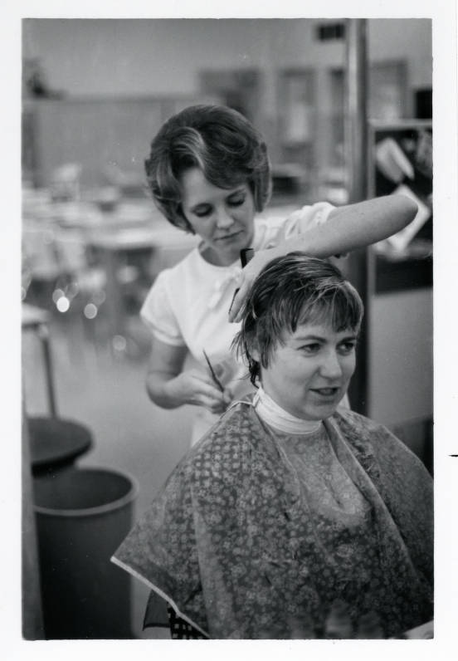 | 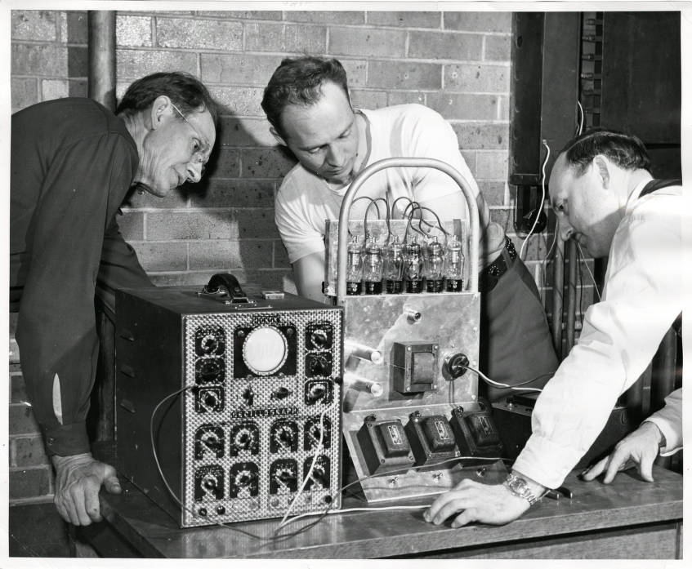 | 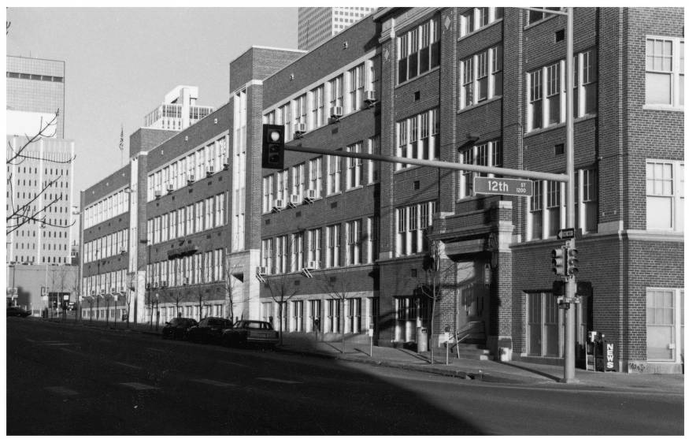 | 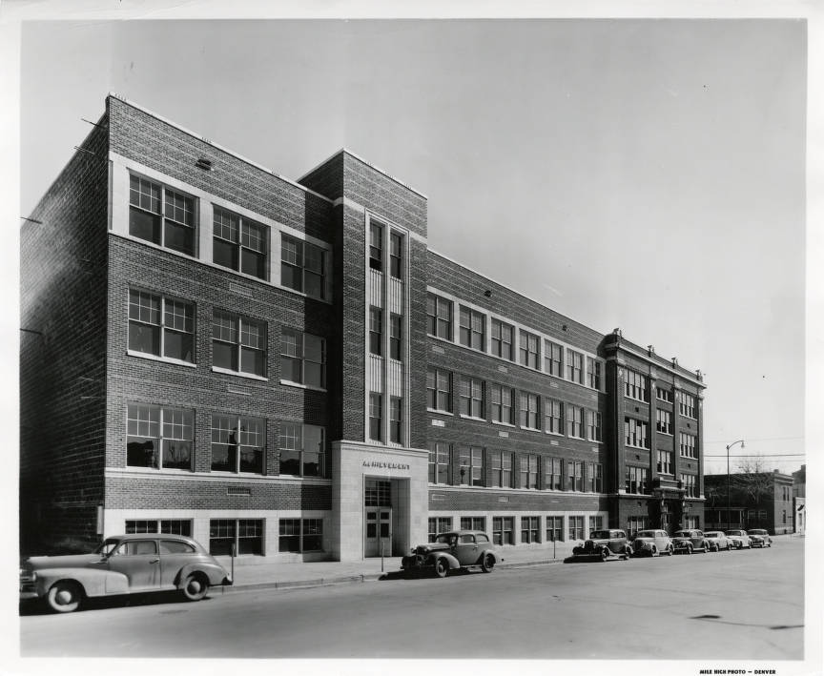
https://digital.denverlibrary.org/digital/collection/p15330coll23/id/11921/rec/50 | https://www.coloradohistoricnewspapers.org/?a=d&d=MCB19220825-01.2.18&srpos=1&dliv=none&e=-----1951--en-20--1--img-txIN%7ctxCO%7ctxTA-emily+griffith-------0------ | https://digital.denverlibrary.org/digital/collection/p15330coll23/id/11914/rec/43 | https://digital.denverlibrary.org/digital/collection/p15330coll23/id/11923/rec/52 | https://digital.denverlibrary.org/digital/collection/p15330coll22/id/82347/rec/84 | https://digital.denverlibrary.org/digital/collection/p15330coll23/id/11900/rec/119

9 Pearl Street | Opportunity School Students
Boys who need a home, take care of a duck. | The advanced shorthand class, in costume for a play in front of the building.
In addition to the Opportunity School, Emily Griffith established a home for homeless boys. Now called the Griffith Center, the facility still exists. | The Opportunity School offered classes in a variety of areas that allowed immigrants and others to train in areas in which they could find jobs.
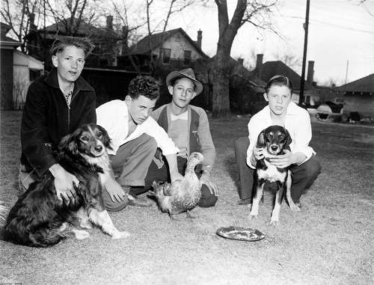 | 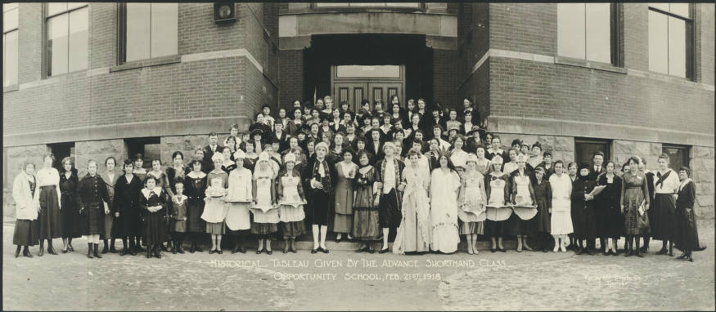
https://digital.denverlibrary.org/digital/collection/p15330coll22/id/65862/rec/131 | https://digital.denverlibrary.org/digital/collection/p15330coll22/id/68117/rec/130

Foundations Annotations
Curriculum Connections

History
Curriculum Standards

CO State History Grade Level Expectation 1: Analyze primary and secondary sources from multiple points of view to develop an understanding of the history of Colorado. (Fourth Grade)
- Draw inferences about Colorado history from primary sources such as journals, diaries, maps, etc.
- Identify cause-and-effect relationships using primary sources to understand the history of Colorado's development.
- Identify and describe how major political and cultural groups have affected the development of the region.

CO State Grade Level Expectation 2: The historical eras, individuals, groups, ideas, and themes in Colorado history and their relationship to key events in the United States within the same historical period. (Fourth Grade)
- Recognize and describe cause-and-effect relationships within Colorado history and draw conclusions about how various events and people affected the development of the state.

CO State Grade Level Expectation 2: People in the past influence the development and interactions of different communities or regions (Third Grade)
b) Give examples of people, events, and developments that brought important changes to a community or region.

Content and Thinking Objectives

The students will be able to:

- identify the characteristics that enabled Emily Griffith to achieve her goals for making education opportunities available to all.
- explain how the Opportunity School differed from other education options available at the time.
- cite how Emily’s personal experiences led to her passion for education for immigrants and the poor.
- analyze how the Opportunity School impacted individual lives as well as the Denver community.

Inquiry Questions, Activities and Strategies

Inquiry Questions:

What inspired Emily Griffith to develop the Opportunity School?

How did Emily Griffith’s personal characteristics contribute to her accomplishments?

How did the people of Denver benefit from the Opportunity School?

How can one person’s passion for a cause impact an entire community?

How does giving people the opportunity to learn and grow their skills change their lives and the community in which they live?

Inquiry Activities:

Using the primary sources provided, invite students to generate a list of the ways Emily Griffith influenced education in Denver.

After reading the Colorado Encyclopedia article, ask students to describe ways Emily Griffith provided educational opportunities for immigrants and poor people in Denver.

After viewing the video from Rocky Mountain PBS or reading the primary source news article “One Woman” from the Moffat County Bell, ask students to cite three ways Emily Griffith impacted Denver and its citizens.

Assessment Strategies

Depending upon how one uses the resources and which standards are chosen, assessment can take many forms. For example:

CO State History Grade Level Expectation 2: People in the past influence the development and interactions of different communities or regions. (Third Grade)

Give examples of people, events, and developments that brought important changes to a community or region by writing a story from the point of view of a person who attended the Opportunity School. In the story describe the class or classes “you” took and how it influenced your life. Include a description of and interaction with your principal, Miss Emily Griffith.

CO State Grade Level Expectation 2: The historical eras, individuals, groups, ideas, and themes in Colorado history and their relationship to key events in the United States within the same historical period. (Fourth Grade)

Recognize and describe cause-and-effect relationships within Colorado history and draw conclusions about how various events and people affected the development of the state by creating a brochure or poster advertising the Opportunity School. Your product should be inviting to immigrants and other citizens who are trying to improve their lives. Be sure to identify the year your brochure or poster is for and make sure that it addresses the educational needs of the people of the era.

Other Resources
Web Resources

RMPBS Colorado Experience Video: “Miss Opportunity: The Life and Times of Emily Griffith”
PLEASE PREVIEW AND EDIT FOR CONTENT APPROPRIATE FOR YOUR STUDENTS: there is a brief reference to prostitution and some discussion of the murders at the end.
https://video.rmpbs.org/video/colorado-experience-miss-opportunity-life-times-emily-griffith/

Colorado Women’s Hall of Fame: Emily Griffith (Article):
https://www.cogreatwomen.org/project/emily-griffith/

Denver Public Library: Emily Griffith (Article written for children):
(https://history.denverlibrary.org/colorado-biographies/emily-griffith-1868-1947

“Opportunity News”: A newsletter of the Emily Griffith Opportunity School, April 1945. https://digital.denverlibrary.org/digital/collection/p15330coll23/id/11055/rec/1

History Colorado (Short biography written for children):
“Emily Griffith,” History Colorado, n.d.

Secondary Sources

Debra Faulkner, Touching Tomorrow: The Emily Griffith Story (Palmer Lake, CO: Filter Press, 2005).
Joyce B. Lohse, Emily Griffith: Opportunity’s Teacher (Palmer Lake, CO: Filter Press, 2005).
Emily C. Post, Emily Griffith: Opportunity for All (Palmer Lake, CO: Filter Press, 2013).
Jeanne Varnell, Women of Consequence: The Colorado Women’s Hall of Fame (Boulder: Johnson Books, 1999)..

Working together to tell the story of our state!

Developers

Sponsors

Partners
