Title | Stanley Hotel
Developed by | Laura Israelsen, Teacher Librarian, Hulstrom Options School  Michelle Pearson, Teacher, Century Middle School
Grade Level | 3-5
Essential Question | How did F.O. Stanley contribute to the development of Estes Park and leave a lasting impact on Colorado through his inventions?  Why does the Stanley Hotel play an iconic role in the landscape of upper Estes Park?  What social and economic decisions caused people to relocate and travel to Estes Park?  How have past events at the Stanley Hotel influenced present day Colorado?  How have people interacted with the environment over time in a positive or negative way?  How does the architecture of the Stanley Hotel represent a time period in United States history that is reflected in other national parks and tourist locations?
Contextual Paragraph | Freelan Oscar Stanley (1849-1940) was an inventor and a visionary. He and his twin brother, Francis Edgar, developed the Stanley Steam Car. F.O. Stanley came to Colorado in 1903 with a diagnosis of tuberculosis expecting to live only three months. He survived an additional 37 years. In the years he spent in Colorado, he not only established and built the iconic Stanley Hotel, but was responsible for the development of the site of Estes Park. His involvement in the region extended to the development of the road systems, financing the water system, and the launch of a major advertising campaign to bring tourists to the city via Stanley motor coaches which traveled through the canyon from Lyons. Known as a resort hotel, the Stanley was a “draw” to tourists from across the nation looking for a comfortable and luxurious experience in the Colorado Rockies at the turn of the 20th century.  Today, the hotel remains prominent in the built environment of Estes Park. “Its buildings are notable for their horizontal lines and extreme symmetry of different design elements combined with classical detail and ornamentation. This 19th century expression of Georgian architecture combined with classical elements is…unique to the Estes Park area.” (from: National Register Nomination Form). The hotel has been a host to contemporary travelers and moviemakers and is well-known today as the setting for the movie based on Stephen King's novel The Shining.  It was originally listed in the National Register of Historic Places in May of 1977.The nomination was updated to establish a larger National Register District in 1985. The Nomination update added additional land surrounding the property, which was contained in F.O. Stanley’s original purchase, and significant service buildings (described below) which were built in 1909 to 1912 west of the hotel. These service buildings all face east toward the hotel, except for the Boiler House which faces south. They are architecturally compatible with the main buildings by the symmetry of their design elements, by their Georgian Revival features, and by their forms and materials.  The northernmost of those buildings is the North Dormitory, a two story frame building, rectangular in plan with a hipped roof. The South Dormitory is very similar to its neighbor, although slightly larger.  The Manager's Cottage is located between the Laundry Building and the Hotel. It was originally L-shaped in plan, but an addition at the south corner, where there had originally been a porch, has made the present plan rectangular. The house is two story frame with a hipped roof over the original building and a flat roof on the addition. This is the only building on site for which symmetry was not the primary design characteristic.  The Gatekeeper's House was moved to its present site south of the Manager's Cottage in 1926. Prior to that it sat at the bottom of the hill in the town of Estes Park. It is a one and one half story frame house with a gable roof running parallel to the front facade. The Maintenance Building is located to the north of the Manor House. It is a one story frame building with a hipped roof. Undistinguished by its architectural detailing, it nonetheless fits comfortably into the district.

Resource Set
Hotel Stanley, Estes Park | Stanley Hostess | The Stanley Hotel in Estes Park, CO | Stanley Chalets | Chevrolet Employees Dinner at Stanley Manor | New Stanley Hotel, Estes Park, CO
View of the Hotel Stanley in Estes Park, CO (completed in 1909); complex includes main hotel, two smaller buildings, and stable. c. 1911 and 1920 | A woman employed by the Stanley Hotel poses outdoors probably near Estes Park (Larimer County), CO. c. 1940 and 1950? | The Stanley Hotel in Estes Park, a town on the eastern edge of Rocky Mountain National Park in north-central CO. | View of a billboard on the Boulder - Longmont Road in Denver, CO. Shows a man in a hat and with a creel fishing in a river and a woman on horseback who waves her hat in front of the Stanley Hotel. c. 1920 and 1930 | A group of Chevrolet employees pose on the steps on the Stanley Manor at the Stanley Hotel in Estes Park, CO; children are included in the group.  March 7, 1926 | Exterior view of Stanley Hotel under construction, Estes Park, CO. The hotel was built by Freelan Oscar Stanley and completed in 1909.
A view of the original complex of the Stanley Hotel at the start of its role in the community as a significant tourist location. | This image connects to the personal and cultural side of the history of the Stanley Hotel. It allows students to understand more about the people that worked there. | A commanding view of the front of the Hotel. It highlights the grandeur of the building. It can also be used to analyze the building’s style and character defining features. | This image provides context for the building and historic district. It allows students to see the advertising of the time and link these primary sources to the essential questions. | Analyzing these images provides students with an understanding of the hotel’s clientele and the tourism industry during the height of the early 1900s. | This image can be used to support a conversation about the hotel’s proximity to the mountains of Rocky Mountain National Park, and how that may have driven an increase in visitation and population in the region.

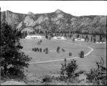 | 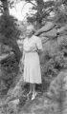 | 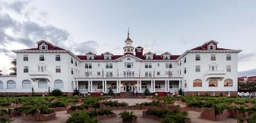 | 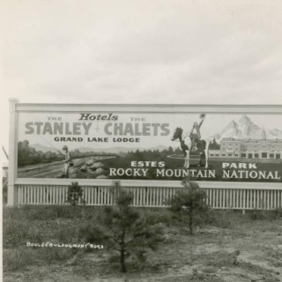 | 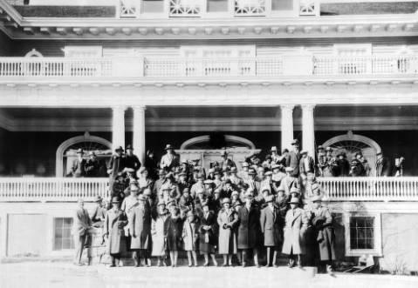 | 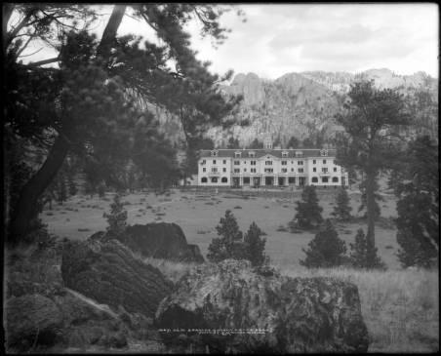
http://cdm16079.contentdm.oclc.org/cdm/singleitem/collection/p15330coll22/id/10725/rec/20 | http://digital.denverlibrary.org/cdm/singleitem/collection/p15330coll21/id/5943/rec/12 | http://www.loc.gov/pictures/resource/highsm.33392 | http://cdm16079.contentdm.oclc.org/cdm/ref/collection/p15330coll22/id/84389 | http://cdm16079.contentdm.oclc.org/cdm/ref/collection/p15330coll22/id/9288 | http://cdm16079.contentdm.oclc.org/cdm/ref/collection/p15330coll22/id/739

Taken from the Stanley Hotel looking South | Stanley Hotel Image of Tourists/Citizens on Horseback | Stanley Hotel Video – Current Media | Stanley Hotel National Register of Historic Places Nomination – Front Steps | Stanley Hotel District National Register Nomination View of the Complex from the North | Lake Hotel, .5 miles East of Grand Loop Road and 1.3 miles southwest of Lake Junction Lake, Teton County WY.
Taken from the Stanley Hotel. Tourists and visitors enjoy the swimming pool at the Stanley Hotel in Estes Park, CO. The town of Estes Park is below, and Longs Peak and the mountain range is in the distance. | Men and women pose on horseback near the Stanley Hotel in Estes Park, CO. One man stands on his saddle and tips his hat. An automobile is parked nearby. c. 1946 | Video of Stanley Hotel Tour. It is posted on the official Stanley Hotel website and offers a glimpse inside the beautiful hotel and references some of the stories of haunted rooms. | Application for inclusion of the Stanley Hotel in the National Register of Historic Places. 1977 | Historic photo of the area around the Stanley from a different perspective than others in this collection. | Looking North toward dining room and Portico. 33 photos found in the Historic American Building Survey (HABS) Collection of the Library of Congress.
This image allows students to see the type of outdoor activities that took place at the complex. | This reflects some of the people who would have visited the Stanley Hotel in the 1940’s. It also is a closer image of the refined hotel architectural details that would appeal to upper class clientele. | This video provides a contemporary view of the Stanley Park Hotel and National Register District. | This gives immediate access to the National Register nomination of the Stanley Hotel District. The form PDF includes Significance (pgs. 3-5) and Building descriptions (pgs. 6-7). | This is a historic photo taken from the South side of the Stanley Hotel complex. It lends itself to the discussion of WHY the building would be built in this direction (with the mountains as a dramatic backdrop for the buildings). | As the oldest remaining hotel within Yellowstone National Park, Lake Hotel reflects the changes in visitor needs since its opening in 1891. It also represents the changes in architectural tastes over the years as reflected in the many additions and remodeling of the structure.

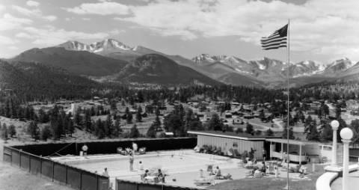 | 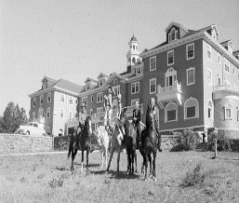 | 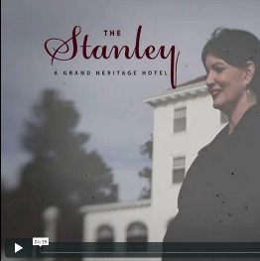 | 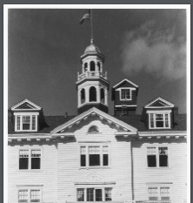 | 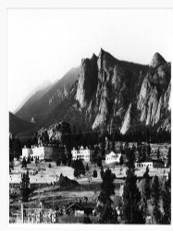 | 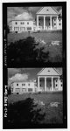
http://cdm16079.contentdm.oclc.org/cdm/ref/collection/p15330coll22/id/9599 | http://digital.denverlibrary.org/cdm/ref/collection/p15330coll21/id/5944 | https://vimeo.com/55211762 | http://focus.nps.gov/nrhp/AssetDetail?assetID=177d3c4b-5ce8-471b-817d-78afa468700b | http://focus.nps.gov/nrhp/AssetDetail?assetID=d68ffac4-1e44-422a-bb80-e3d15faf504c | https://www.loc.gov/resource/hhh.wy0308.photos?st=gallery

Lake Hotel, Yellowstone Park, WY National Register of Historic Places Nomination Form | Stanley Hotel District National Register of Historic Places Nomination Form | Stanley Hotel Arial Photo
Nomination form contains 28 pages of information and photos of the hotel. | Expanded 1985 Nomination Form for the Stanley Hotel District. | 1994 State Historical Fund grant application accessed via COMPASS. Resource includes site map, photographs and other historical information. Rich resource.
The information contained in the nomination form can be used to compare this hotel to the Stanley Hotel as a means to understand tourist society in the early 20th century. | The form includes 13 pages listing the significance of the buildings that make up the district. It also includes maps of the area and a biography of F.O. Stanley. | This image provides an overview of the area and can be compared to a contemporary Google Earth link for analysis of changes over time of the built environment.
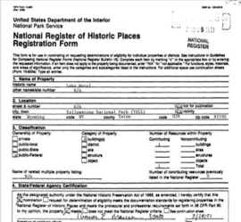 |  | 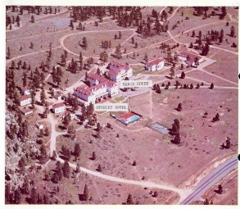
https://npgallery.nps.gov/NRHP/AssetDetail?assetID=1d810861-607e-496e-b909-e783d38f188c | https://npgallery.nps.gov/NRHP/AssetDetail?assetID=9ece3884-d4ea-4e3e-910d-432413ca2245 | http://gis.co.gov/OAHP_Images/5LR/478/5LR_478-b_Site_Form.pdf

Foundations Annotations
Curriculum Connections

History
Geography
Curriculum Standards

CO State Geography Standard 1: Use several types of geographic tools to answer questions about the geography of Colorado. (Fourth Grade)
d. Illustrate, using geographic tools, how places in Colorado have changed and developed over time due to human activity.
CO State History Standard 1: Organize and sequence events to understand the concepts of chronology and cause and effect in the history of Colorado. (Fourth Grade)
a. Construct a timeline of events showing the relationship of events in Colorado history with events in United States and world history.
c. Explain the cause-and-effect relationships in the interactions among people and cultures that have lived in or migrated to Colorado.
d. Identify and describe how major political and cultural groups have affected the development of the region.
Content and Thinking Objectives

Students will be able to:
- use maps and photos to understand how we interpret the past and how humans use space in their natural and built environment. (Third Grade)
- make a claim and be able to support it with evidence. (Fourth Grade)
- understand change and transformation over time. (Fifth Grade)
- examine places, regions and the connections among them. (Prepared graduates in Geography [2])
- analyze key historical periods and patterns of change over time within and across nations and cultures. (Prepared graduates in History [1])
Objectives are based on the Colorado Department of Education Content Connections located at:
https://www.cde.state.co.us/contentareas/contentconnections/5gr_changetransform

Inquiry Questions, Activities and Strategies

Inquiry Activities
Using the primary and secondary set of sources, ask students to investigate why Estes Park developed as a tourist town at the turn of the 20th century under the guidance of F.O Stanley.
Ask students to debate whether or not Estes Park would have been established without the influence of F.O. Stanley.
Ask students to compare the architecture of the Yellowstone Lake Hotel with the Stanley Hotel (both built near or in National Parks at about the same time period) and discuss the message conveyed by the architecture.
Ask students to examine the panoramic photos and other historical images of Estes Park during the different time periods of development. How did the development of roads encourage people to travel and stay in Estes Park while contributing to the economy of the town?
Using the National Register Nominations for the Stanley Historic District and Stanley Hotel, determine why, in some instances, it is important to preserve a collection of buildings as a historic district rather than just one individual building on a particular site. How does a historic district contribute more fully to our understanding of the place?

Activity/Strategy Information from the Colorado Department of Education: https://www.cde.state.co.us/cosocialstudies/instructionalstrategies
Assessment Strategies

Depending upon how one uses the resources and which standards are chosen, assessment can take many forms. For example:

CO State Geography Standard 1: (d) (Fourth Grade) Classify and analyze the types of connections between the Yellowstone Hotel and the Stanley Hotel using primary source documents. Use a Venn diagram or a technology tool like Spicy Nodes to curate information.

CO State History Standard 1: (a and c) (Fourth Grade) After analyzing items from the resource set, construct a timeline of events showing the relationship of events in Colorado history with events in United States and explain the cause-and-effect relationships among the people and cultures that have lived in or migrated to Estes Park.

Other Resources
Web Resources

National Register of Historic Places: https://www.nps.gov/nr
Travel Information on the Stanley Hotel: http://www.familytravelcolorado.com/Stanley_Hotel_Estes_Park.html
Social Studies Strategies from the Colorado Department of Education: https://www.cde.state.co.us/cosocialstudies/instructionalstrategies
The Colorado Office of Archaeology and Historic Preservation Record on COMPASS: COMPASS Stanley Historic District Statement of Significance and Register Nomination (Contains both the 1977 and 1985 nominations and statements of significance.)
The 1977 National Register Significance Statement: National Park Service Stanley Hotel Register Nomination Significance Statement
Colorado Encyclopedia Entry on The Stanley Hotel: https://coloradoencyclopedia.org/article/stanley-hotel
Secondary Sources

Denny Von Fin, Stanley Hotel (Minnetonka, MN: Bellweather Media, 2014).
Rebecca F. Pittman, History and Haunting of the Stanley Hotel (Estes Park, CO: Rebecca Pittman, 2011).

Preservation Connection

The Stanley Hotel and associated buildings were built between 1909 and 1912. The complex represents a spectacular grouping of Classic Revival style buildings. The sophistication and-refinement of the design would be rare in any location; in the mountain west it is unique. The structures “are notable for their horizontal lines and extreme symmetry of different design elements combined with classical detail and ornamentation. This nineteenth century expression of Georgian architecture combined with classical elements is…unique to the Estes Park area.” (from: 1977 National Historic Register Nomination Form – Description section)

The Stanley Hotel and Stanley Hotel National Register Historic District play a critical role in the understanding of the tourism industry in Estes Park, Colorado as well as the nation in general. The National Register Nomination for the Stanley Hotel Historic District not only states the importance of the hotel as a tourist destination, but also as a landmark building on the landscape of the Estes Park Valley. The hotel was originally listed in the National Historic Register in 1977 along with four other buildings. In 1985 the nomination boundary was expanded to include more buildings and increased land. “The presence of the Stanley Hotel had a major impact on the tourist economy of Estes Park and…can be said to have placed the town on the map….because of the scope of its operation and its sheer magnificence, it quickly became a major tourist attraction.” (from: 1977 National Historic Register Nomination Form – Significance section)

Preservation Inquiry Questions

Why is it critical to preserve the Stanley Hotel for future generations?

How is the architecture of this building significant and unique to the Estes Park area?

How does the architecture of this building contribute to the development of the city of Estes Park as a tourist destination?

Why is it important to preserve not just the Stanley Hotel, but also the Stanley Historic District?

Working together to tell the story of our state!

Developers


Sponsors


Partners
