Title | Fort Garland
Developed by | Anthony Hodes, Education ala carte
Grade Level | 3 – 4
Essential Questions | How can primary sources and the built environment help us learn about Colorado’s past?  Why did people of various cultures migrate to and settle in Colorado?  How did the locations of settlements and the natural environment impact the homes and other buildings constructed?  Why/How is Fort Garland important in the settlement of the San Luis Valley and southern Colorado?
Contextual Paragraph | In 1858 Fort Garland was built at the order of Brigadier General John Garland to replace Fort Massachusetts as an outpost to protect settlers in the San Luis Valley. The buildings of the new fort were built of adobe mud bricks and the layout of the fort echoed that of other contemporary military posts in the West. It consisted of a rectangle of single-story buildings featuring a sally port (main entrance) on the south side. The rectangle encompassed a grassy parade ground lined with cottonwoods and a flagpole in the center. The buildings were made of adobe, their interiors plastered with mud and whitewashed with lime. Roofs were of sod. There were board floors, and open fireplaces, with stoves for additional heat. Water was obtained from Ute Creek, by means of an accquia (Spanish for canal or trench) flowing around the parade ground. Sanitary provisions, even at the post hospital, were primitive. When the fort was built, the nearest railroad was 950 miles away and six weeks were required for mail to go from Fort Garland to Washington. The post buildings formed a parallelogram around the parade ground. On the north side were the officers' quarters, on the east the cavalry barracks, on the west the infantry barracks, and on the south were two long buildings which served as offices and store rooms and housed the guard room and adjutant's headquarters.  As originally constructed, the fort could accommodate seven officers and two companies of one hundred men each. Kit Carson served as the commandant from 1866-1867. In September of 1879, the garrison at Fort Garland expanded to what would be its largest size ever which included 15 companies, most of which had to live in tents during a brutal snowy winter. Within a year, the Utes were militarily escorted out of their centuries-old central Rockies home and directed to sagebrush reservations in eastern Utah or smaller reservations in southern Colorado.  November 30, 1883, Fort Garland was abandoned as an active post of the United States Army. Its last garrison was Company A, 22nd Infantry, Captain Javan B. Irvine commanding. It stayed in operation until the coming of the railroad and the removal of American Indians decreased the need of the outpost in the San Luis Valley. Over time most of the structures fell down. Some were torn down. In 1928 a group of public-spirited citizens of the San Luis Valley bought the property to preserve the fort and in 1945 they presented it to the State Historical Society of Colorado for restoration and preservation. Today, only the buildings around the central parade grounds remain.
Resource Set
Fort Garland, between 1858-1883 | Proposed Fort Garland Restoration based on Official War Department Map 1867 | Fort Garland, 1879 | Fort Garland, exterior | John Garland, oil painting | Historical Sketch of Fort Garland
View of Fort Garland, in Fort Garland (Costilla County), CO. Soldiers stand by adobe barracks. c. 1858 and 1883. | Proposed Fort Garland Restoration based on Official War Department Map 1867. From Site Form and Nomination. | Fort Garland operated as a US Army post in the San Luis Valley from 1858 to 1883, helping to secure and enforce treaties with local Native Americans. | Exterior of Fort Garland, 1946. | Portrait of John Garland (for whom Fort Garland in CO was named) wearing a blue military uniform with clouds and mountains in the background. | Fort Garland about the time Kit Carson commanded. “New Mexico Geological Society 22nd Annual Fall Field Conference Guidebook,” p. 301.
Fort Garland was built in 1858 as an outpost to protect settlers from the Utes in the San Luis Valley.  Stereographic print. | Brigadier General John Garland, commander of the Ninth Military Department ordered that the fort be built. At times there were more than 1,000 men stationed and living at the Fort and in the camping area. | In 1861 the American Civil War was moving west; two companies of CO Volunteers were mustered into federal service at Fort Garland. They marched to bolster forces against the Texan Confederates, who were attempting to capture the West. With the defeat of the Texans near Santa Fe at Glorietta Pass in 1862, the West was saved for the Union. | At the time of this photo, Fort Garland had not been in use for 60 years and its adobe buildings had fallen into disrepair. | John Garland achieved the rank of Brigadier General and gave 50 years of service. His efforts and work were pivotal to the efforts of the Union in the southwest. He died while still active duty in New York City on June 5, 1861. | Key components to explore on this sketch:  Parade grounds, cavalry barracks, officer’s quarters, company quarters, infantry barracks, hospital, ice house, shops/laundress, stables, commissary, and pond.  This map illustrates the location of buildings at the fort.

 | 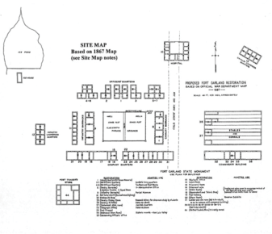 | 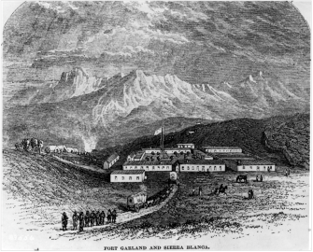 | 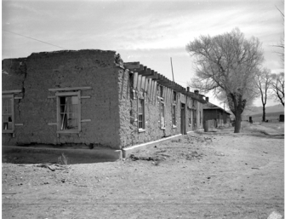 | 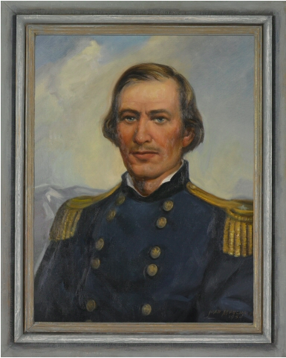 | 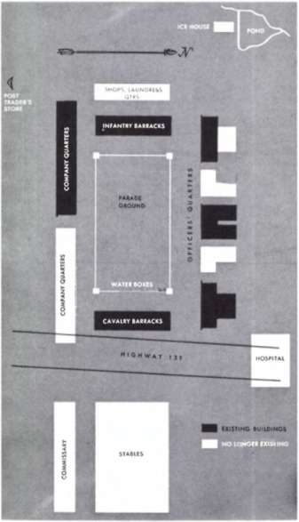
http://digital.denverlibrary.org/cdm/ref/collection/p15330coll22/id/73344 | http://gis.co.gov/OAHP_Images/5CT/46/5CT_46-d_Site_Form_and_Nomination.pdf | http://coloradoencyclopedia.org/image/fort-garland-1879 | http://5008.sydneyplus.com/HistoryColorado_ArgusNet_Final/Portal/Portal.aspx?component=BasicSearchResults&record=4cff3c0d-3d13-46bd-87b8-37f6c92464ba | http://5008.sydneyplus.com/HistoryColorado_ArgusNet_Final/Portal/Portal.aspx?component=BasicSearchResults&record=7be792ef-68ff-4afd-a961-1a62086643aa | https://nmgs.nmt.edu/publications/guidebooks/downloads/22/22_p0301_p0303.pdf

Colonel Doniphan and Fort Garland | No. 227-Fort Garland | Fort Garland, Plaque | Coin: Shield Nickel | Revolver used at Fort Garland | Main entrance to Fort Garland, CO
Depicted in the drawing is Colonel Alexander Doniphan, an officer in General Kearny's army. His bust is drawn on the left side. Major William Gilpin's bust is on the right. Between the two men is a drawing of Fort Garland in 1876. c. 1962-1963 | Buffalo soldiers at Fort Garland, 1875-1880.  Stereograph print. | Fort Garland, Plaque, 1946. | Heavily tarnished 1867 "shield nickel" without rays and without a mintmark (indicating Philadelphia) used by troopers at Fort Garland. | Forty-four caliber hinged break action center fire revolver. Nickel plated finish. Smooth walnut grips of rounded butt profile. Lanyard ring. Ribbed round barrel. 6-shot fluted cylinder. Single action. Checkered hammer spur. Used at Fort Garland, 1874-1878. | Main entrance to Fort Garland, CO. U.S. War Dept., Corps of Engineers; Geographical Explorations and Surveys West of 100th Meridian, Expedition of 1874; Lieutenant George M. Wheeler, commander.  Stereograph print.

The tenuous relationship between indigenous tribes such as the Utes and the Navajo and settlers led the establishment of Fort Garland. | Company G of the Ninth Cavalry, a unit of Buffalo Soldiers, operated out of the fort from the spring of 1876 until September 1879. The Buffalo Soldiers were African American troopers. | This plaque was erected in 1930 by State Historical Society of Colorado, and the Hua Atolla Chapter of the Daughters of the American Revolution. | This coin was issued from 1866 until 1883 and named for the design on it. It was recovered during the archaeological excavation of the fort. | The 44 caliber revolver was standard issue for US Army soldiers. | Note the flagstaff and cannons in the courtyard inside the entrance.
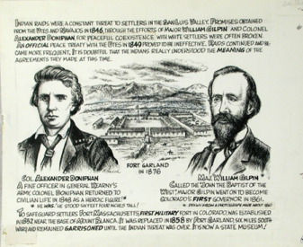 | 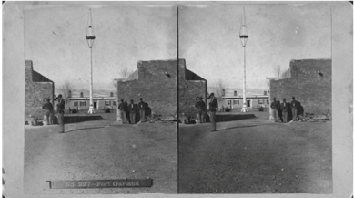 | 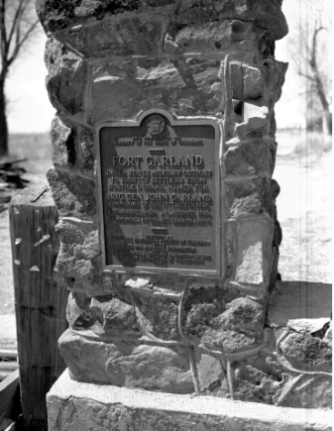 | 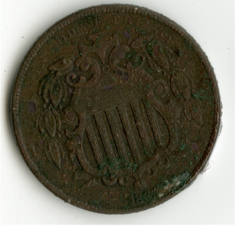 | 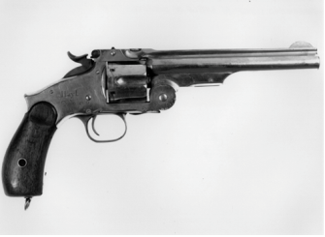 | 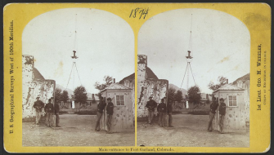
http://5008.sydneyplus.com/HistoryColorado_ArgusNet_Final/Portal/Portal.aspx?component=BasicSearchResults&record=d5d24b66-6595-49a4-b1d3-a3dbfa4a49c7&lang=en-US | http://5008.sydneyplus.com/HistoryColorado_ArgusNet_Final/Portal/Portal.aspx?component=BasicSearchResults&record=9eaeee83-5f40-4a35-a1e8-22c65a752ac1 | http://5008.sydneyplus.com/HistoryColorado_ArgusNet_Final/Portal/Portal.aspx?component=BasicSearchResults&record=7857a60d-234f-465a-87a5-6a08fdd5a2f6 | http://5008.sydneyplus.com/HistoryColorado_ArgusNet_Final/Portal/Portal.aspx?component=BasicSearchResults&record=d7e2742a-cf0c-4485-ba97-ffd804b26ad4&lang=en-US | http://5008.sydneyplus.com/HistoryColorado_ArgusNet_Final/Portal/Portal.aspx?component=BasicSearchResults&record=d9cf2232-84ed-4d8a-a970-08537f0aa0a7 | https://www.loc.gov/item/2005695629/

Fort Garland, CO, 1874 | Sierra Blanca Peak in Colorado in the background, Fort Garland, CO | Commandant’s Quarters | Company Quarter’s | Artifacts found during 2004-2005 field school excavation of Fort Garland | Site Form Nomination - Cultural Resource Re-evaluation Form, 2006
Fort Garland, CO. U.S. War Dept., Corps of Engineers; Geographical Explorations and Surveys West of 100th Meridian, Expedition of 1874; Lt. George. M. Wheeler, commander.  Stereograph print. | Fort Garland. U.S. War Dept., Corps of Engineers; Geographical Explorations and Surveys West of 100th Meridian, Expedition of 1874; Lt. George M. Wheeler, commander.  Stereograph print. | Commandant’s Quarters (Building 1 on 1867 map). The building presently houses museum displays devoted to Kit Carson. From Site Form and Nomination – Cultural Resource Re-evaluation Form, 2006. Page 56 | Company Quarter’s (Building 14-21 on 1867 map). From Site Form and Nomination – Cultural Resource Re-evaluation Form, 2006. Page 59 | High concentrations of bone, dishware, and bottle suggest that this might have been situated in a kitchen dump. From Site Form and Nomination – Cultural Resource Re-evaluation Form, 2006. Page 37 | Nomination form contains detailed preservation and archaeological information (108 pages). Included are photos, scale drawings, maps and descriptions.
Note the people in this photo of the Officer’s Quarters. Families lived in the three officer’s quarters. | The Fort was strategically located in the San Luis Valley. | Commanders had quarters that were exclusively for them. | These Company’s Quarters were reconstructed in the 1960s after the original structure was razed. | Extensive archeological excavation was conducted on this site from 2004-2006. | This form contains a wealth of information that provide fodder for any number of lessons and activities.
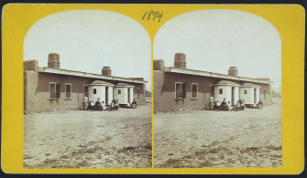 | 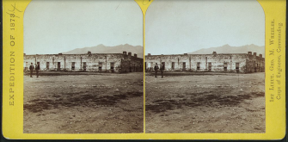 | 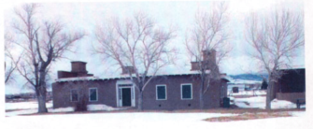 | 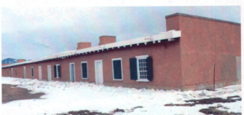 | 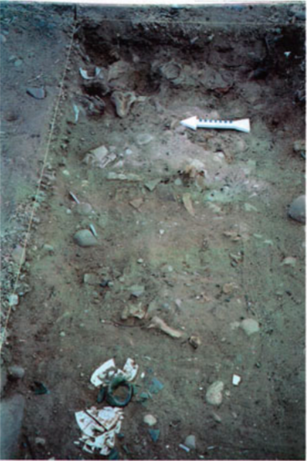 | 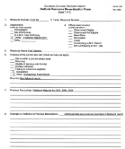
https://www.loc.gov/item/2005695628/ | https://www.loc.gov/item/2005695633/ | http://gis.co.gov/OAHP_Images/5CT/46/5CT_46-d_Site_Form_and_Nomination.pdf | http://gis.co.gov/OAHP_Images/5CT/46/5CT_46-d_Site_Form_and_Nomination.pdf | http://gis.co.gov/OAHP_Images/5CT/46/5CT_46-d_Site_Form_and_Nomination.pdf | http://gis.co.gov/OAHP_Images/5CT/46/5CT_46-d_Site_Form_and_Nomination.pdf

Foundations Annotations
Curriculum Connections

Economics

Geography

History
Curriculum Standards

CO State History Standard 2: People in the past influence the development and interaction of different communities or regions. (Third Grade)
- Describe the history, interaction, and contribution of the various peoples and cultures that have lived in or migrated to a community or region.

CO State History Standard 1: Organize and sequence events to understand the concepts of chronology and cause and effect in the history of Colorado. (Fourth Grade)
- Construct a timeline of events showing the relationship of events in Colorado history with events in United States and world history.
- Analyze primary source historical accounts related to Colorado history to understand cause-and-effect relationships.
- Explain the cause-and-effect relationships in the interactions among people and cultures that have lived in or migrated to Colorado.
- Identify and describe how major political and cultural groups have affected the development of the region.

CO State History Standard 2: The historical eras, individuals, groups, ideas and themes in Colorado history and their relationships to key events in the United States. (Fourth Grade)
- Analyze various eras in Colorado history and the relationship between these eras and eras in United States history, and the changes in Colorado over time.
- Describe interactions among people and cultures that have lived in Colorado.

CO State Geography Standard 2: The concept of regions is developed through an understanding of similarities and differences in places. (Third Grade)
- Observe and describe the physical characteristics and human features of a region.
- Identify the factors that make a region unique including cultural diversity, industry and agriculture, and landforms.
- Give examples of places that are similar and different from a local region.
Curriculum Standards (continued)

CO State Geography Standard 2: Connections within and across human and physical systems are developed. (Fourth Grade)
- Describe how the physical environment provides opportunities for and places constraints on human activities.
- Explain how physical environments influenced and limited migration into the state.
Analyze how people use geographic factors in creating settlements and have adapted to and modified the local physical environment.

CO State Economics Standard 1: People respond to positive and negative incentives. (Fourth Grade)
- Give examples of the kinds of goods and services produced in Colorado in different historical periods and their connection to economic incentives.
- Explain how the productive resources of Colorado have influenced the types of goods produced and services provided.

Content and Thinking Objectives

Students will be able to:
- compare and contrast changes in landscape over time.
- use primary sources to learn about the past.
- identify social and economic decisions that caused people to migrate to different regions.
- Describe life in another historical era, e.g., the 19th century in the San Luis Valley.

Inquiry Questions, Activities and Strategies

Inquiry Questions
What is the difference between a military fort like Fort Garland and a trading post fort like Bent’s Fort? What role does each play in migration and settlement?

Why did forts, settlements and cities develop where they did in Colorado?

What role did Kit Carson play in the history of Fort Garland and the San Luis Valley?

How was the construction of Fort Garland effected by the physical and human characteristics of the region?

Inquiry Questions, Activities and Strategies (continued)

Inquiry Activities
Look at the photos of Fort Garland and examine the adobe that was used in its construction. Explain why or why not adobe was a good choice for construction of the Fort. What other structures in the San Luis valley were built from adobe?

Research and describe the important role that the Buffalo Soldiers played at Fort Garland.

Examine the two maps of Fort Garland, the Proposed Fort Garland Restoration based on Official War Department Map 1867 and the Historical Sketch of Fort Garland. Find the following features on each map: Officers’ Quarters, Commandant’s Quarters, Infantry Barracks, Pond, Cavalry Barracks, Infantry Laundry, Mess Hall, Quartermaster/Commissary, Ice House Cavalry Stables, Hospital and Company Quarters. What activities took place in each area? Why were the structures located where they were? What types of places are not on this map (wells, outhouses, flagpole, garden, cemetery)? Where should they be located?

Assessment Strategies

Depending upon how one uses the resources and which standards are chosen, assessment can take many forms. For example:

CO State History Standard 1 (a, c) (Fourth Grade) Construct a timeline showing the relationship of events in Colorado with events in United States as they relate to westward expansion and the role Fort Garland played in that expansion. Explain the cause-and-effect relationships among the people and cultures that have lived in or migrated to the San Luis Valley. Include the US military, Buffalo Soldiers, Ute Indians, and Mexicans.

CO State Geography Standard 2: (a, b, c) (Fourth Grade) After analyzing items from the resource set, analyze the types of people who migrated westward and why? How did that migration impact Fort Garland? What geographic reasons would settlers have used to determine where they should settle? How might the built environment be effected as settlers moved westward across Colorado? How did westward expansion and the expansion of economic opportunity impact Native peoples? What evidence do you find about Fort Garland that supports this?

Other Resources
Web Resources

National Register of Historic Places: https://www.nps.gov/nr

James T. Forrest and Rosamund Slack, Old Fort Garland. Project Guttenberg: https://www.guttenberg.org/files/47492/47492-h/47492-h.htm

Museums of the San Luis Valley: http://www.museumtrail.org/the-story-of-fort-garland.html

Resources from History Colorado:
- http://www.historycolorado.org/sites/default/files/files/Researchers/ColoradoMagazine_v23n5_September1946.pdf
  - Edgar C. McMechan, “Historical Projects at Fort Garland and Pike's Stockade,” Colorado Magazine 23, no. 5 (1946).
- http://exhibits.historycolorado.org/lincolnhills/lincoln_home.html#africanAmericanColoradoans

Rocky Mountain PBS Colorado Experience “San Luis Valley”: http://rmpbs.org November 12, 2015.
- Click on Colorado Experience, scroll to “Places” click on “see more”

Site Form and Nomination – Cultural Resource Re-evaluation Form, 2006:
- http://gis.co.gov/OAHP_Images/5CT/46/5CT_46-d_Site_Form_and_Nomination.pdf

Secondary Sources

Anne Wainstein Bond, “Buffalo Soldiers at Fort Garland,” Colorado Heritage (Spring 1996).

Phil Carson, Fort Garland Museum: A Capsule History and Guide (Denver: Colorado Historical Society, 2005).

John Henry Nankivell, “Fort Garland, Colorado,” Colorado Magazine, 16, no. 1 (1939).

Preservation Connection

According to the Colorado State Office of Archaeology and Historic Preservation, “A cultural landscape is defined as ‘a geographic area,’ including both cultural and natural resources and the wildlife or domestic animals therein, associated with a historic event, activity or person or exhibiting other cultural or aesthetic values” (Charles A. Birnbaum, ASLA, Preservation Brief 36: Protecting Cultural Landscapes: Planning, Treatment and Management of Historic Landscapes, 1994). In the case of Fort Garland as a historic site it is a… “landscape significant for its association with a historic event, activity or person.”

The link to the Site Form and Nomination – Cultural Resource Re-evaluation Form, 2006 in the resource set provides a wealth of detailed information that can be used to help students understand the importance of preservation and its many facets. Teachers wanting to incorporate STEM related activities or lessons in their studies of history will find a plethora of sources in this 108-page document. The continuation of Section 16 [pages 16 and 17] located on about pages 90 and 91 in the document contains questions for research appropriate for older students.

Questions to consider for third and fourth graders:

- How would visiting Fort Garland help students to understand life in another time period and how its location was important to Colorado?

- If what remains of Fort Garland had not been preserved, how would studying these events in Colorado’s history be more challenging?

- Why is important to preserve endangered places and structures?

Working together to tell the story of our state!

Developers


Sponsors


Partners


