Title | Crystal Mill
Developed by | Anthony Hodes, Education ala Carte
Grade Level | 4-8
Essential Question | Why is it important to preserve sites like Crystal Mill?  What can be learned from Crystal Mill’s role in Colorado’s history?  What was the role played by silver mining in Colorado’s history?
Contextual Paragraph | The wooden Crystal Mill was constructed in 1892-1893 by George C. Eaton and B.S. Philips and was used as a powerhouse. It sits on a dramatic rock outcrop above the Crystal River near the town of Marble. It consists of three sections: the compressor house, the gear house, and the penstock. Originally it had a turbine waterwheel that generated more than 90 horsepower which operated a compressor. The compressed air was carried through pipelines for the Sheep Mountain Mining and Tunnel Company for silver mining. The mill generated power for mining operations until 1917 when the Sheep Mountain Mine closed. The Crystal Mill is reportedly one of the most photographed sites in Colorado and has appeared in many publications. Crystal Mill was placed in the National Register of Historic Places on July 5, 1985.  The settlement is reachable by four-wheel-drive vehicle along a narrow, rock-strewn road hugging a precipice. Crystal was incorporated on July 8, 1881, but mined as early as the 1860s. At its peak, Crystal had more than 400 residents, two newspapers, a pool hall, a men's club, a barber shop and two hotels. Miners sought silver, lead, copper, iron, and zinc. Very little gold has been discovered.

Resource Set
Sheep Mountain, Tunnel Mill, Crystal City | Waterfall in town of Crystal, Gunnison County, CO | Crystal Mill powerhouse | Crystal - 1947 | National Register of Historic Places Inventory—Nomination Form, Sheep Mountain Tunnel Mill/Crystal Mill, April 1985 | Crystal Mill, one of the most-photographed (though most difficult to reach) historic sites in Colorado
View of the Sheep Mountain Tunnel mill (also known as the Lost Horse Mill, Dead Horse Mill, and Crystal Mill) in Crystal (Gunnison County), CO. The log building is perched on a crag over the Crystal River. It includes a wooden structure built on the face of the rock that housed a vertical shaft from the horizontal water wheel that generated compressed air. The remains of a collapsed stamp mill are nearby. c. 1963. | View of the Crystal Mill powerhouse built in 1893, on Crystal River; shows the wooden dam with raised water level and the wooden shaft that turns the waterwheel; rooftops of the wood frame structures of Crystal City, CO in the distance, 1893. | View of the remains of the log Crystal Mill powerhouse built in 1893, on Crystal River, Gunnison County, CO. Shows the stamp mill in ruins. Photo taken circa 1960. | View of the Sheep Mountain Mill powerhouse building near Crystal (City), Gunnison County, CO. It includes a log building with a vestibule, a rustic ladder extending from the building down to the water, and an adjacent falling-apart building, 1947. | National Register Nomination forms contain a wealth of information including photos, history of the building, architecture, photos and more. | The mill sits in what is now mostly a ghost town, whose few residents leave the area in the brutal winters of the High Rockies. Crystal was incorporated on July 8, 1881, but mined as early as the 1860s. At its peak, Crystal had more than 400 residents. Miners sought silver, lead, copper, iron, and zinc. Very little gold has been discovered.

A modern day look at the approach to the mill and a sense of its geography and structure. The compressor house is the largest part of the structure. The smaller one-story structure is the gear house. Beneath the gear house are the remains of the penstock. The turbine waterwheel and all mill machinery are no longer present. The ruins of a collapsed stamp mill are nearby. | This image shows the mill soon after it was built and operational. The compressor house is the largest part of the structure and made of logs. The smaller one-story board and batten structure is the gear house. Beneath the gear house is the penstock constructed of rough milled beams using common mine timbering techniques. The dam system diverted water from the Crystal River to drive the powerhouse machinery. | Over time the mill fell into disrepair and no longer was an operational mill. Restoration efforts over the years aimed to stabilize the building with concrete footings and a cable system to prevent the building from leaning further over the river. | An earlier picture of the mill as it began to deteriorate. | The application for the Crystal Mill to be listed in the National Register of Historic places. | Current era picture of the Crystal Mill still precariously situated on the rock cliff.
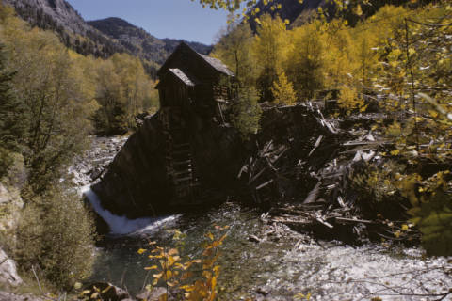 | 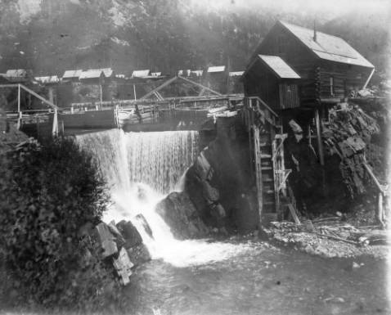 | 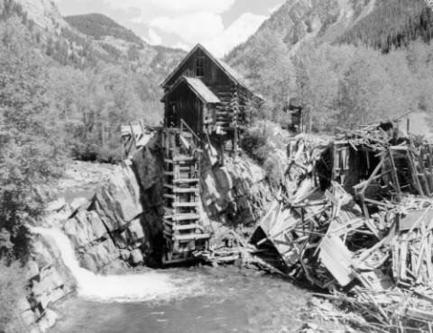 | 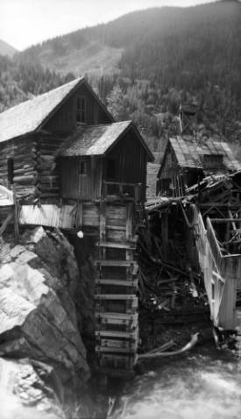 | 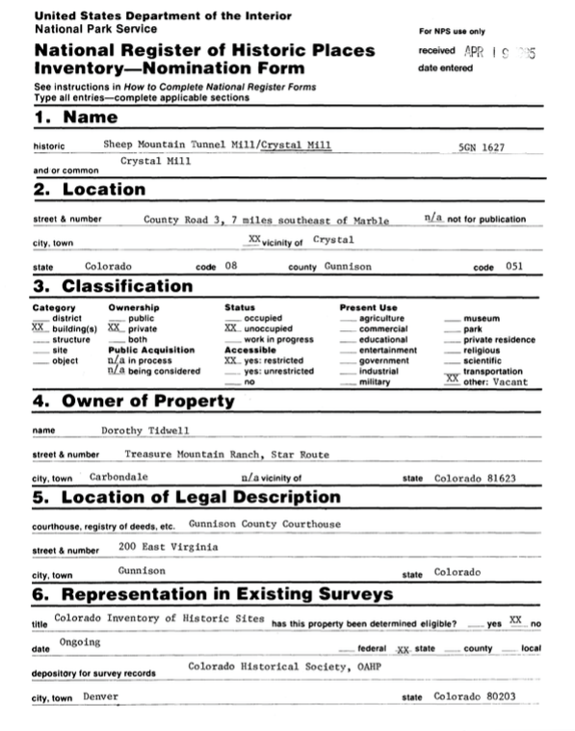 | 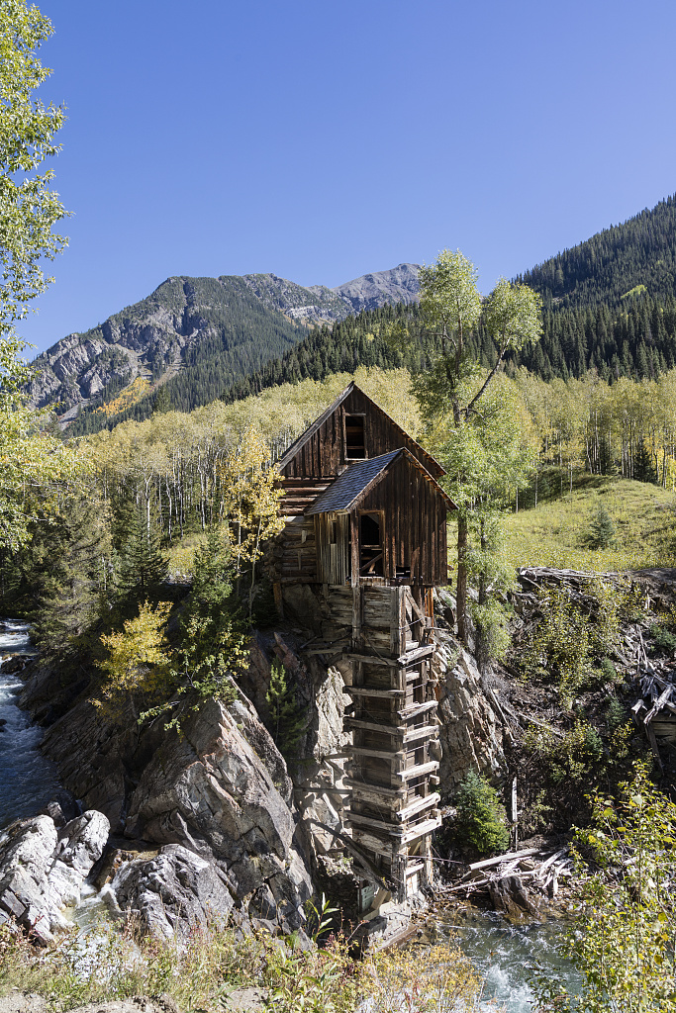
http://digital.denverlibrary.org/cdm/singleitem/collection/p15330coll22/id/84462/rec/3 | http://digital.denverlibrary.org/cdm/singleitem/collection/p15330coll22/id/5161/rec/5 | http://digital.denverlibrary.org/cdm/singleitem/collection/p15330coll22/id/5135/rec/1 | http://digital.denverlibrary.org/cdm/singleitem/collection/p15330coll22/id/87631/rec/15 | https://npgallery.nps.gov/nrhp/GetAsset?assetID=15311a1e-deda-4eea-ad81-bcec145281da | https://www.loc.gov/item/2017685219/
Crystal Mill, facing southeast | Crystal Mill, facing southeast | Crystal Mill, facing southwest | Crystal Mill, one of the most-photographed (though most difficult to reach) historic sites in CO
Crystal Mill, 7 miles east of Marble, CO in Gunnison County, 1984. | Crystal Mill, 7 miles east of Marble, CO in Gunnison County, 1984. | Crystal Mill, 7 miles east of Marble, CO in Gunnison County, 1984. | The mill sits in what is now mostly a ghost town, whose few residents leave the area in the brutal winters of the High Rockies, 2015.
Photos of the Crystal Mill from 1984. The compressor house is the largest part of the structure. It is made of hand-peeled round logs with v-notched corner joints. The gear house is the smaller one-story board and batten structure. Beneath the gear house is the penstock constructed of rough milled beams using common mine timbering techniques. The turbine waterwheel and all mill machinery are no longer present. The ruins of a collapsed stamp mill are nearby. | Photos of the Crystal Mill from 1984. The compressor house is the largest part of the structure. It is made of hand-peeled round logs with v-notched corner joints. The gear house is the smaller one-story board and batten structure. Beneath the gear house is the penstock constructed of rough milled beams using common mine timbering techniques. The turbine waterwheel and all mill machinery are no longer present. The ruins of a collapsed stamp mill are nearby. | Close up view of the powerhouse from 1984. The compressor house is the largest part of the structure. It is made of hand-peeled round logs with v-notched corner joints. The gear house is the smaller one-story board and batten structure. | Another current era photo of Crystal Mill which is now a ghost town.
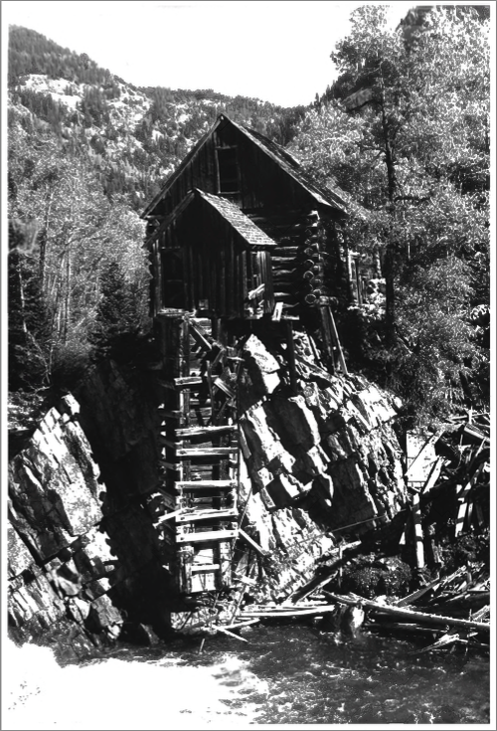 | 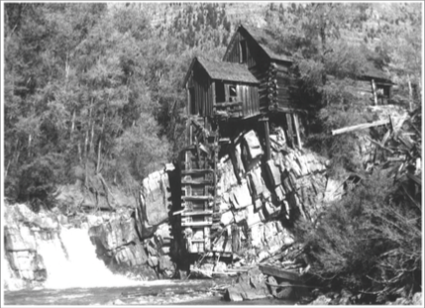 | 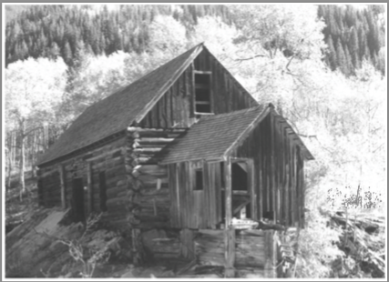 | 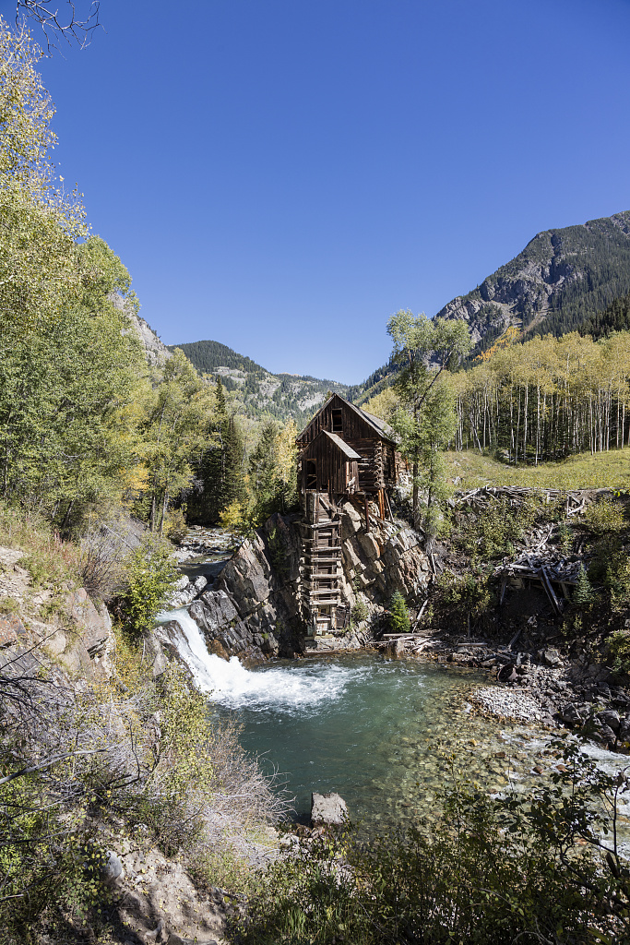
https://npgallery.nps.gov/GetAsset/e042e255-924e-4650-bafb-7f8324b1b68b/  image 2 | https://npgallery.nps.gov/GetAsset/e042e255-924e-4650-bafb-7f8324b1b68b/  image 3 | https://npgallery.nps.gov/GetAsset/e042e255-924e-4650-bafb-7f8324b1b68b/  image 4 | https://www.loc.gov/item/2017685218/

Foundations Annotations
Curriculum Connections

History

Geography

Reading/Writing

Curriculum Standards

CO History Standard 1: Organize and sequence events to understand the concepts of chronology and cause and effect in the history of Colorado. (Fourth Grade)
- Construct a timeline of events showing the relationship of events in Colorado history with events in United States and world history.
- Analyze primary source historical accounts related to Colorado history to understand cause-and-effect relationships.
- Explain the cause-and-effect relationships in the interactions among people and cultures that have lived in or migrated to Colorado.

CO Geography Standard 2: Connections within and across human and physical systems are developed. (Fourth Grade)
a. Describe how the physical environment provides opportunities for and places constraints on human activities.
b. Explain how physical environments influenced and limited migration into the state.

CO History Standard 1: Formulate appropriate hypotheses about United States history based on a variety of historical sources and perspectives. (Eighth Grade
- Use and interpret documents and other relevant primary and secondary sources pertaining to United States history from multiple perspectives.

CO Geography Standard 1: Use geographic tools to analyze patterns in human and physical systems. (Eighth Grade)
- Explain the establishment of human settlements in relationship to physical attributes and important regional connections.

CCSS.ELA-LITERACY.RH.6-8.1: Cite specific textual evidence to support analysis of primary and secondary sources.

CCSS.ELA-LITERACY.RH.6-8.2: Determine the central ideas or information of a primary or secondary source; provide an accurate summary of the source distinct from prior knowledge or opinions.

Content and Thinking Objectives

Students will be able to:
- analyze and question primary sources.
- describe life in another historical era.
- explain why settlements developed where they did in Colorado.
- describe the importance of a historic site.

Inquiry Questions, Activities and Strategies

Inquiry Activities
Compare images of Crystal Mill from 1893, 1947,1960, 1963, 1984, 2015. What features do you see? How have the building and structures changed over time?

Discuss the impact that silver boom and bust had on the settlement of Colorado.

Ask students to research the location of several silver mines in Colorado. Track the locations of these mines on a map and discuss the history of the settlement of these areas.

Explore the history of Crystal City from 1917 through present day. What impact does Crystal Mill and Crystal City have on today’s economy? Consider the role of tourism in Colorado.

Research the role powerhouses and mills played in Colorado. Compare this innovation with other forms of power used today and 100 years ago.

Inquiry Strategies
Use the Library of Congress’ Photo Analysis Sheet, and analyze two of the primary sources presented here. (http://www.loc.gov/teachers/usingprimarysources/resources/Analyzing_Photographs_and_Prints.pdf)

Assessment Strategies

Depending upon how one uses the resources and which standards are chosen, assessment can take many forms. For example:

CO History Standard 1 (a) (Fourth Grade) Using sources from the resource set, create a visual timeline of the evolution of Crystal Mill and the activities that happened there from 1893 to 2015.

CO Geography Standard (d) (Eighth Grade) Explain the establishment of Crystal Mill, Sheep Mountain Mining and Tunnel Company, and other activity in the area in relationship to physical attributes and important regional connections. Consider the milling activity in the area, including silver and marble.

Other Resources
Web Resources

National Register of Historic Places Homepage: www.nps.gov/nr

History Colorado: http://www.historycolorado.org/oahp/gunnison-county

Colorado Encyclopedia: https://coloradoencyclopedia.org/article/marble-mill-site

National Register of Historic Places Inventory: https://npgallery.nps.gov/nrhp/GetAsset?assetID=15311a1e-deda-4eea-ad81-bcec145281da

U.S. Forest Service History: https://www.fs.usda.gov/Internet/FSE_DOCUMENTS/stelprdb5187127.pdf

Marble, CO Tourism: http://www.marbletourismassociation.org/crystal_mill.html

Ghost Town Gallery: http://www.ghosttowngallery.com/htme/crystal.htm

Secondary Sources

Lisa Adler, prep., Mining-related Properties in the Colorado State Register of Historic Properties Third Edition Updated Through December 1, 2006, www.coloradohistory-oahp.org

http://www.crystaltalebooks.com

Preservation Connection

National Register 7/5/1985, 5GN.1627
“The powerhouse at Crystal known as Crystal Mill is notable in Colorado for its association with the development of the metal mining industry. It may be unique in the state for its use of water to generate power for historic underground mining-operations. The powerhouse was also locally significant in that it facilitated the mining process and allowed mining to continue in Crystal at the period of the Silver Crash when mining was not generally lucrative.” (National Register of Historic Places Nomination form)

The powerhouse used a turbine waterwheel to run an air compressor that powered air drills for the mine. The compressor house is the largest part of the structure. It is made of hand-peeled round logs with v-notched corner joints. The gear house is the smaller one-story board and batten structure. Beneath the gear house is the penstock constructed of rough milled beams using common mine timbering techniques. The waterwheel was located in the penstock.

Why is it important to preserve a site like Crystal Mill?

What can be learned from Crystal Mill and its role in the silver industry?

Why was the Crystal Mill and each of its individual buildings and structures built in that layout? How did it utilize the natural environment?

What features of the Mill still exist and what does it tell you about construction for its time? How does that compare to the way powerhouses are built today?

Working together to tell the story of our state!

Developers


Sponsors


Partners


