Title | Central City Opera House
Developed by | Anthony Hodes, Education ala Carte
Grade Level | 4 – 8
Essential Questions | How has the Central City Opera House remained a cultural center for the region throughout the years?  How did the mining industry impact the Opera House?  What can be learned from the Central City Opera House and the culture it houses?
Contextual Paragraph | At the time the opera house was built, Central City was a booming mining town. Residents were interested in bringing culture to Central City and located the opera house prominently on Eureka Street. The Central City Opera House was built by funds raised through the Gilpin County Opera House Association and it was the first permanent opera house built in Colorado. Designed by Robert S. Roeschlaub, noted Denver architect, its opening night was March 4, 1878. Its opening helped establish Central City as the cultural center of the state until 1881 when Tabor Opera House opened in Denver. Prominent 19th century actors such as Fannie Barlow, Edwin Booth (older brother of John Wilkes Booth), Madame Januschek, Joseph Jefferson and others performed at the Central City Opera House.  In 1896, the building was repaired and electricity was added. One of the original contractors, Peter MacFarlane helped renovate it in 1903. From 1910-1927 it operated as a movie theatre until it closed in January of 1927. In 1931 the Opera House was given to the University of Denver who restored it and opened it again on July 16, 1932. Lillian Gish starring in “Camille” was the main attraction at the reopening.  The Central City Opera House remains in operation today with the annual Summer Music Festival which includes the Flower Girl Presentation.

Resource Set
Opera House, Central City, Gilpin County, CO | Opera House, Central City, Gilpin County, CO | Opera House, Central City, Gilpin County, CO | Central City Opera House | Central City Opera House interior | Performance of "Camille"
View of the Central City Opera House from the street in 1933 or later. | A straight on photo of the Opera House from the street taken in 1933 or later. | Photograph of the Interior of the Opera House taken in 1933 or later. | Architectural features of the building include: a mansard roof, a dormer window, a balcony with spindles, and arched windows and entrances. A cow stands in the foreground. c. 1932 | View, from the stage, of the seating section of the Central City Opera House in Central City, CO. c. between 1930 and 1950. | View of a crowd in front of the Central City Opera House in Central City (Gilpin County), CO. Signs by the arched doors read: "The Central City Opera House Special New York Attraction, 8 Gala Performances July 16 to July 23 Miss Lillian Gish (herself in person) in 'Camille,'”1932.
This is one of the oldest photographs on file of the Central City Opera House. | This photo gives a three-dimensional view of the Opera House. | Part of the draw of the Opera House was the ornate internal details that included multi-colored paintings in a classical motif. They were painted by John C. Massman of San Francisco. | Strategically located on Eureka Street in Central City the Opera House has been one of the hubs of the city for many years | This photograph offers a more detailed view of the Opera House from the stage. It is how it would appear to the opera singers. | The Opera House had fallen into disrepair in the early 1900’s. After being given to Denver University, it was refurbished. This picture is from the re-opening.

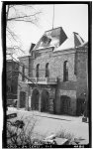 | 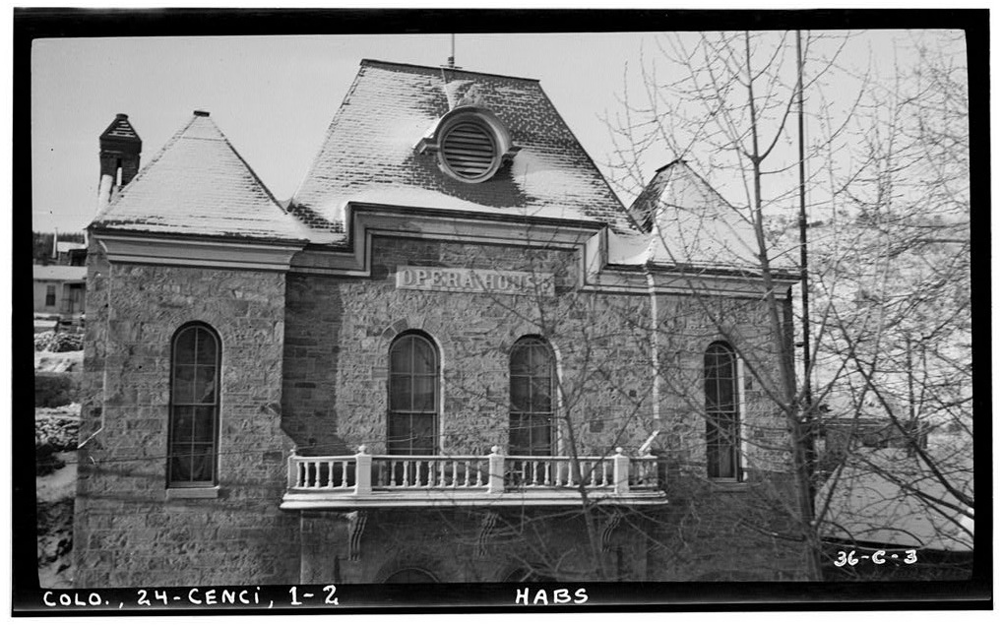 | 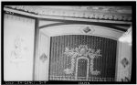 | 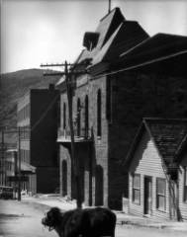 | 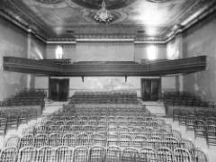 | 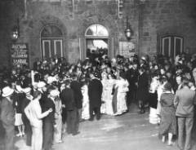
https://www.loc.gov/resource/hhh.co0023.photos/?sp=1 | https://www.loc.gov/resource/hhh.co0023.photos/?sp=2&st=single | https://cdn.loc.gov/service/pnp/habshaer/co/co0000/co0023/photos/021362p_150px.jpg | http://digital.denverlibrary.org/cdm/ref/collection/p15330coll22/id/9611 | http://digital.denverlibrary.org/cdm/ref/collection/p15330coll22/id/8480 | http://digital.denverlibrary.org/cdm/ref/collection/p15330coll22/id/78642

Central City | Opera House, Central City, 1938 | National Register Nomination form | Central City Opera House | Wanted – An Opera House, The Evening Call – Daily Register | Central City Opera House, Central City, CO, 1957
This photo of the town of Central City is from between 1898 and 1900. Several prominent buildings of Central City are visible, including the Central City public high school and St. Paul's Episcopal Church in the right mid-ground and the Teller House, the Central City Opera House and St. James Methodist Church in the center background. | Photograph from 1938 of the Central City Opera House which was renovated and reopened in the 1930s. Described as "the finest temple of the Muse west of the Missouri" and designed by Architect Robert S. Roeschlaub, the oldest opera house in Colorado. It is constructed of Gilpin County granite, except for the top and sides. | Form submitted in January of 1972 to nominate the Opera House for listing on the National Register of Historic Places.  It was nominated for its architecture and engineering as well as its musical significance. | Interior view of the Central City Opera House in Central City (Gilpin County), CO. It shows the stage curtain, the proscenium, ceiling frescoes, painted trompe l'oeil sculpture, and ornate trim. The theater has a patterned carpet and wooden spindle chairs with velvet cushions. April 1973. | Evening Call - Daily Register, March 8, 1878 | Cars are parked on Eureka Street in front of the of the Central City Opera House in Central City (Gilpin County), CO. The stone building had a mansard roof, a balcony and arched doorways. Lettering on the building reads: "Opera House." The four-story brick Teller House is next door.
The Opera House was an integral part of Central City. This photograph offers context as to the geography of the area and what kinds of businesses existed in and around this mountain town. | Upon re-opening, the Opera House returned to its status as one of the cultural centers for miles around. | The Central City Opera House was officially listed in the National Register of Historic Places in January of 1973. | The opulence of the Central City Opera House is still apparent nearly 100 years after it first opened. | The local newspaper’s viewpoint on the competition between Denver and Central City for the importance of an opera house. | Another view of the Opera House from the center of Central City. The Opera House has continued to host summer festivals that draw remarkable talents in the world of opera.

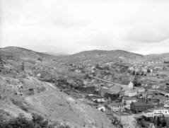 | 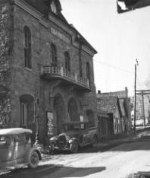 | 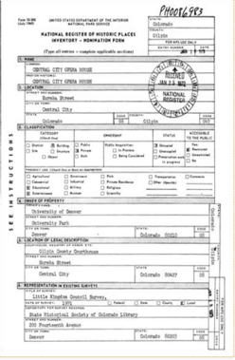 | 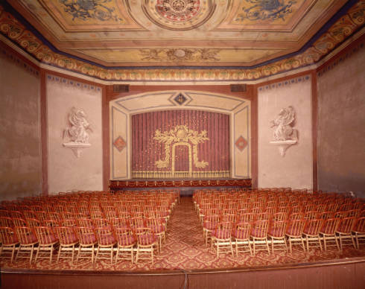 | 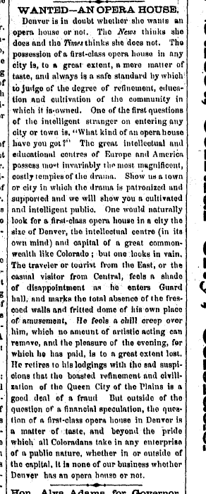 | 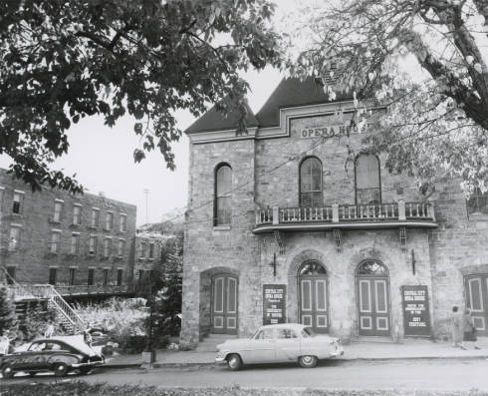
http://digital.denverlibrary.org/cdm/ref/collection/p15330coll22/id/74537 | http://digital.denverlibrary.org/cdm/ref/collection/p15330coll22/id/1702 | https://npgallery.nps.gov/NRHP/GetAsset/37266f3f-e5f3-41b3-aa15-c9b86d76a536?branding=NRHP | http://digital.denverlibrary.org/cdm/singleitem/collection/p15330coll22/id/82050/rec/21 | https://www.coloradohistoricnewspapers.org/cgi-bin/colorado?a=d&d=TEC18780308.2.12&srpos=6&e=08-03-1878-----en-20-TEC-1--txt-txIN-opera+house-------0-Gilpin | http://digital.denverlibrary.org/cdm/singleitem/collection/p15330coll22/id/88851/rec/28

Foundations Annotations
Curriculum Connections

History

Geography

Language Arts
Curriculum Standards

CO State History Standard 1: Organize and sequence events to understand the concepts of chronology and cause and effect in the history of Colorado. (Fourth Grade)
- Construct a timeline of events showing the relationship of events in Colorado history with events in United States and world history.
- Analyze primary source historical accounts related to Colorado history to understand cause-and-effect relationships.
- Explain the cause-and-effect relationships in the interactions among people and cultures that have lived in or migrated to Colorado.

CO State History Standard 2: The historical eras, individuals, groups, ideas and themes in Colorado history and their relationships to key events in the United States. (Fourth Grade)
- Describe interactions among people and cultures that have lived in Colorado.

CO State Geography Standard 2: Connections within and across human and physical systems are developed. (Fourth Grade)
- Describe how the physical environment provides opportunities for and places constraints on human activities.
- Explain how physical environments influenced and limited migration into the state.
- Analyze how people use geographic factors in creating settlements and have adapted to and modified the local physical environment.

CCSS.ELA-LITERACY.RH.6-8.1: Cite specific textual evidence to support analysis of primary and secondary sources.
CCSS.ELA-LITERACY.RH.6-8.2: Determine the central ideas or information of a primary or secondary source; provide an accurate summary of the source distinct from prior knowledge or opinions.

Content and Thinking Objectives

Students will be able to:
- explain why settlements developed where they did in Colorado.
- use primary sources to learn about the past.
- describe the importance of a historic site.
- identify social and economic decisions that caused people to migrate to different regions.
Inquiry Questions, Activities and Strategies

Inquiry Questions
Based on the photo of Central City taken from a mountain-top above the city, how can you tell the Opera House was an important part of the community?

Inquiry Activities
Read the newspaper article from The Evening Call, March 8, 1878. This article was published in Central City’s newspaper the same week that the Central City Opera House first opened. The article discusses the pros and cons of Denver opening its own Opera House. Knowing the rocky history of the Central City Opera House, write a brief essay about whether or not Denver should have opened an Opera House in the 1870s and 1880s. Discuss the similarities and differences in the history of the Tabor Grand Opera House and the Central City Opera House?

Research the history of opera and the role of opera houses in the United States. Discuss the role that the Central City Opera House played in that history.

Inquiry Strategies
Use the Library of Congress Primary Source Analysis tools (http://www.loc.gov/teachers/usingprimarysources/guides.html) to analyze these two primary sources from the resource set: Central City Opera House, Central City, CO., 1957 and Opera House, Central City, 1938.

Assessment Strategies

Depending upon how one uses the resources and which standards are chosen, assessment can take many forms. For example:

CO State History Standard 1 (a-c) (Fourth Grade) Using the primary sources provided along with others you find in your research of Central City and Gilpin County, create a visual timeline of Central City Opera House and Gilpin County and the related activities that happened there. Include the boom and bust history of the Opera House and how that related to the boom and bust of the mining industry.

CO State Geography Standard 2 (a-c) (Eighth Grade) Explain the establishment of the Central City Opera House and other activities in the area in relation to physical attributes and important regional connections. Consider the other buildings and businesses, the mines, the railroad and other factors that impacted migration to Gilpin County.
Other Resources
Web Resources

National Register of Historic Places: https://www.nps.gov/nr

Central City Opera: https://centralcityopera.org/programs/historic-preservation/historic-properties

Resources from the Colorado Encyclopedia: http://coloradoencyclopedia.org/search/google/Central%20City%20Opera%20House

Resources from History Colorado: http://www.historycolorado.org/event/tabor-legacy-central-city-opera-and-leadville-bus

National Register Digital Assets: https://npgallery.nps.gov/AssetDetail/37266f3f-e5f3-41b3-aa15-c9b86d76a536

Secondary Sources

Roger Baker, Before Camille: The First Fifty-Five Years of the Central City Opera House and Theater in Central City (Central City, CO: Black Hawk Publishing, 2007).
Alan Granruth, ed., The Little Kingdom of Gilpin: Gilpin County, Colorado (Gilpin County Historical Society, 2000).

Charles A. Johnson, Opera in the Rockies: A History of the Central City Opera House Association, 1932-1992 (Central City, CO: Central City Opera House Association, 1992).
Charles Henry Johnson, Jr., The Central City Opera House: A 100 Year History (Colorado Springs, CO: Little London Press, 1980). http://c70003.eos-intl.net/C70003/OPAC/Details/Record.aspx?BibCode=1345825

Preservation Connection

The Renaissance Revival Style Central City Opera was the first opera house opened in the state of Colorado. As a cultural center for the state and then the mountain towns, its structure reflected the boom and bust of the mining industry that surrounded it. Designed by Colorado’s first officially licensed architect, Robert S. Roeschlaub, it was listed in the National Register of Historic Places in January of 1973.

Significant for its architecture and engineering, the opera house has 4-foot thick walls. Constructed primarily of stone and brick, the exterior has changed very little over the years. Still on its original site it has such notable features as a double pitched shed roof on the north façade along with a false mansard roof flanked by 2 hipped roofs.

Questions to consider:

If you were writing the Nomination Form for the National Register, which components (architectural style, relationship to important people, building materials, place in history, etc.) would you highlight as the most significant reason to preserve the Central City Opera House?

What can be learned from the Central City Opera House and the culture that it houses?

Visit the Colorado Encyclopedia at www.coloradoencyclopedia.org and read about Robert Roeschlaub. What other historic Colorado buildings did he design?
Working together to tell the story of our state!
Developers


Sponsors


Partners


