Title | Barney Ford
Developed by | Cathy Fuller Guardian Angels School Denver, CO Archdiocese of Denver
Grade Level | Elementary / 3-5
Essential Question | Who was Barney Ford and what is his connection to Colorado history?  What were the opportunity costs of the decisions he made?
Contextual Paragraph | Barney Ford was a former slave who used the underground railroad to escape from a South Carolina plantation. He used the underground railroad to travel to Chicago, then further traveled west to settle in California. Ford and his wife never reached California, but instead started a hotel business in Nicaragua. Due to war in Nicaragua, Ford returned to Chicago where he ran a livery station that was also a part of the underground railroad. In 1860, the Fords went seeking prosperity with gold by traveling to Colorado. After failed mining attempts, and repeated instances of discrimination, Ford moved to Denver to try his hand at business. Ford did indeed become a successful businessman, building a barbershop, a restaurant and hotels. Ford became an influential statesman during the early days of Colorado’s statehood. He worked for civil rights of African American citizens including the right to vote and greater education opportunities. His story is an example of determination and intelligence bringing about change in America.

Resource Set
Statue of Barney Ford in Breckenridge, Colorado | The Ford House | Re-created classroom inside the Ford House | 1514 Blake Street Denver | Barney Ford | Residence of BL Ford Breckenridge
Ford, a onetime runaway mulatto slave, who discovered gold on what is now Barney Ford Hill nearby, made a fortune | Designed by Elias Nashold and built in 1882 in Breckenridge, Colorado | Re-created classroom inside the Ford House, designed by Elias Nashold and built in 1882 in Breckenridge, Colorado | View of a commercial building at 1514 Blake Street (built 1863 - at onetime Barney Ford's People's Restaurant) in the Union Station Neighborhood of Denver, Colorado. | Barney Ford 1822-1902 Businessman Came to Denver in 1860 | Reproduction of a print of the Barney L. Ford house in Breckenridge (Summit County), Colorado.
Ford contributed to the development of Breckenridge, CO | This circa 1882 house was built for Barney Ford, who escaped slavery to become a prosperous entrepreneur and activist. | By the 1870s, Ford had become one of the wealthiest men in Colorado. He and a friend, Henry Wagoner, founded a school for African Americans. | The People’s Restaurant, Ford’s first successful restaurant in Colorado, is the only property that still stands that once belonged to Ford. | Barney Ford was nominated as a member of the Colorado Black Hall of Fame in 1973. | At the time it was built in 1882, this house was one of the finest in Breckenridge, but had no kitchen as Ford owned a restraint down the street.
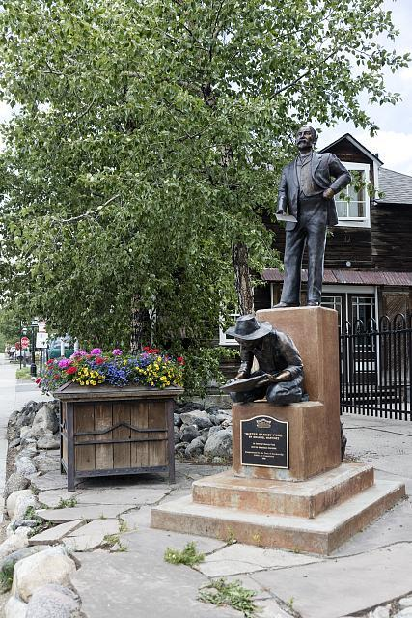 | 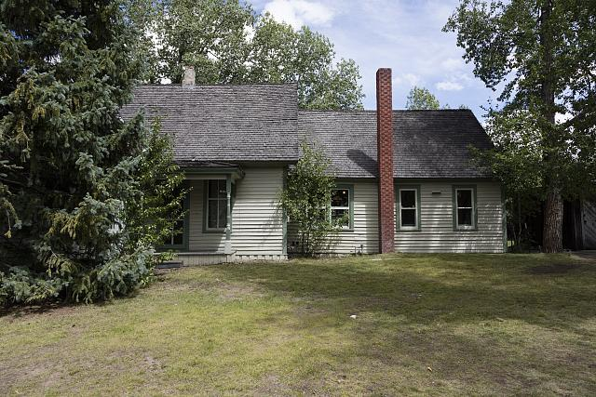 | 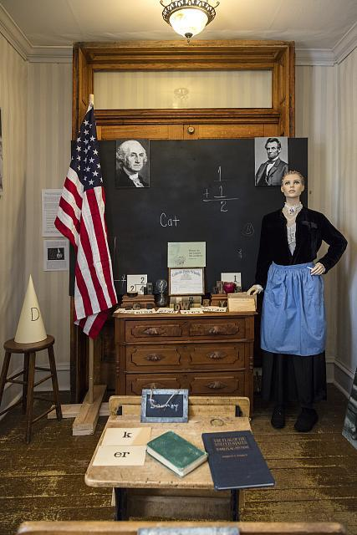 | 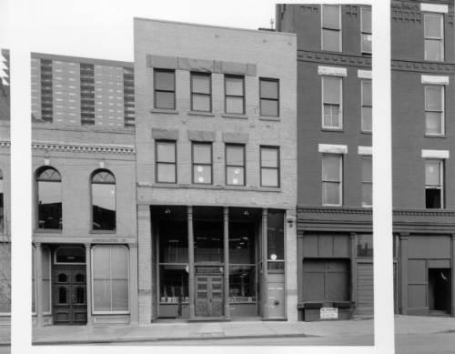 | 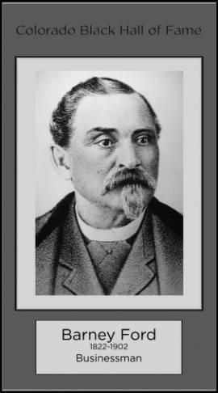 | 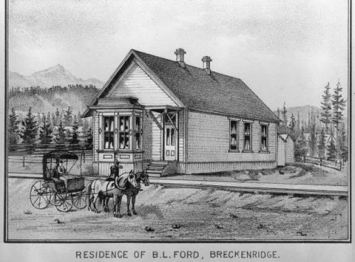
https://www.loc.gov/item/2015633653/ | https://www.loc.gov/resource/highsm.33637/ | https://www.loc.gov/resource/highsm.33637/ | http://digital.denverlibrary.org/cdm/ref/collection/p15330coll22/id/83377 | http://digital.denverlibrary.org/cdm/ref/collection/p15330coll23/id/9916 | http://digital.denverlibrary.org/cdm/ref/collection/p15330coll22/id/84106

Former Colored member of legislature is dead | Inter-Ocean Hotel in Denver | Barney L. Ford Building | Barney L. Ford art original | Inter-Ocean Hotel Cheyenne, Wyoming BL Ford proprietor | A view from Nigger Hill showing Breckenridge.
Obituary of Barney L. Ford and brief highlights of his life. Clipping includes a photograph of an elderly Mr. Ford. Date 1902 | The Inter-Ocean Hotel opened on October 29, 1873, at the corner of 16th (Sixteenth) and Blake Streets in downtown Denver, Colorado, built by Barney L. Ford, a prominent African American businessman. | Exterior photograph of the Barney L. Ford Building located in Denver, Colorado. Portions of the three-story brick commercial structure date from the 1860s. | Barney L. Ford art original | Illustration of the Inter-Ocean Hotel at the corner the 16th (Sixteenth) and Capitol in Cheyenne (Laramie County), Wyoming. | A view from Nigger Hill showing Breckenridge in the Blue River Valley and the Tenmile Range in the background. Date: 1929
Obituaries often show the contributions of a person to their community. This obituary recounts Ford’s escape from slavery and real estate holdings | The building was razed in the early 1970s | The building is important for its association with Barney L. Ford an early Denver businessman, civic leader, and politician | Painting of Barney Ford showing his age when he came to Denver. | Letters on the front of the hotel read: "1875 Inter-Ocean Hotel, B.L. Ford." Date between c. 1875 and 1880. | View of Breckenridge, Colorado, northwest, from Barney Ford Hill (formerly called "Nigger Hill").
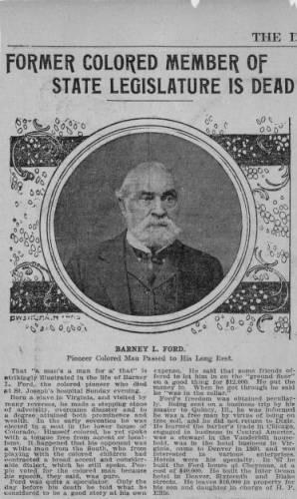 | 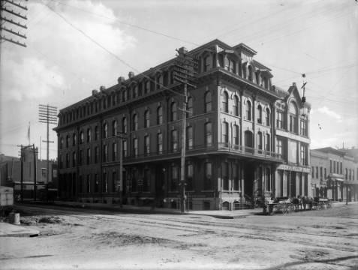 | 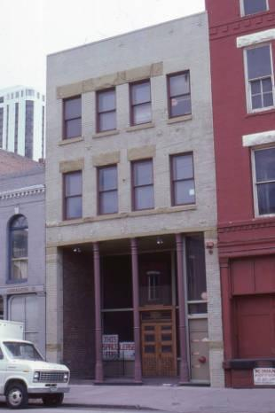 | 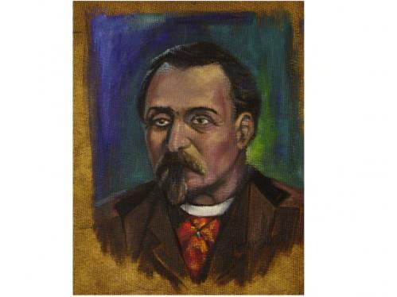 | 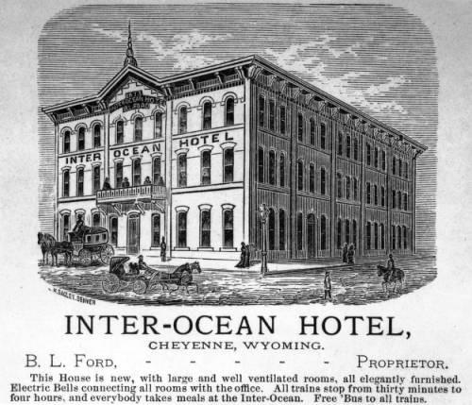 | 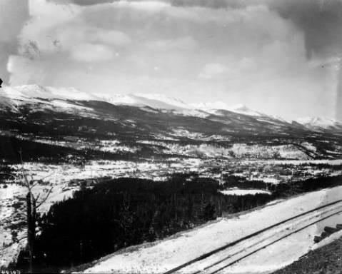
http://digital.denverlibrary.org/cdm/ref/collection/p15330coll22/id/84111 | http://digital.denverlibrary.org/cdm/ref/collection/p15330coll22/id/76319 | http://digital.denverlibrary.org/cdm/ref/collection/p16079coll2/id/1074 | http://digital.denverlibrary.org/cdm/ref/collection/p15330coll22/id/84654 | http://digital.denverlibrary.org/cdm/ref/collection/p15330coll22/id/84107 | http://digital.denverlibrary.org/cdm/ref/collection/p15330coll22/id/2505

Foundations Annotations
Curriculum Connections

- History
- Economics
Curriculum Standards

CO State History Standard 1: Organize and sequence events to understand the concepts of chronology and cause and effect in the history of Colorado
- a. Analyze primary source historical accounts related to Colorado history to understand cause-and-effect relationships
- c. Explain the cause-and-effect relationships in the interactions among people and cultures that have lived in or migrated to Colorado
- d. Identify and describe how major political and cultural groups have affected the development of the region

CO State History Standard 2: The historical eras, individuals, groups, ideas and themes in Colorado history and their relationships to key events in the United States
- d. Describe interactions among people and cultures that have lived in Colorado

CO State Economics Standard 2: The relationship between choice and opportunity cost
- a. Define choice and opportunity cost
- b. Analyze different choices and their opportunity costs
- c. Give examples of the opportunity costs for individual decisions
- d. Identify risks that individuals face

Content and Thinking Objectives

- Students will be able to arrange the events in Barney Ford’s life.
- Students will be able to analyze the choices Barney Ford made in terms of opportunity cost.
- Students will be able to explain the impact Barney Ford had on Colorado’s statehood.
- Students will be able to investigate the role of discrimination on African Americans in the American West.
- Students will be able to identify the names and contributions of African Americans who used the Underground Railroad to escape slavery.

Inquiry Questions, Activities and Strategies

- Using the primary sources provided, make a visual timeline of the Barney Ford’s life.
- Define opportunity cost. Follow with a discussion asking students to identify the times when Ford had to make a decision that changed the course of his life. Students can answer questions such as: What factors affected his decisions? Why did he make one choice rather than another? Ask students to do a cost/benefit analysis using a t-chart.
- After reading about Ford’s life, ask students to predict what would have happened if Ford had not intervened in Colorado’s bid for statehood because of his beliefs about the disenfranchisement of African Americans in the Colorado Territory.
- Students may research other people who used the Underground Railroad to find success as free men/women.
Students can share the instances of discrimination that they faced that may have been barriers to their goals.

Assessment Strategies

Depending upon how one uses the resources and which standards are chosen, assessment can take many forms. For example:
- CO State History Standard 1: (c-d) Students identify different minority groups who settled the American West, then list their contributions to the settlement of certain areas, or their effects on legislation in western states.
- CO State History Standard 2 (d) Using one of the African Americans researched, students write an essay about his/her contributions to American History.
- CO State Economics Standard 2: (a-d) Ask students to do a cost/benefit analysis of their daily choices, then explain the opportunity cost of one of their decisions. Students may also do the same with the events of a famous historical figure.

Other Resources
Web Resources

- http://www.historycolorado.org/sites/default/files/files/Educators/3rd_4th/Barney_L_Ford.pdf
- http://www.blackpast.org/aaw/ford-barney-l-1822-1902
- http://ford-elementary-archive.wikispaces.dpsk12.org/Barney+Ford+Biography
- http://breckheritage.com/barney-ford-victorian-home/
- http://www.findagrave.com/cgi-bin/fg.cgi?page=gr&GRid=8821848
- https://www.nps.gov/nr/travel/underground/co1.htm
- https://savingplaces.org/stories/preserving-a-slice-of-african-american-history-at-the-barney-ford-house#.VyosI6MrKXX

Secondary Sources

Barney Ford: Pioneer Businessman (Great Lives in Colorado History) by Jamie Trumbull. Filter Press, Bilingual Edition, 2010 - For students and teachers
Barney Ford, Black Baron by Marian Talmadge. Dodd Mead, 1973 - For teachers

Preservation Connection

Barney Ford was one the first African Americans that fought for equal civil and voting rights for African Americans in Colorado. His accomplishments opened up the door for other minority entrepreneurs in the American West. Ford’s building, the People’s Restaurant at 1514 Blake Street is one of the few remaining buildings in Denver that is associated with him.

Working together to tell the story of our state!

Developers


Sponsors


Partners
