Title | Helen Ring Robinson
Developed by | Elizabeth Duncan and Rae Harris
Grade Level | 4 - 8
Essential Question | In what ways did Helen Ring Robinson’s life impact the development of Colorado and the United States?
Contextual Paragraph | Helen Ring Robinson (HRR) was the first woman elected to the Colorado State Senate in 1912 and the 2nd woman elected to a state senate in the U.S. As an elected state senator, she was involved in legislation that supported women, children, and working people. She was an active participant in the women’s suffrage movement and the peace movement. Her actions paved the way for other women in elected politics and helped to get women the right to vote throughout America with the passage of the 19th Amendment.

Resource Set
Helen Ring Robinson | Helen Ring Robinson, 1911 | Helen R. Robinson | Woman Senator On Stump, 9/22/1915 | Interior of Colorado State Capitol | Ruins Ludlow Colony- Trinidad, Colorado
Portrait, between 1910-1915 (50-55 years old) | Head and shoulders portrait of Helen Ring Robinson, educator, writer, politician and first woman State Senator of Colorado. She wears her hair up in a bun, a light dress with dark floral decoration and a pendant around her neck. | Photograph shows Colorado State Senator Helen Ring Robinson (1878-1923) possibly taken on the Ford Peace Expedition ship, the Oscar II. | New York Times article with the headline “Woman Senator On Stump” | Either the House of Representatives or the Senate in the Colorado State Capitol in Denver, Colorado. (1895-1905) | Photo shows ruins in the aftermath of the Ludlow Massacre, during which a tent camp of striking miners at Ludlow, Colorado was attacked by the Colorado National Guard on April 20, 1914.
This is a photograph of Helen Ring Robinson when she was in her 50s. | Helen Ring Robinson was known as a feminine, maternal woman, who was interested in the rights of women, children, and working people. | Before the U.S. entered World War I, Helen Ring Robinson joined an expedition that hoped to put an end to the fighting in Europe. | “Helen Ring Robinson of Colorado Defends the Suffrage Cause” – subtitle of the article. | Helen Ring Robinson was the first woman elected to the Colorado State Senate in 1912. Men in Colorado voted to extend voting rights and be elected to office in 1893. | HRR was instrumental in helping to end a deadly mining strike in Ludlow, Colorado. She was a supporter of miners and unions.
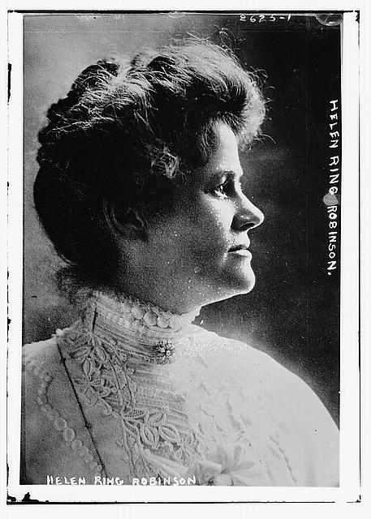 | 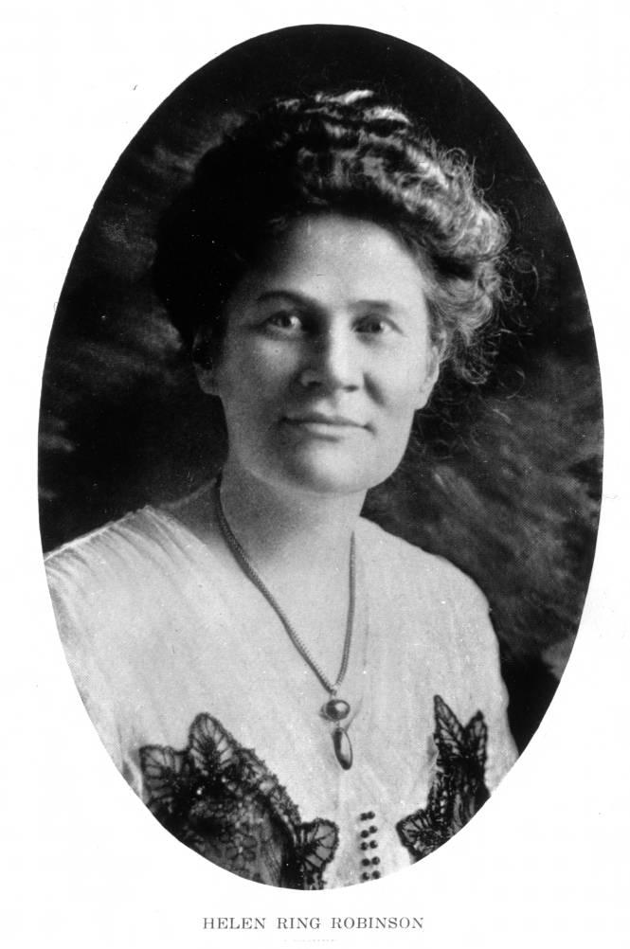 | 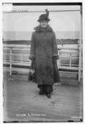 | 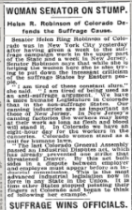 | 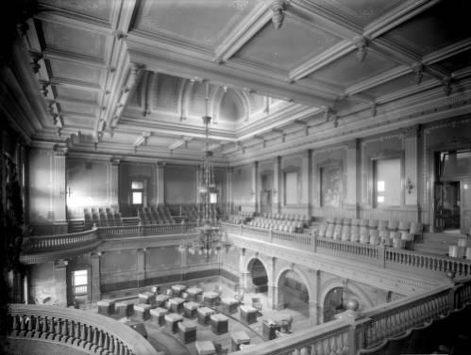 | 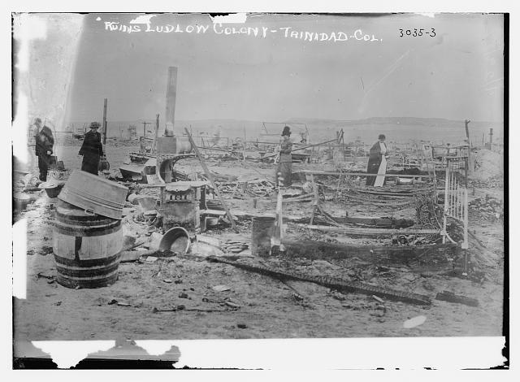
https://www.loc.gov/pictures/resource/ggbain.12451/ | https://digital.denverlibrary.org/digital/collection/p15330coll22/id/10812/rec/4 | https://www.loc.gov/pictures/item/2014700505/ | https://timesmachine.nytimes.com/timesmachine/1915/09/22/104654576.pdf?pdf_redirect=true&ip=0 | https://digital.denverlibrary.org/digital/collection/p15330coll22/id/74682/rec/5 | https://www.loc.gov/pictures/item/2014695836/

Colorado’s ratification of national suffrage amendment, Dec. 23, 1919 | Early women voters in Colorado 1900-1910 | Montclair School in 1897 | Coal miner’s family | Professor Libby Interviewed by Mrs. Robinson | Preparing Women for Citizenship
Photograph of crowd of people standing around desk as Colorado’s ratification of the 19th Amendment document is signed. | Well-dressed men and women stand on the porch of a building with signs that read: "Polling Place, Ward and District 9, Precinct 1" and "Election Notice." | Interior view of a classroom at Stanley School, Denver, Colorado, shows young students sitting side by side at long tables. | Women, girls, boys, and babies pose on stone steps; they are the family of a coal miner on strike in Ludlow, Colorado. | The Silver and Gold - University of Colorado Boulder, Volume XIX, Number 25, March 23, 1911 | Book written by Helen Ring Robinson
Women in Colorado were among the first women in the nation to be able to vote and hold office. HRR advocated for suffrage (voting rights for women) across the U.S. | Colorado granted women the right to vote and hold office in 1893. HRR was the first woman elected to serve in the Colorado State Senate. | As a senator, HRR chose to “look after the women and children.” In the field of education, she fought for minimum wage for teachers, support for rural and poor schools, and a minimum length for the school year. | HRR focused support on working people, like coal miners. The legislation she introduced was part of the “progressive movement” that was interested in improving the lives of all citizens. | Among her many interests, Helen Ring Robinson was very interested in education and interviewed Professor Libby of the University of Colorado on the topic when she was working as a journalist. | Helen Ring Robinson wrote this book to help prepare women for voting.  Topics listed in the Table of Contents, the opening paragraphs, and the final paragraph may be of particular interest.
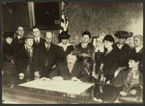 | 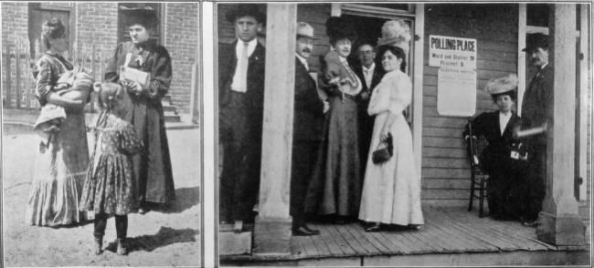 | 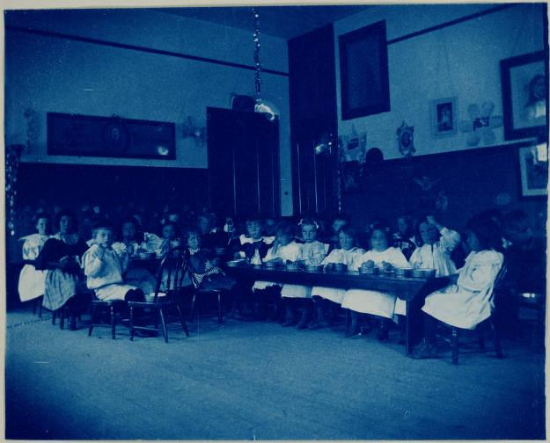 | 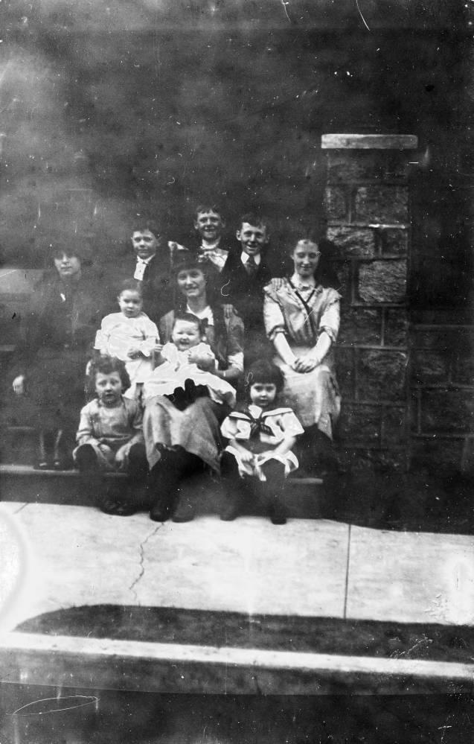 | 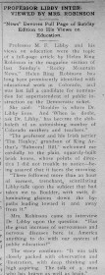 | 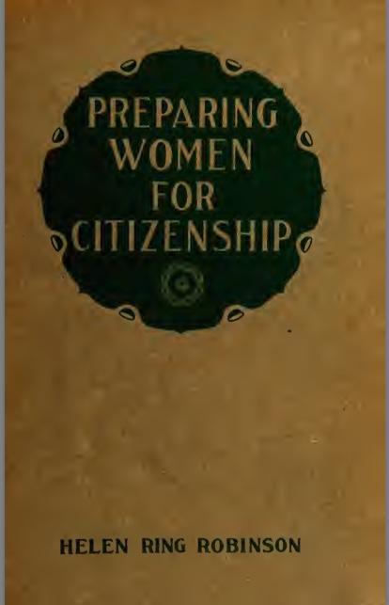
https://www.loc.gov/item/mnwp000305/ | https://digital.denverlibrary.org/digital/collection/p15330coll22/id/87832/rec/21 | https://digital.denverlibrary.org/digital/collection/p15330coll22/id/22924/rec/98 | https://digital.denverlibrary.org/digital/collection/p15330coll22/id/34139/rec/21 | https://www.coloradohistoricnewspapers.org/?a=d&d=SAG19110323-01.2.24&srpos=14&e=-------en-20--1--img-txIN%7ctxCO%7ctxTA-Helen+Ring+Robinson-------0------ | https://ia800202.us.archive.org/23/items/cu31924014107399/cu31924014107399.pdf

Helen Ring Robinson Dies at Hospital in Denver | Advertisement Helen Ring Robinson Candidate (see page 3) | Senator Helen Ring Robinson in Washington
Obituary of HRR in Walsenburg World newspaper on July 13, 1923. | Newspaper Clipping advocating Helen Ring Robinson for Colorado State Senate. | The Weekly Courier (Fort Collins, Larimer County) January 16, 1914

Article summarizes some of HRR’s contributions to Colorado and the U.S. | Helen Ring Robinson’s campaign focused on her hope to represent women and working people in Colorado. | Helen Ring Robinson was one of the principal figures at the national convention of suffragists.
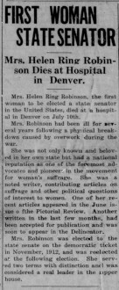 | 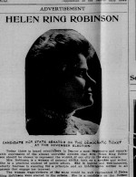 | 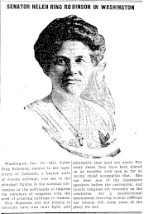
https://www.coloradohistoricnewspapers.org/?a=d&d=WWW19230713-01.2.7&srpos=2&e=-------en-20--1--img-txIN%7ctxCO%7ctxTA-helen+ring+robinson+dies-------0----- | https://www.coloradohistoricnewspapers.org/?a=d&d=ULB19121024-01&e=-------en-20--1--img-txIN%7ctxCO%7ctxTA-Helen+Ring+Robinson-------0------ | https://www.coloradohistoricnewspapers.org/?a=d&d=TWC19140116.2.82&srpos=24&e=-------en-20--21--img-txIN%7ctxCO%7ctxTA-Helen+Ring+Robinson-------0------
Foundations Annotations
Curriculum Connections

History
Civics
Curriculum Standards

CO State History Standard 1: Analyze primary and secondary sources from multiple points of view to develop an understanding of the history of Colorado. (Fourth Grade)
- Draw inferences about Colorado history from primary sources such as journals, diaries, maps, etc. Identify cause-and-effect relationships using primary sources to understand the history of Colorado's development.
- Identify and describe how major political and cultural groups have affected the development of the region.
CO State History Standard 2: The historical eras, individuals, groups, ideas, and themes in Colorado history and their relationship to key events in the United States within the same historical period. (Fourth Grade)
- Recognize and describe cause-and-effect relationships within Colorado history and draw conclusions about how various events and people affected the development of the state.
CO State Civics Standard 1: Identify, investigate, and analyze multiple perspectives on civic issues. (Fourth Grade)
- Identify and explain multiple perspectives when exploring issues faced by the state of Colorado.
- Discuss how various individuals and groups influence the way an issue affecting the state is viewed and resolved.
CO State Civics Standard 2: The origins, structures, and functions of the Colorado government. (Fourth Grade)
- Identify and explain a variety of roles leaders, citizens, and others play in state government.

Content and Thinking Objectives

The students will be able to demonstrate they understand that:

- Colorado was among the first states to allow women to vote and hold public office, enabling HRR to be elected.
- HRR brought a new perspective to the legislature, through her focus on improving the lives of women and children
- HRR had a unique position as one of the only elected female senators to be able to advocate for voting rights/suffrage for all women in the U.S.
- HRR was part of the Progressive movement that focused on social issues such as education, labor rights, food safety, and mental wellness.
- HRR lived her values of involved citizenship through her public activities, writing, and social priorities.

Inquiry Questions, Activities and Strategies

Inquiry Questions:

How did Helen Ring Robinson’s life influence her actions?

How was HHR important in expanding the focus of Colorado’s government?

What did HRR mean when she said, “I am going to be the housewife of the senate”? How was her focus different from the focus of her male colleagues?

Why was HRR influential in advocating for women to vote nationwide?

Inquiry Activities:

Read the article and study the attached resources.

Make a list of Helen Ring Robinson’s contributions to Colorado and the United States.

Assessment Strategies

Depending upon how one uses the resources and which standards are chosen, assessment can take many forms. For example:

CO History Standard 1 (Fourth Grade) The Legislature of Colorado wants to add a portrait of an influential Colorado senator to adorn the senate chamber. Write a persuasive essay nominating Helen Ring Robinson for this honor, citing her contributions and accomplishments.

Other Resources
Web Resources

Colorado Women’s Hall of Fame: https://www.cogreatwomen.org/inductees/women-in-the-hall/

Strong Sisters: http://www.strongsisters.org/helen-ring-robinson/

Google Books – Preparing Women for Citizenship: https://www.google.com/books/edition/Preparing_Women_for_Citizenship/tvoTAAAAIAAJ?hl=en&gbpv=1&dq=Helen+Ring+Robinson&printsec=frontcover#v=onepage&q=Helen%20Ring%20Robinson&f=false

Secondary Sources

Pascoe, Pat, Helen Ring Robinson: Colorado Senator and Suffragist, (Boulder: University Press of Colorado 2011).

Working together to tell the story of our state!
Developers

Sponsors

Partners
