Title | Hovenweep National Monument
Developed by | Laura Douglas, Education ala Carte
Grade Level | 3 – 4
Essential Question | How can primary sources help us learn about the past and how the people lived at the Hovenweep villages?  Why is it important to preserve archaeological sites like Hovenweep?  What can be learned from this site?  What social and economic decisions caused people to migrate to the Hovenweep and southwestern Colorado?

Contextual Paragraph | Hovenweep National Monument was established by President Warren G. Harding on March 2, 1923. The monument protects six prehistoric ancestral Puebloan villages that existed 800 years ago. It is located along a 16-mile stretch of land on the Utah-Colorado border west of Cortez, Colorado.  The villages include: Square Tower, Holly, Horseshoe, Hackberry, Cutthroat Castle, and Cajon. Square Tower is the largest section of the monument and contains the remains of almost thirty independent structures, including the impressive Square Tower, a three-story tower built on a boulder at the mouth of Little Ruin Canyon. Approximately 500 people lived near Square Tower.  Tree ring dating indicates most of the Hovenweep structures, including the square and circular towers, storage granaries, D-shaped dwellings and many kivas, were built in the mid-1200s beginning in 1230s and ending in the late 1270s.  Archaeologists are not clear how the structures of Hovenweep were used. The towers might have been celestial observatories, defensive structures, storage facilities, civil buildings, or homes. Most towers were associated with kivas, but their actual function remains a mystery. Architecture, masonry and pottery styles and features indicate that the approximate 2,500 inhabitants of Hovenweep were closely associated with groups living at Mesa Verde and other nearby sites.  By 1300, the Puebloan people throughout the Four Corners region had migrated to Arizona and New Mexico because of drought, and possibly warfare. The Hopi, Zuni, and Rio Grande Pueblo tribes are descendants of the ancestral Puebloan people. The name "Hovenweep" is a Paiute/Ute word meaning "Deserted Valley" which was used by photographer William Henry Jackson in 1874.

Resource Set

Ruins consisting of 700-year old structures, Hovenweep National Monument, 2015 | Cave dwellings near the fortified rock on the McElmo | Rocky Mountain PBS Colorado Experience: Living West: Water | Square Tower, Ruin Canon | Map of Canyon of the Ancients National Monument | Double tower and mesa buildings in Ruin Canon, Utah
Once home to over 2,500 people, Hovenweep includes six prehistoric villages built between 1200 and 1300 CE. A variety of structures, including multistory towers are perched on canyon rims and balanced on boulders. | View of North American Indian (Ancestral Puebloan) stone cliff dwellings in an eroded canyon wall in what is now Hovenweep National Monument, probably in Utah. Shows layered, eroded rock formations, brush and sparse trees in the valley and on top of mesas. A stone and masonry wall is below the cliff.  Photographed by William Henry Jackson. c. 1890 and 1900 | What happened to the Ancient Puebloans of Mesa Verde and Goodman Point? After settling in southwest Colorado for over 700 years, they suddenly left their cliff dwellings and spring side kivas, leaving behind a variety of archaeological treasures. Historians and archaeologists discuss the possibility that this drastic move was caused by a devastating drought in the southwest region. Published on Oct. 31, 2014. | View of Native American (Anasazi) dwelling ruins of Square Tower and Hovenweep Castle at Little Ruin Canyon in Hovenweep National Monument, Utah. Shows a tower-like structure, dwellings on top of a mesa, and stones scattered on the ground. c. 1900 | Map of the Canyon of the Ancients National Monument, 2006. | View of Twin Towers and Eroded Boulder (Bowlder) House, Native American (Anasazi) ruins of the Square Tower Group Ruins in Little Ruin Canyon, Hovenweep National Monument, Utah. c. 1900

This modern-day image of Hovenweep is a good example of how the structures were built on rocky terrain. | The rugged terrain and geographic features can be seen in this image showing how Hovenweep architecture was influenced by the terrain. | This 28-minute video provides a detailed description and images from the Four Corners region and a discussion about the Ancestral Puebloan people, agriculture and water. | The impressive construction on rocky terrain and the proximity of various structures is evident in this image. | This map can be used to demonstrate the relationship and proximity between Hovenweep National Monument and other Ancestral Puebloan people living in the area. | Stone dwellings with round and square walls are on a mesa top and under the cover of a rock.
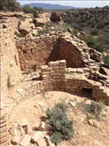 | 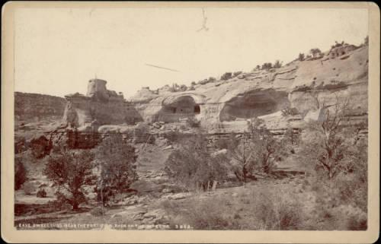 | 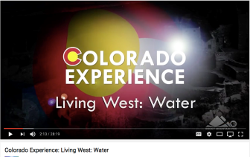 | 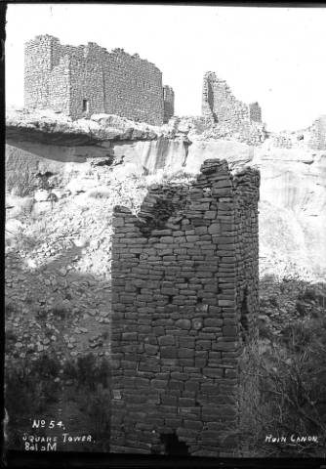 | 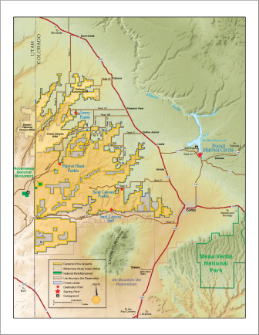 | 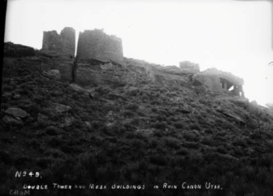
https://npgallery.nps.gov/AssetDetail/0e2e534b3ed748efa0bf5ffef1dd408f | http://digital.denverlibrary.org/cdm/singleitem/collection/p15330coll22/id/80191/rec/50 | https://www.youtube.com/watch?v=HYBAkSyiYas | http://digital.denverlibrary.org/cdm/singleitem/collection/p15330coll22/id/91091/rec/9 | https://upload.wikimedia.org/wikipedia/commons/7/7d/Map_of_Canyon_of_the_Ancients_National_Monument.png | http://digital.denverlibrary.org/cdm/singleitem/collection/p15330coll22/id/60845/rec/19

Ruined Fortress on the Hovenweep | Pre-historic ruin, Ruin Canon, UT | Square Tower Group, near park headquarters, Aneth, San Juan County, UT | Prehistoric Ruins in Holly Canyon, CO | Hovenweep National Monument, Colorado-Utah | Hovenweep, Little Ruin Trail Guide, NPS

View of ancient Native American (Anasazi) stone masonry ruins at what would become Hovenweep National Monument in Utah and Colorado. | Twin Towers of the Anasazi cliff dwelling ruins in Little Ruin Canyon, Hovenweep National Monument, Utah. Shows two rounded structures of masonry walls built on a cliff, one with a door at the base. c. 1908 | The Square Tower Group is one of six ruin complexes that together comprise the Hovenweep National Monument, an entity established in 1923 based on the recognition of the pre-European Pueblo Culture and on the significance of its stone masonry. | View of Native American (Ancestral Puebloan) ruins in Holly Canyon, in what later became Hovenweep National Monument in CO. c. 1898 | Map of Hovenweep National Monument and surrounding area in Utah and Colorado | This trail guide not only includes a map noting distances between each of the structures, it also gives a historical overview of the site and detailed information about each structure.
Most of the structures still standing at Hovenweep were constructed from 1230 to 1275, about the same time as the cliff dwellings at Mesa Verde. | The shape of the structures and location of the doorway is seen here. | Sketch of Square Tower Group from field notes from 1933. Demonstrates proximity of each structure on the site as well as rise in elevation. | The multi-story Square Tower has a slight spiral shape and demonstrates the detailed stone masonry. There are hackberry trees growing next to Square Tower where a seep can be found. The seep, or place where water would slowly ooze out of the ground, would have made this an ideal location for a structure. | This map gives a good idea of the distances between the various sites. | Illustrated and described in the trail guide are Twin Towers, Rim Rock House, Boulder House, Stronghold House, Unit Type House, Tower Point Hovenweep Castle and the Square Tower.

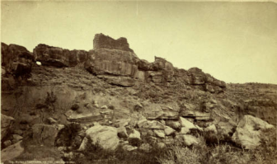 | 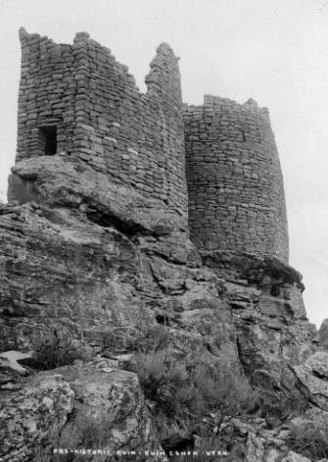 | 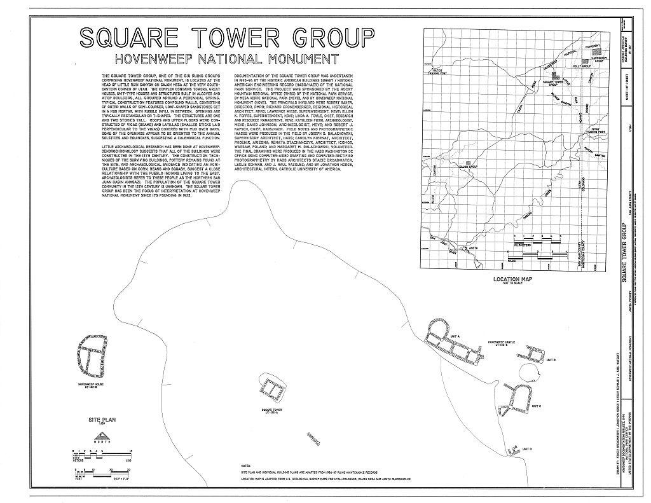 | 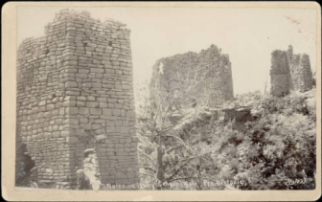 | 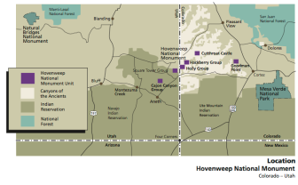 | 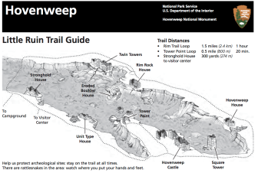
http://digital.denverlibrary.org/cdm/singleitem/collection/p15330coll22/id/24167/rec/25 | http://digital.denverlibrary.org/cdm/singleitem/collection/p15330coll22/id/21820/rec/46 | https://www.loc.gov/resource/hhh.ut0424.sheet | http://digital.denverlibrary.org/cdm/singleitem/collection/p15330coll22/id/72370/rec/32 | https://www.nps.gov/hove/learn/management/upload/HOVE_GMP-FINAL_2011.pdf  page 17 | https://www.nps.gov/hove/planyourvisit/upload/HOVELittleRuinTrailGuide_forWeb.pdf

Square Tower Group, Hovenweep Castle, near park headquarters, Aneth, San Juan County, UT | Square Tower Group, Hovenweep Castle, near park headquarters, Aneth, San Juan County, UT | Square Tower Group, Hovenweep Castle, near park headquarters, Aneth, San Juan County, UT | Square Tower Group, Square Tower, near park headquarters, Aneth, San Juan County, UT | Square Tower Group, Hovenweep Castle, near park headquarters, Aneth, San Juan County, UT | Square Tower Group, Hovenweep House, near park headquarters, Aneth, San Juan County, UT
View of central tower, Hovenweep Castle - Square Tower Group, Hovenweep Castle, near park headquarters, Aneth, San Juan County, UT.  Historic American Buildings Survey, 1933. | View of north wall, unit B - Square Tower Group, Hovenweep Castle, near park headquarters, Aneth, San Juan County, UT Survey number HABS UT-132-C. Historic American Buildings Survey, 1933. | North elevation, Hovenweep Castle - Square Tower Group, Hovenweep Castle, near park headquarters, Aneth, San Juan County, UT. Historic American Buildings Survey, 1933. | Closer view, southeast elevation - Square Tower Group, Square Tower, near park headquarters, Aneth, San Juan County, UT. Historic American Buildings Survey, 1933. | View from south of unit C - Square Tower Group, Hovenweep Castle, near park headquarters, Aneth, San Juan County, UT. Historic American Buildings Survey, 1933. | Southeast elevation - Square Tower Group, Hovenweep House, near park headquarters, Aneth, San Juan County, UT. Historic American Buildings Survey, 1933.

Note the slots and doors of Hovenweep Castle. Some believe that they relate to a solar calendar. | The structures at Hovenweep were constructed with precisely fit stones and set with mortar of sand, ash, clay and water. The engineering and masonry at Hovenweep exhibits the work of skillful craftsman. | Hovenweep Castle is positioned so that light comes through the openings at the sunset of the summer and winter solstice and the spring and winter equinox. | The towers have limited access and few windows. Peepholes are placed in the walls. | The towers of Hovenweep are square, round and D-shaped, and each served a different purpose. Archaeologists continue to study the site trying to determine the use of these tower structures: Celestial Observation? Defense? Food Storage? Homes? | Hovenweep House is located at the head of Little Ruin Canyon.
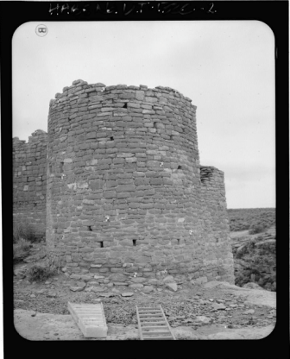 | 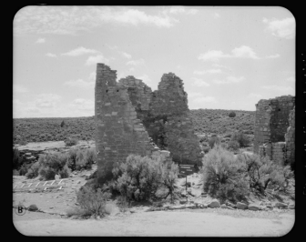 | 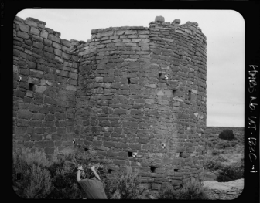 | 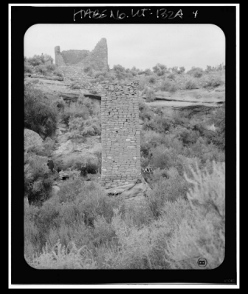 | 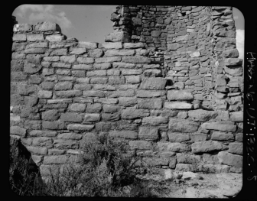 | 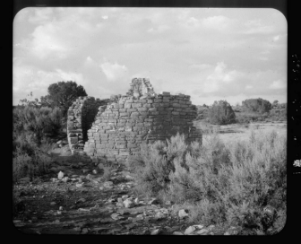
https://www.loc.gov/resource/hhh.ut0549.photos/?sp=2 | https://www.loc.gov/resource/hhh.ut0549.photos/?sp=3 | https://www.loc.gov/resource/hhh.ut0549.photos/?sp=1 | https://www.loc.gov/resource/hhh.ut0547.photos/?sp=4 | https://www.loc.gov/resource/hhh.ut0549.photos/?sp=8 | https://www.loc.gov/resource/hhh.ut0548.photos/?sp=1

Foundations Annotations
Curriculum Connections

History

Geography

Economics

Physical Science (see secondary sources)

Curriculum Standards

CO State History Standard 2: People in the past influence the development and interaction of different communities or regions. (Third Grade)
- Describe the history, interaction, and contribution of the various peoples and cultures that have lived in or migrated to a community or region.

CO State Geography Standard 1: Use various types of geographic tools to develop spatial thinking. (Third Grade)
- Read and interpret information from geographic tools and formulate geographic questions.
c. Locate the community on a map and describe its natural and human features.

CO State Geography Standard 2: The concept of regions is developed through an understanding of similarities and differences in places. (Third Grade)
- Observe and describe the physical characteristics and human features of a region.
- Identify the factors that make a region unique including cultural diversity, industry and agriculture, and land forms.
- Give examples of places that are similar and different from a local region.

Curriculum Standards (continued)

CO State History Standard 1: Organize and sequence events to understand the concepts of chronology and cause and effect in the history of Colorado. (Fourth Grade)
- Explain the cause-and-effect relationships in the interactions among people and cultures that have lived in or migrated to Colorado.

CO State History Standard 2: The historical eras, individuals, groups, ideas and themes in Colorado history and their relationships to key events in the United States. (Fourth Grade)
- Describe interactions among people and cultures that have lived in Colorado.

CO State Geography Standard 2: Connections within and across human and physical systems are developed. (Fourth Grade)
a. Describe how the physical environment provides opportunities for and places constraints on human activities.
b. Explain how physical environments influenced and limited migration into the state.
- Analyze how people use geographic factors in creating settlements and have adapted to and modified the local physical environment.

CO State Economics Standard 1: People respond to positive and negative incentives. (Fourth Grade)
- Give examples of the kinds of goods and services produced in Colorado in different historical periods and their connection to economic incentives.
c. Explain how the productive resources of Colorado have influenced the types of goods produced and services provided.

Content and Thinking Objectives

Students will be able to:
- use primary sources to learn about the past.
- describe archaeological ruins in terms of landscape, geographical features, construction materials and possible uses.
- name some of the natural resources in the Mesa Verde region and discuss how natural resources might have been used by Ancestral Puebloan people.
- consider social and economic reasons that led to the migration of the Ancestral Puebloans.

Inquiry Questions, Activities and Strategies

Inquiry Questions
How long did the Ancestral Puebloan people live in the area in and around Hovenweep? What are some of the reasons they might have left?

There are a lot of maps included in this resource set. Why are maps important in understanding archaeological ruins and the relationships of the people living in these areas. What can you learn about Hovenweep National Monument from looking at one map alone and then looking at several of them together?

Inquiry Activities
Compare the photographs of the different ruins at Hovenweep from the 1800s, the 1900s and 2015. How have they changed? How have the remained the same? Please explain.

Examine the different photographs from Hovenweep National Monument and consider the natural resources. What did the Ancestral Puebloan people eat? Where did they get their food? What plants were important to the Ancestral Puebloan people? How were those plants used? What did they make from the yucca plant?
These are good sources for more historical information:
https://cdn.loc.gov/master/pnp/habshaer/ut/ut0400/ut0424/data/ut0424data.pdf
https://www.nps.gov/hove/planyourvisit/upload/HOVE_VisitorGuide_forWeb.pdf
https://www.nps.gov/hove/planyourvisit/upload/HOVELittleRuinTrailGuide_forWeb.pdf

Examine the different photographs from Hovenweep National Monument. How do you think the Ancestral Puebloan people constructed their homes? What materials did they use? Were those materials a good choice? What missing features might help you better understand what these structures looked like when they were inhabited? Why do you think these no longer exist?

Follow up to the previous activity: Looking at these photos, what do you think they were used for? Why? What features make you think that? What other artifacts could archaeologists find to make a stronger connection to the building use?

Inquiry Questions, Activities and Strategies (continued)

Ask students to research the Ancestral Puebloan people and the different structures from Hovenweep National Monument. Divide students into groups of 3-4 and ask each group to use their research, along with the maps and photographs from this resource set to build a model of one of the components of Hovenweep National Monument. Models should be of the same general scale and should include typical Ancestral Puebloan dwellings, kivas, granaries, towers, and tool and grinding work areas. Students may use any craft materials they can find, including shoe boxes, papier-mache, and homemade adobe. Place the completed models on dirt and grass-covered poster boards and assemble the village. Use the maps included in the resource set to help determine where to place their models and discuss the importance of each structure type and the reason for its placement.
Assessment Strategies

Depending upon how one uses the resources and which standards are chosen, assessment can take many forms. For example:

CO State History Standard 2 (b) (Fourth Grade) Using sources from the Resource Set and this article (http://coloradoencyclopedia.org/article/ancestral-puebloans-four-corners-region), describe the relationship between Hovenweep National Monument and Ancestral Puebloan people living in the area at the same time.

CO State Geography Standard 1 (a, c) (Third Grade) Explain the relationship between the people of Hovenweep National Monument and Ancestral Puebloan groups who were living in the same region at the same time.
Other Resources
Web Resources

National Park Service: https://www.nps.gov/hove/planyourvisit/upload/HOVELittleRuinTrailGuide_forWeb.pdf

National Park Service: https://www.nps.gov/hove/index.htm

United States Geological Survey: https://3dparks.wr.usgs.gov/hove/

Colorado Office of Archaeology and Historic Preservation: http://www.historycolorado.org/oahp/montezuma-county
Secondary Sources

National Park Service Lesson Plan: 3rd grade Physical Science: Utah State Science Core Curriculum Topics, Standard Three: Students will understand the relationship between the force applied to an object and the resulting motion of that object.
Students explore different types of simple machines by examining ancient technologies. Students examine different types of levers using digging sticks and throwing atlatls. They discover how wheels and axles were used to make fire, and how rock wedges can become useful tools.
https://www.nps.gov/arch/learn/education/classrooms/upload/ThirdGrade_Force.pdf

NPS General Management Plan Environmental Assessment
https://www.nps.gov/hove/learn/management/upload/HOVE_GMP-FINAL_2011.pdf

Historic American Buildings Survey, Reduced Copies of Measured Drawings Written Historical & Descriptive Data – detailed sources and thorough bibliography
https://cdn.loc.gov/master/pnp/habshaer/ut/ut0400/ut0424/data/ut0424data.pdf

Preservation Connection

On March 2, 1923, President Warren G. Harding proclaimed Hovenweep a unit of the National Park System. It was listed on the National Register on October 15, 1966 and additional documentation was approved in September 20, 2016, record number 5MT.22280. The nomination form and supporting materials have not, as yet, been digitized. The monument protects six prehistoric ancestral Puebloan villages inhabited 800 years ago. It is near Cortez, Colorado along the Colorado-Utah border. The site is significant in the areas of Exploration/Settlement, Religion, Architecture, and Archaeology.

Why is it important to preserve places like Hovenweep National Monument?

What can be learned about the “villages” where the Ancestral Puebloan people lived at Hovenweep as well as at other settlements such as Mesa Verde, Lowry Pueblo, and others?

Why is it important to continue studying this and other historic archaeology sites?
Working together to tell the story of our state!

Developers Sponsors



Sponsors

Partners


